Notes are prepared while studying Udemy course.

What is Git?

* It’s version control system
* Manage code history
  + It means version history
* Track the changes
  + Like from which branch code get merged.
  + Ex: TICMS 3.0 to TICMS 3.4 code merge

But disadvantage of Git is it works on your local system and not in collaborative manner.

Ex1:

Suppose you have install a Git software and make a project using it. And due to some reason you have travelled to some other city without your laptop and once you reached that city you thought you have to get access to your code for some reason. Unfortunately you won’t the reason is Git only works on your local system.

Ex 2:

Suppose you have built project and after some time you want that some other developer need to work on it for further development, in this case both you and some other developer won’t work simultaneously and collaboratively as Git works only on Local system.

To resolve this problem we gave Git Hub.

What is Git Hub?

* Development platform
* Provide collaborative environment where user can push their code so that as and when needed other team member can pull those changes on their local.



How git works?

Few concepts are involved as below:

* Working directory
  + It means project folder
* Repository
  + It is .git hidden folder inside you working directory

Git commands from scratch:

You have created new project then how do you enabled it to Git? Or what is “git init” command?

* Once project folder is created then navigate to that folder and run below command
  + Command: git init
    - It will create .git hidden folder under working directory
    - But still your project is not yet added to git local repository
* Then how come we add project to local repository?
  + First run the “git status” command to see status of current files
  + To add files in local repository run “git add . (dot) OR {File-name}
    - Here . (dot) consider all files
  + Run again “git status” to see status of current files
* Command to see current branch?
  + “git branch” > Will list all branches
* Command to create new branch?
  + “git branch {branch_name}
    - Once you create branch then we have to switch to that newly created branch using below command
      * “git chechout {bach_name}
  + “git checkout –b {banch_name}
    - This command will create branch itself and switch git control from current branch to newly created branch.
* Command to create branch with specific commit
  + “git checkout –b {brach_name} “commit_id”
* Command to merge changes from branch A to master / any other branch
  + First switch to destination branch like
    - “git checkout {branch_name}”
      * Ex: “git checkout master
  + Then run merge command with source branch name
    - “git merge {source_branch_name}”
      * It will merge “ALL” files from source branch to current branch
* How to check all history of current branch and files?
  + “git log”
* How to commit file
  + “git commit –m “commit messge”
* What is use of switch command?
  + It is alternative to checkout command. Only intension is to separate the concept.
  + Using switch command we can create and switch within the branches
  + Ex: git switch {branch-name} : to switch branch
  + Ex: git swith **–c** {branch-name} : to create and switch branch

Merging sub branch file into master branch:

1. Git should point to destination branch in our case its master because we are merging from second-branch to master branch.
2. To check in which branch we are currently just type “git branch” command, it will show output like below and highlight current present branch in green color.

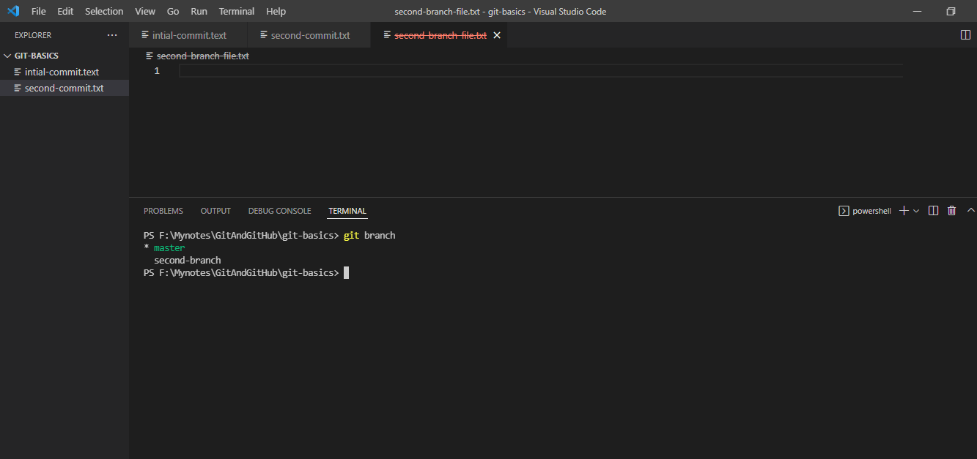

1. After running git merge “branch-name” command all the files that were present in second-branch will get merged into master branch.

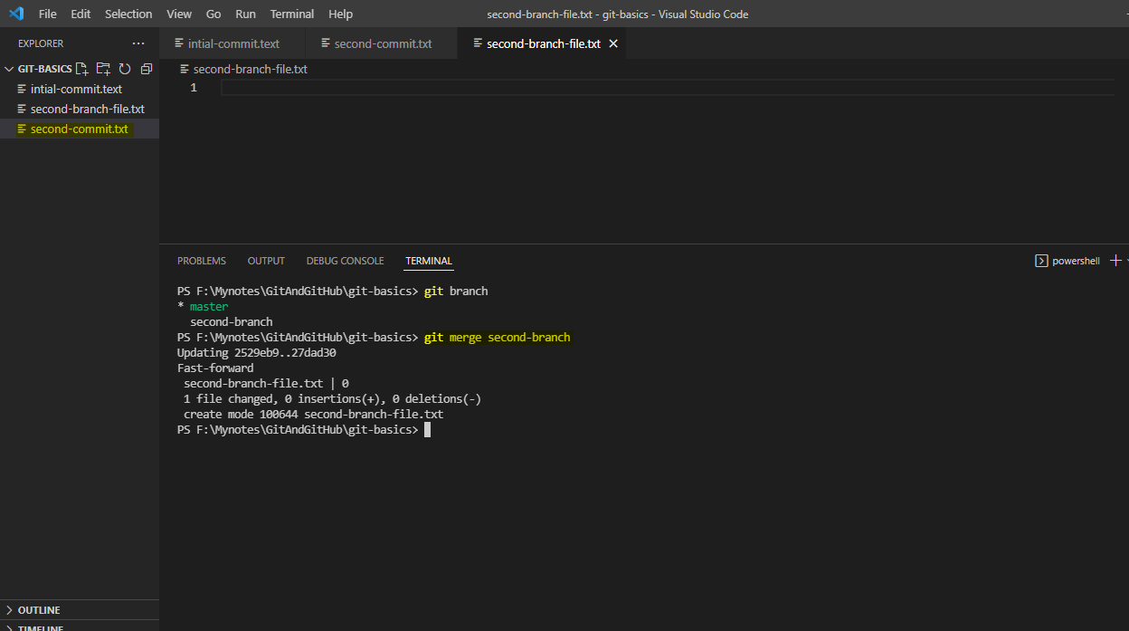

After Log command once merged

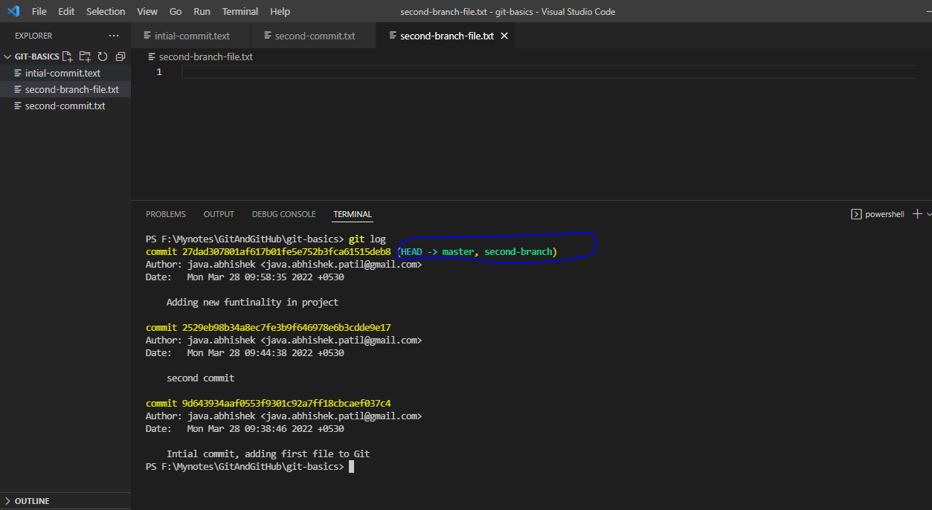

What is HEAD?

* Head means “Latest commit”

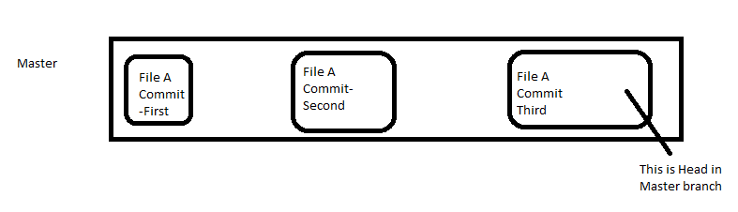

The “detached Head”.

Deleting data

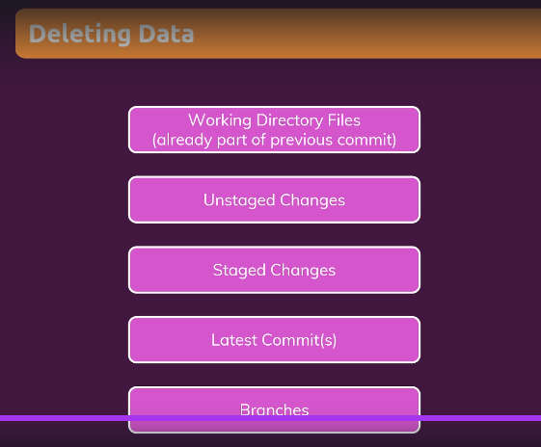

Commands:

* “git ls-files:
  + Tell us which are the files currently present in the current branch

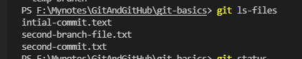

* “git rm {file-name}
  + Remove the file from staging area

Ex:

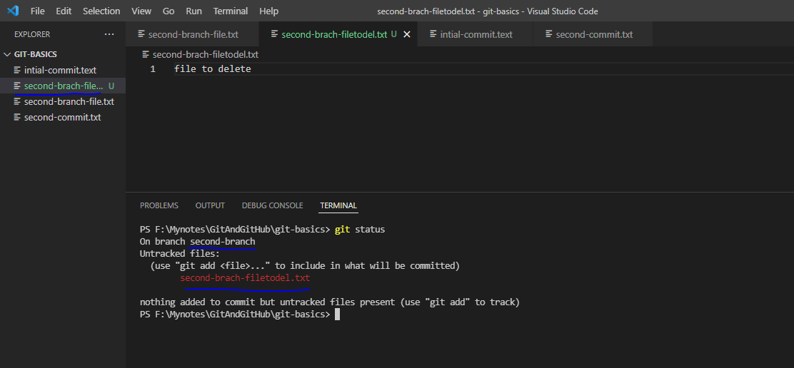

This is new file is created in second branch. We need to add it to staging area like below

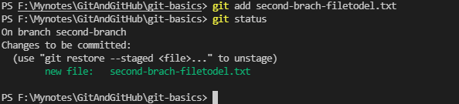

Committing file:

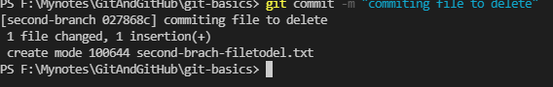

List the file:

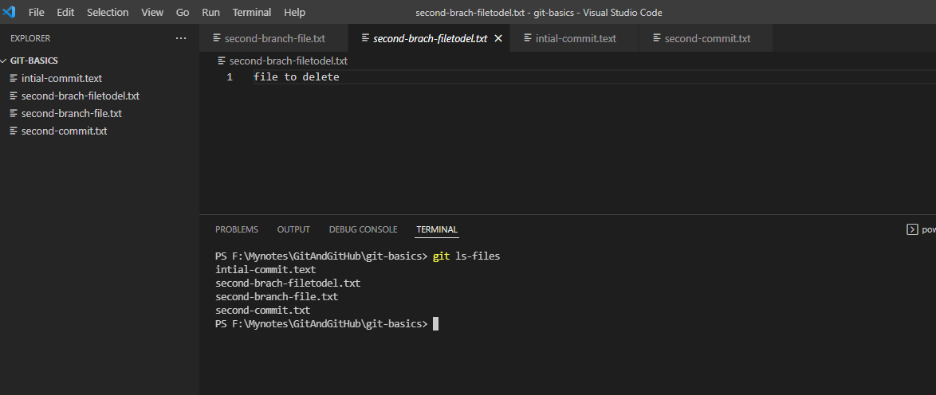

Now manually delete file and check the status

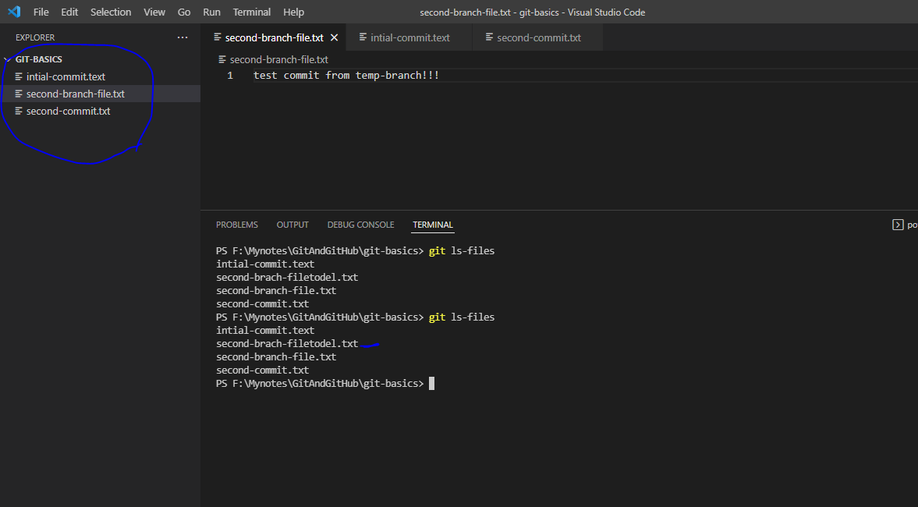

Note that here still we will see delete file name on terminal, now check git status

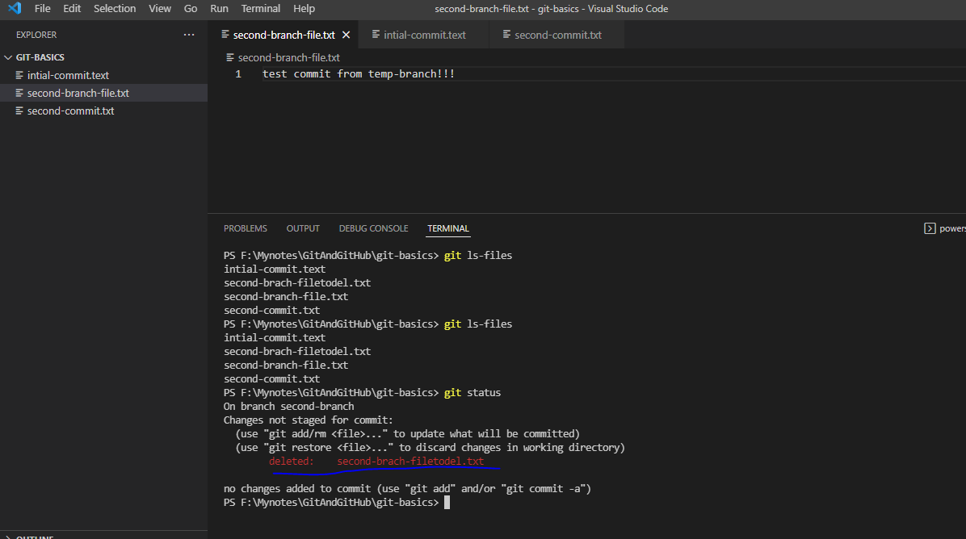

Now we have to actually delete file from repository.

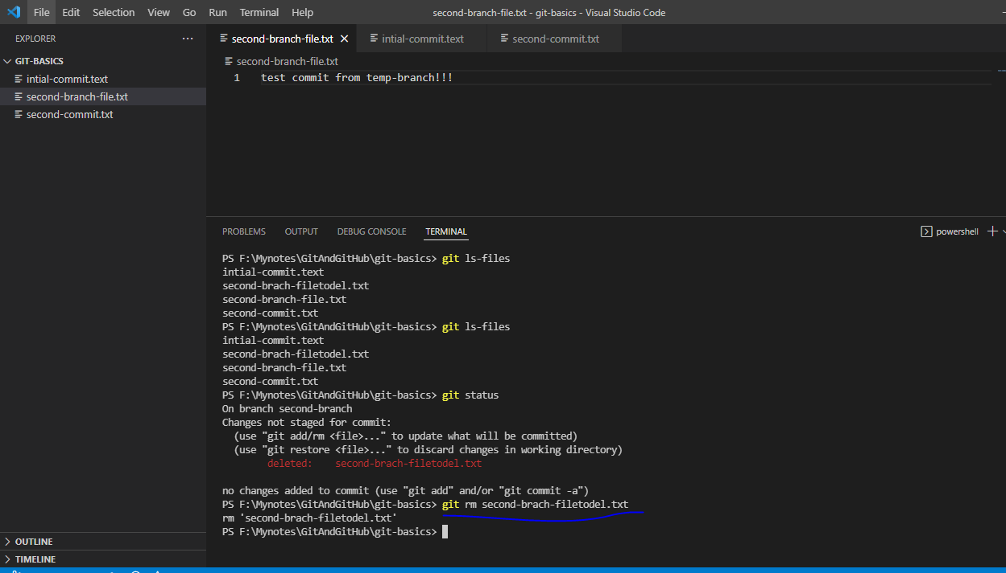

Check files

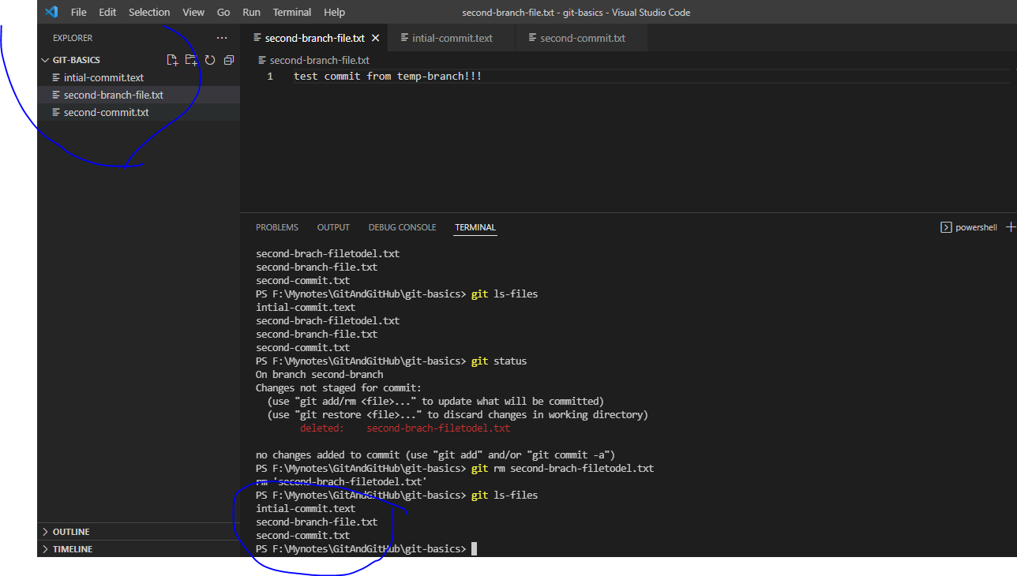

How to unstage file?

Let say you made changes in the intial-commit.txt file and add it to stage like below

1. Made changes and run git status to check

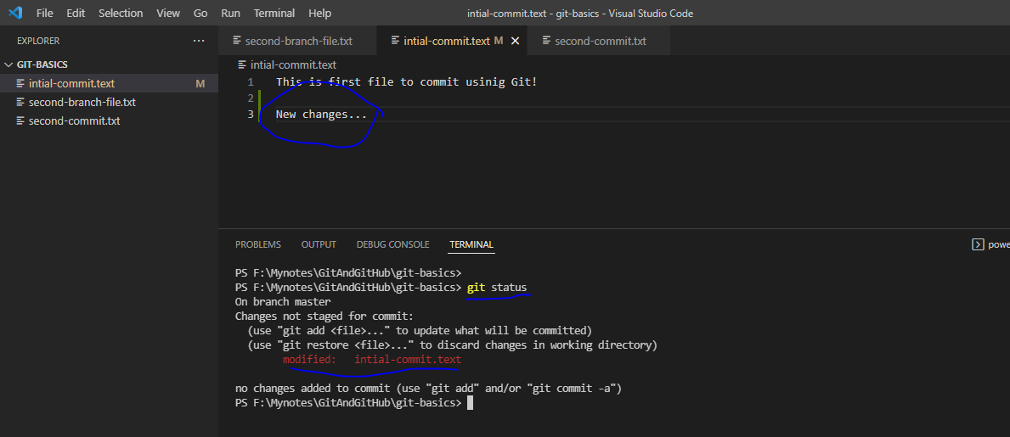

1. Now add it to staging area

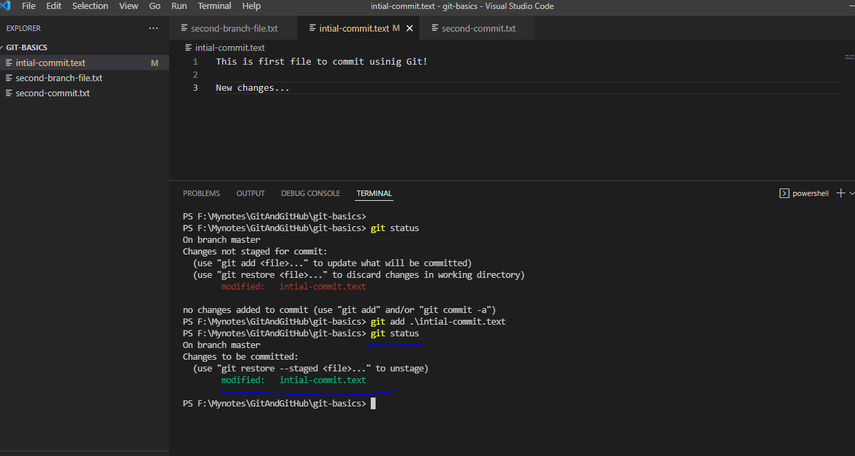

1. Now revert it back from staging
   1. Note that file will keep its changes but it will just get removed from staging area if you use “- - staged” flag

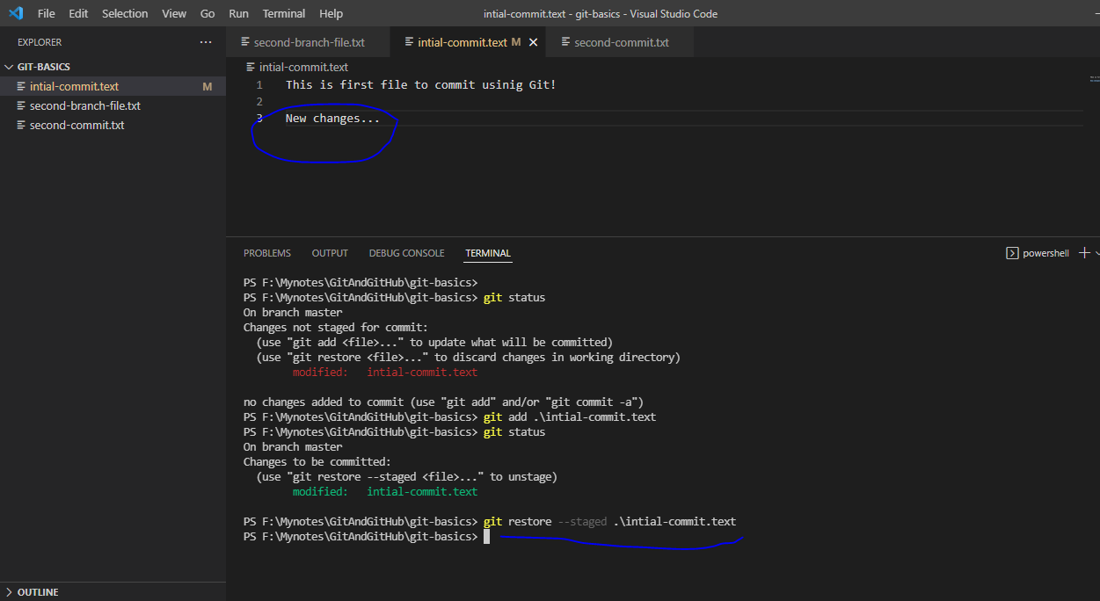

1. Now run git status to check

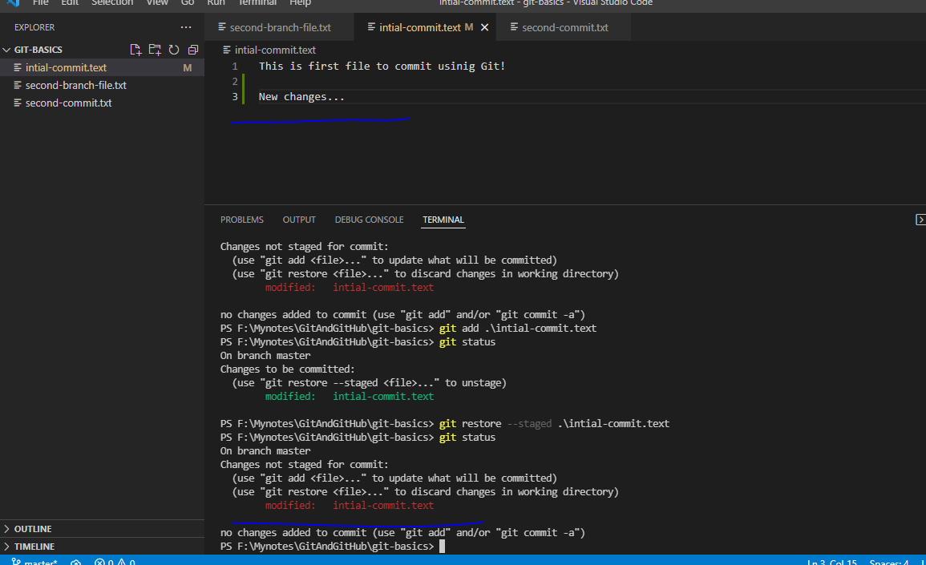No file is present in staging area.

1. If you want to revert back to HEAD version then don’t use “—staged” flag- It means whatever changes you made in the file will gone

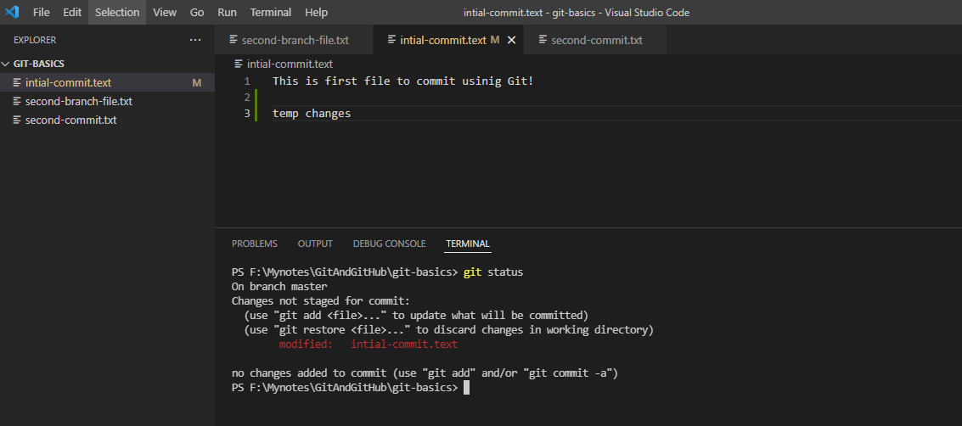

Add the changes to staging area

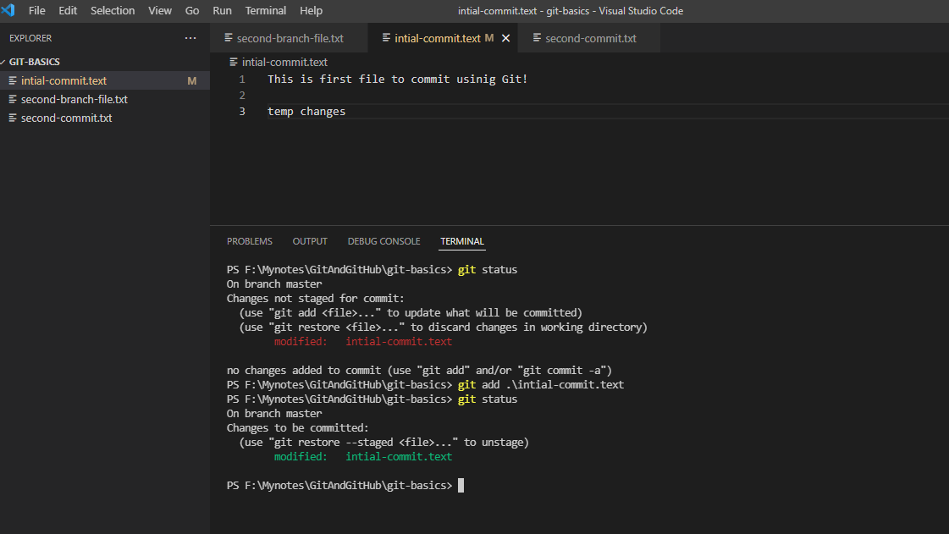

Run the command to unstagg the changes from staging area

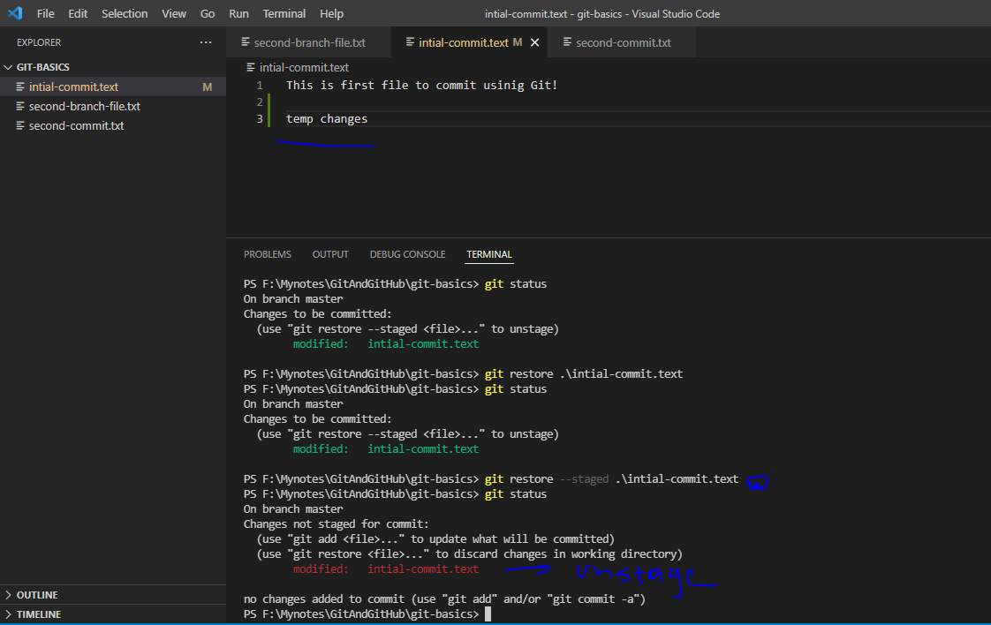

Now run again same command to revert the changes from actual file

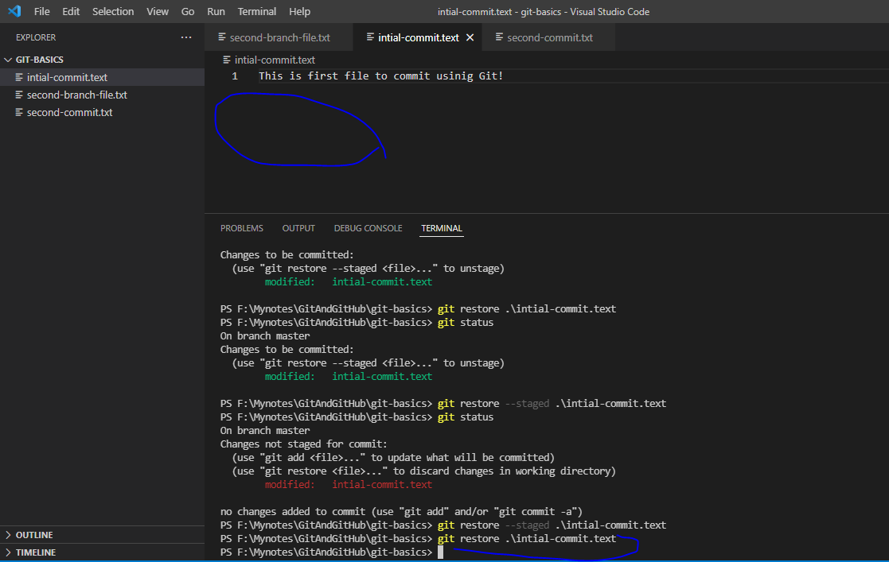Note that changes from actual file are gone.

1. If you want to revert back to HEAD version- It means whatever changes you made in the file will gone

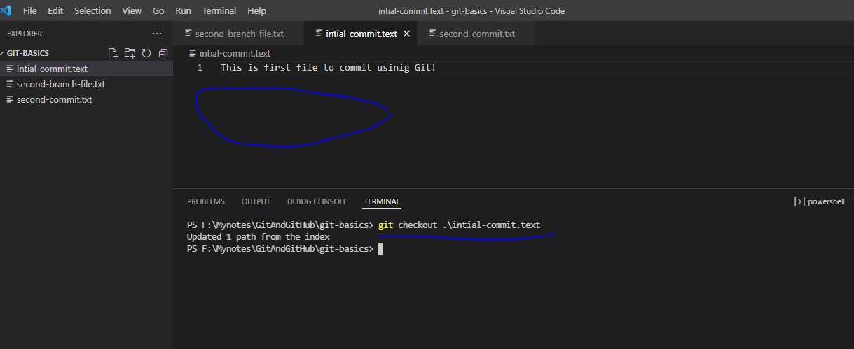

Note that changes from file are discard and file is get restored with repository HEAD version.

How to delete the file/folder which are untracked (untracked mean the file/folder are not in staging area now)

Ex: Add/create file called test.txt

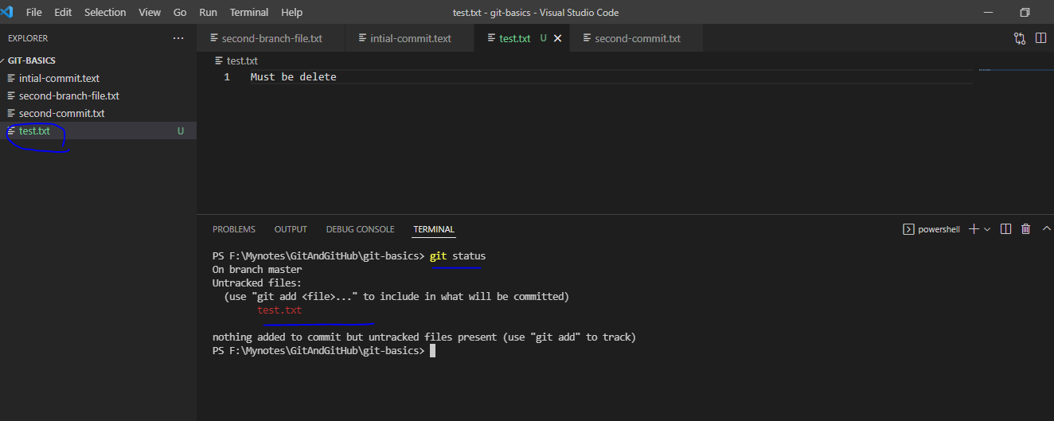

Now we have to delete test.txt file from working directory, so before deleting run below command to verify which are such files.

“git clean –dn” – It will list all such file

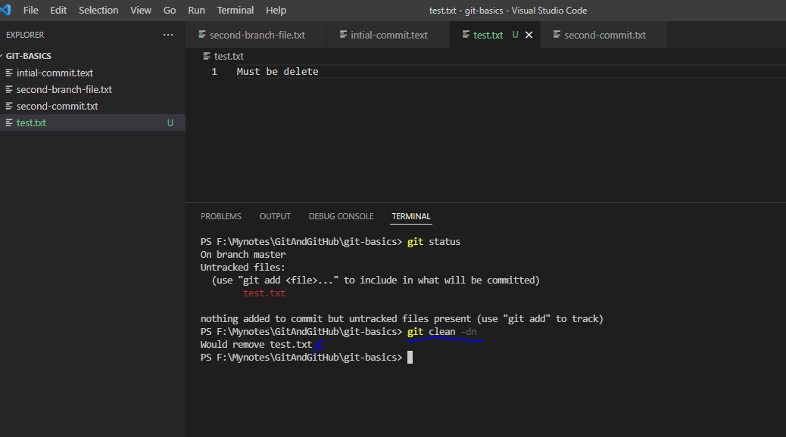

Now run “git clean –df” command to actual delete.

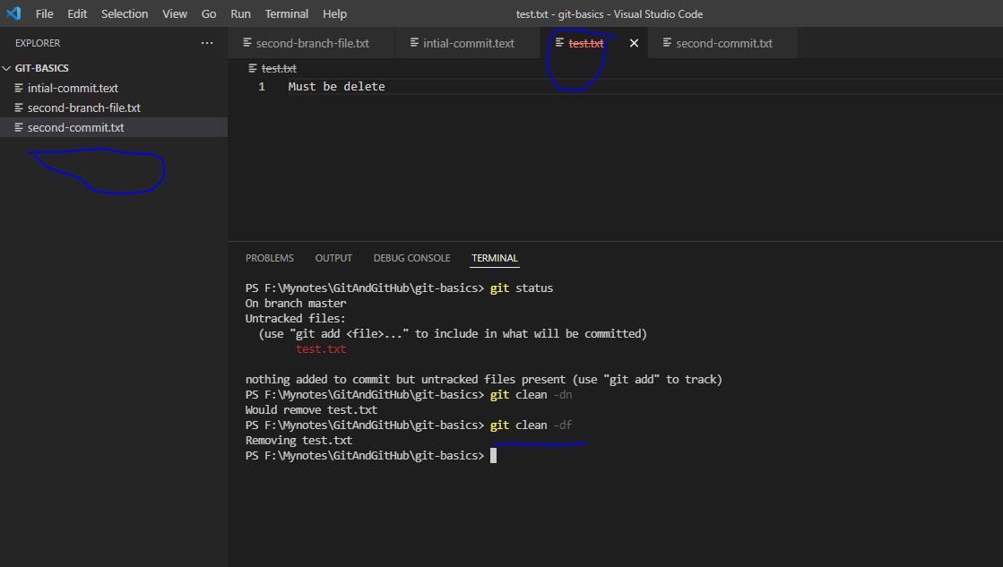

If have multiple files and have to delete specific file then use filename then command like below

“git clean –df {file_name}

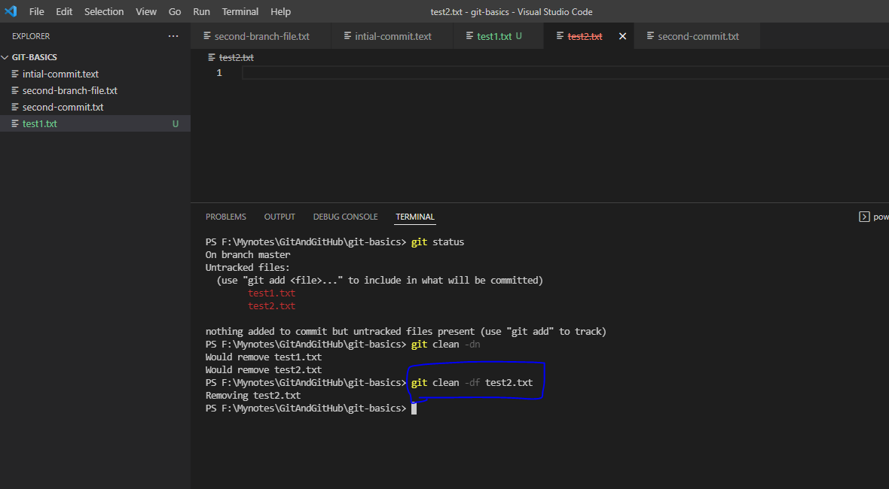

Deleting commit with “git reset command

Add the file, add it to staging area and commit the changes

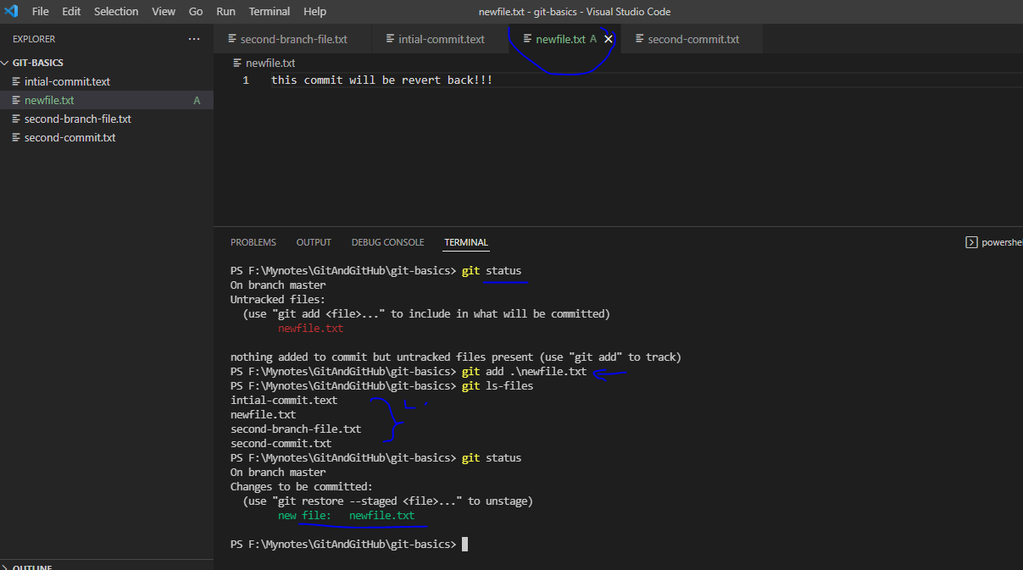

Now commit the changes

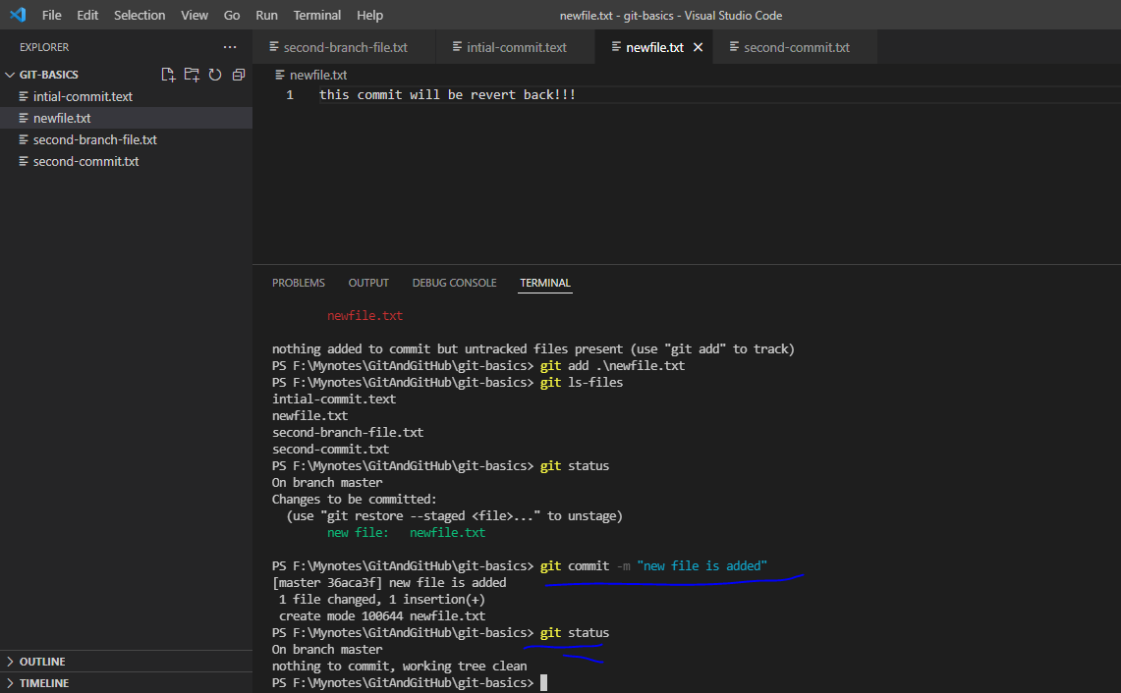

Here is commit log

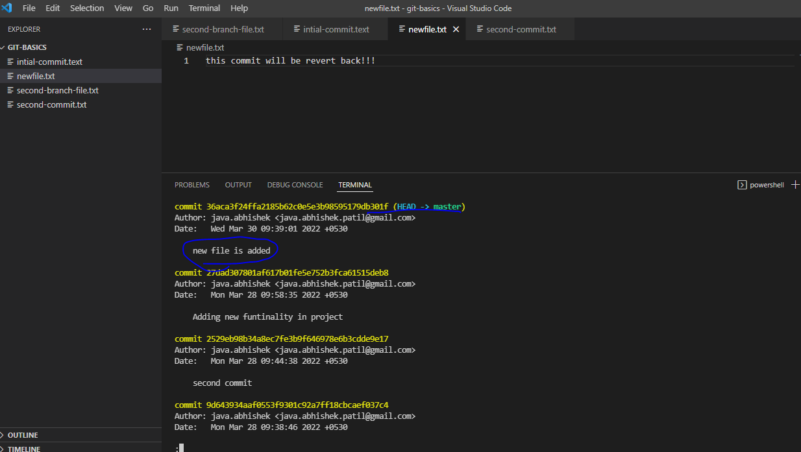

1. Now using below command we will remove the latest commit

git reset --soft HEAD~1 -- Just remove the latest commit and revert back to HEAD first version as we define ~1

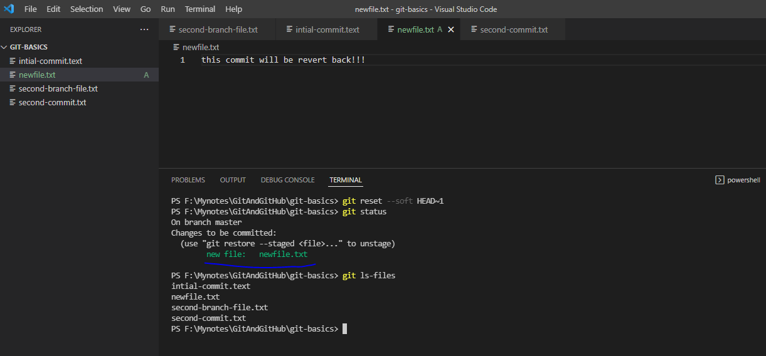

File is come back to staging area and now check commit log, our last commit should not be there

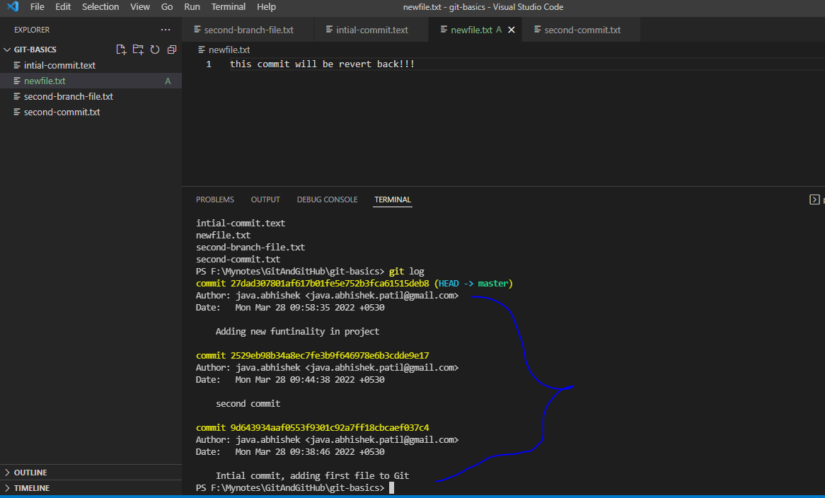

With this --soft option, git will just revert the changes till HEAD~1 version and keep the changes in staging area and working directory

1. With below command we can remove the changes from staging area:

git reset HEAD~1 -- Same as above command but remove the changes from staging area but keep the file in working directory

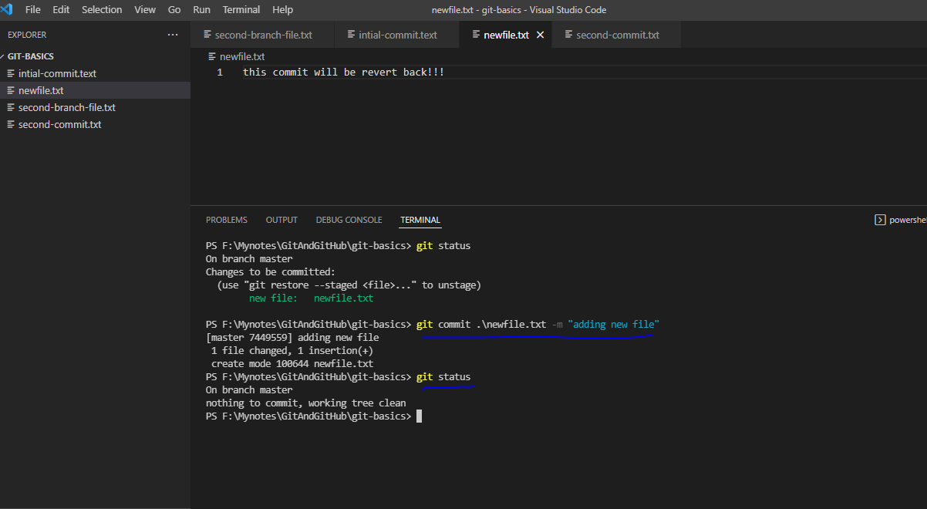

Now see the commit log

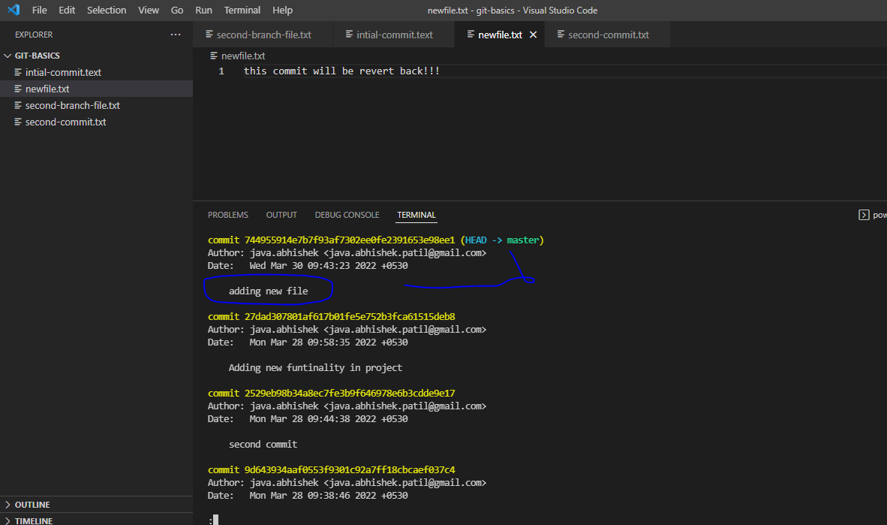

Now use the command: git reset HEAD~1

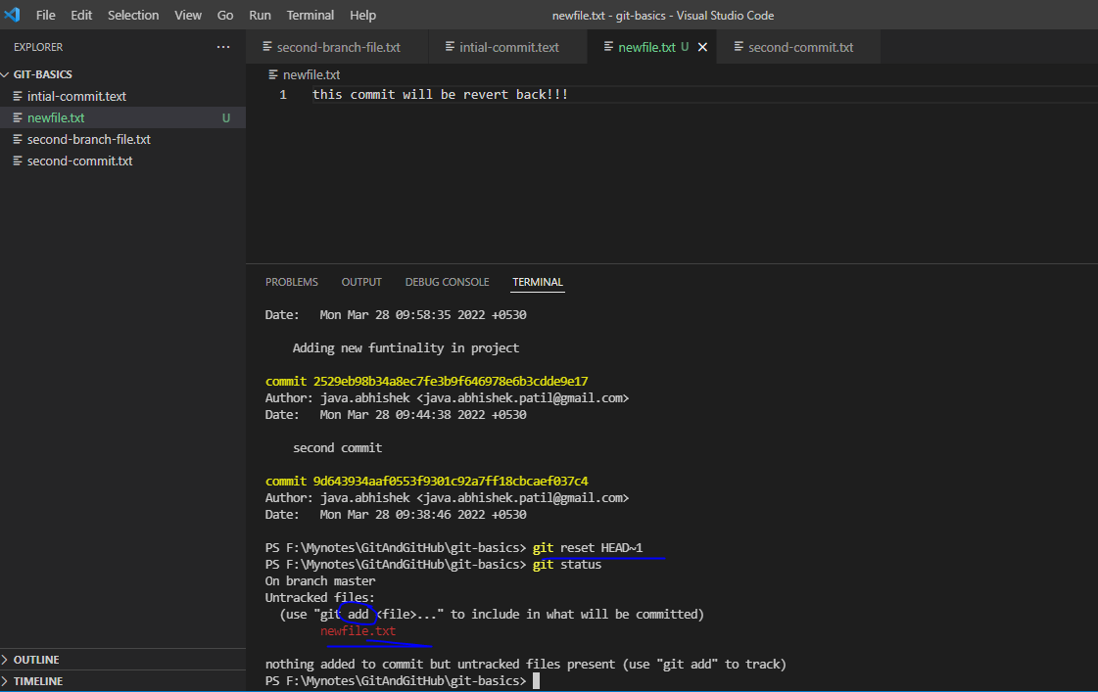

Check commit log:

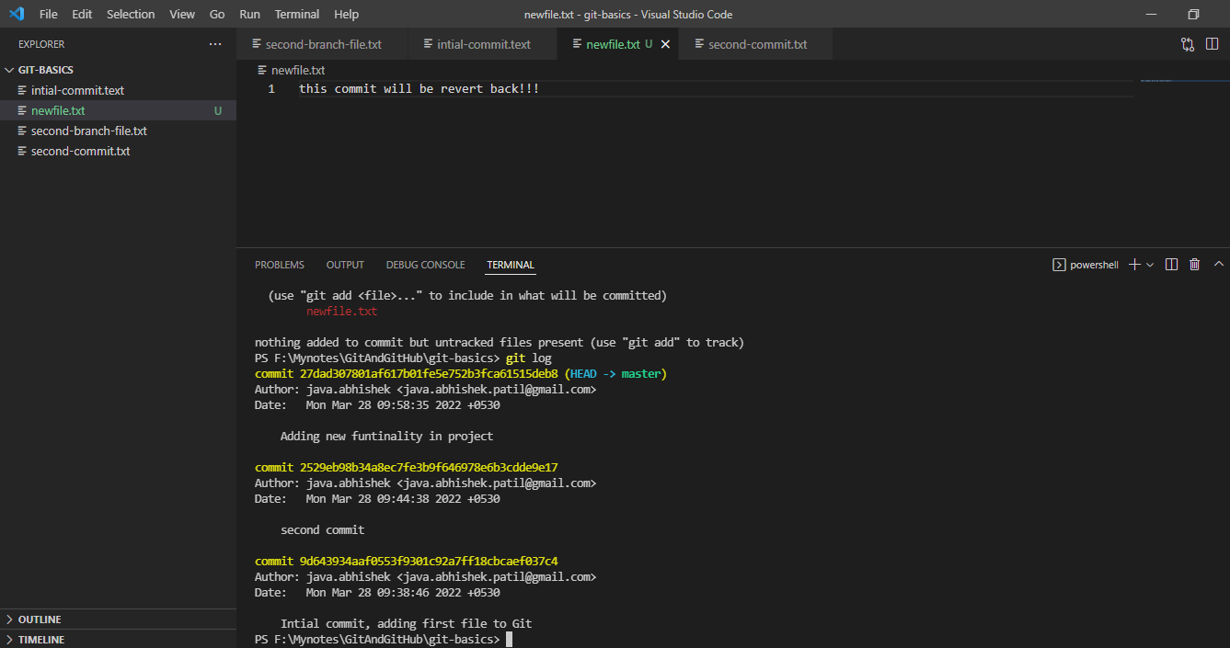

1. With below command we will remove the file as well

git reset --hard HEAD~1 -- Same as above command but remove the changes from staging area and remove the file from working directory

Committing file:

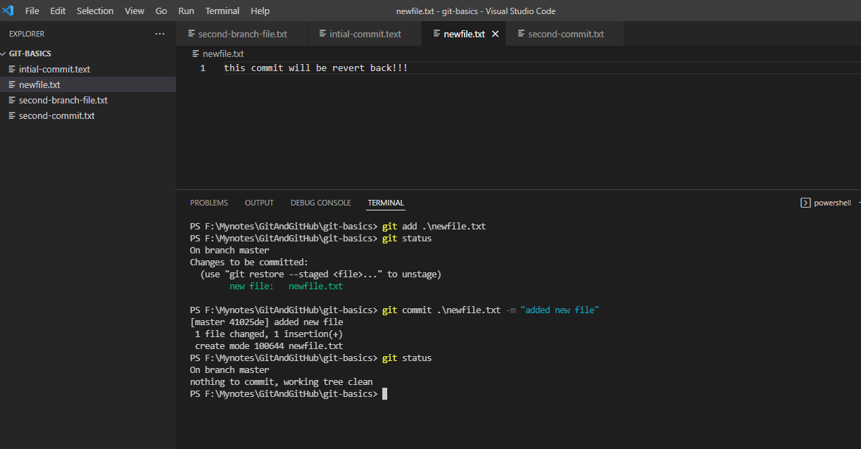

Commit log

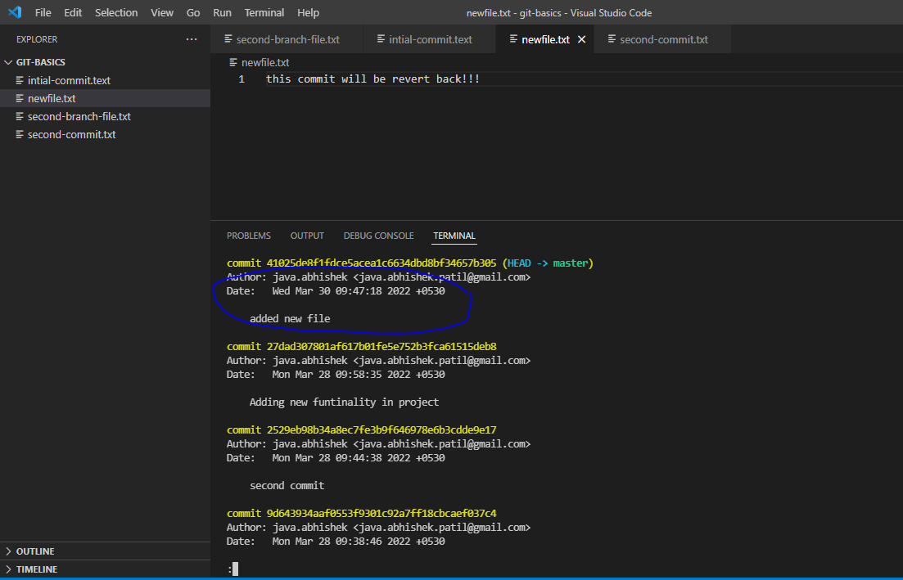

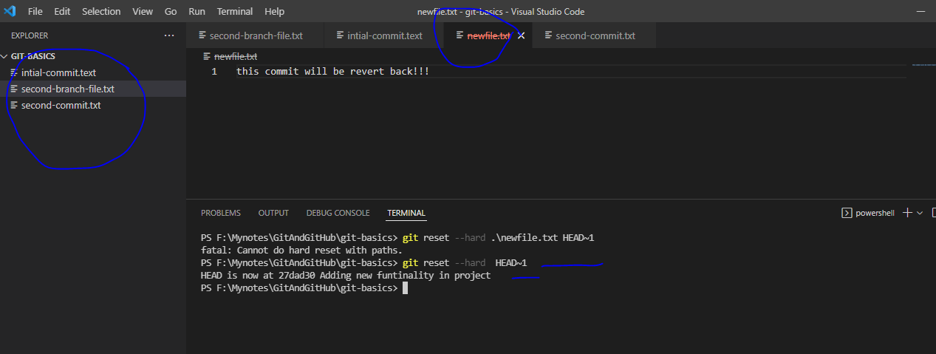

Find the history of any file: git log –full-history – {file Name}

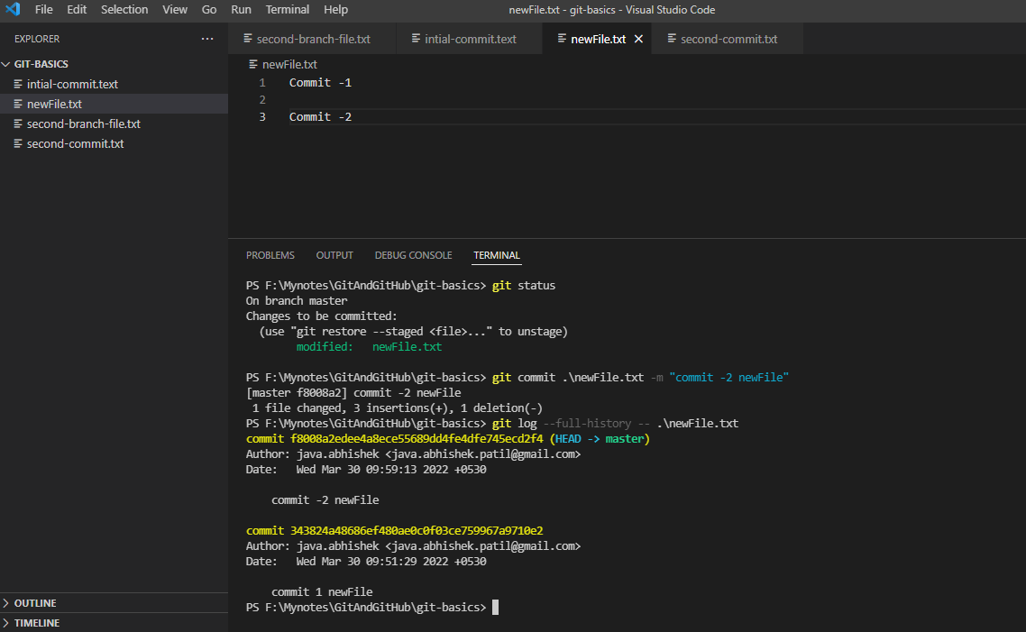

Deleting branch:

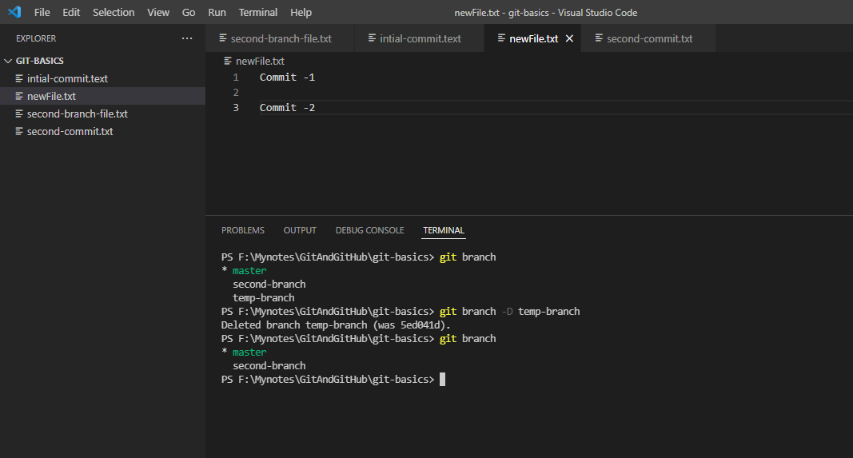

Command: git branch –D OR –d {branch_name_2, branch_name_2,…}

Committing changes from “detached Head”:

What does mean by “detached head”?

> If someone directly checkout the any commit with some commit ID then git will not create any branch for it, it will considered as detached head

Ex:

List of commit that we made

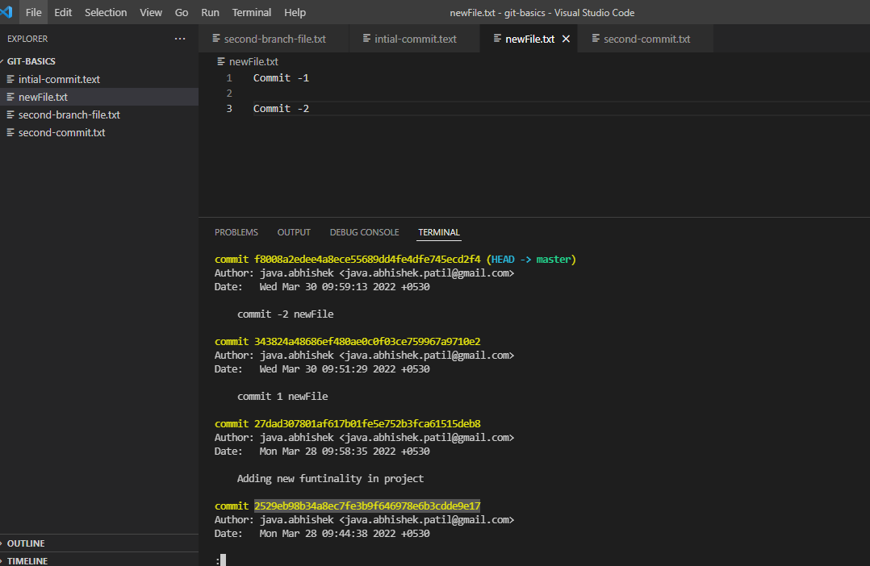

Checkout fist comment

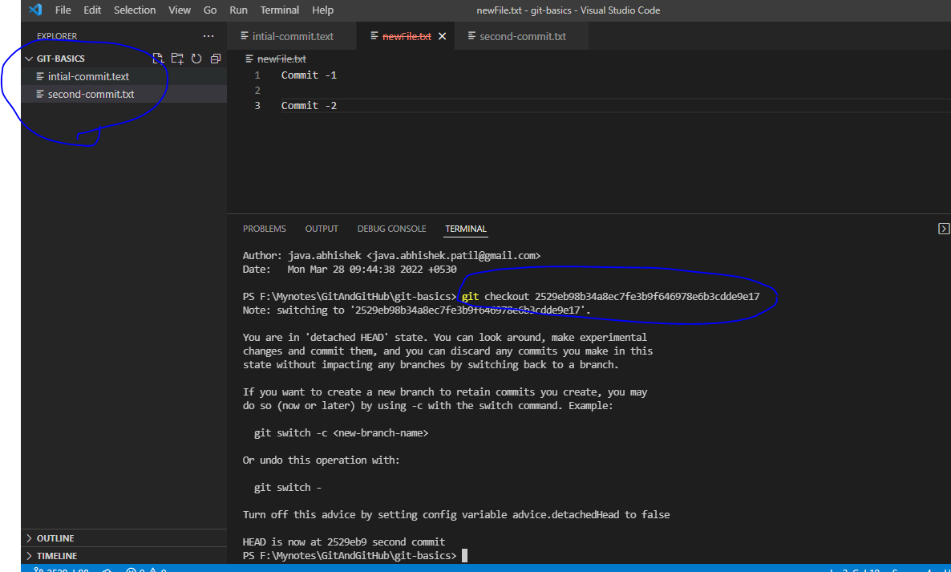

Now we have only two files in our workspace and it will considered as detached head.

Here is detached head log

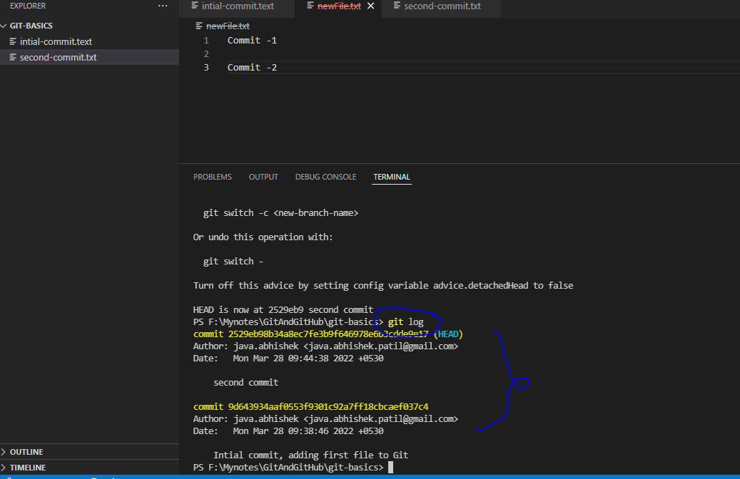

Now check the branch

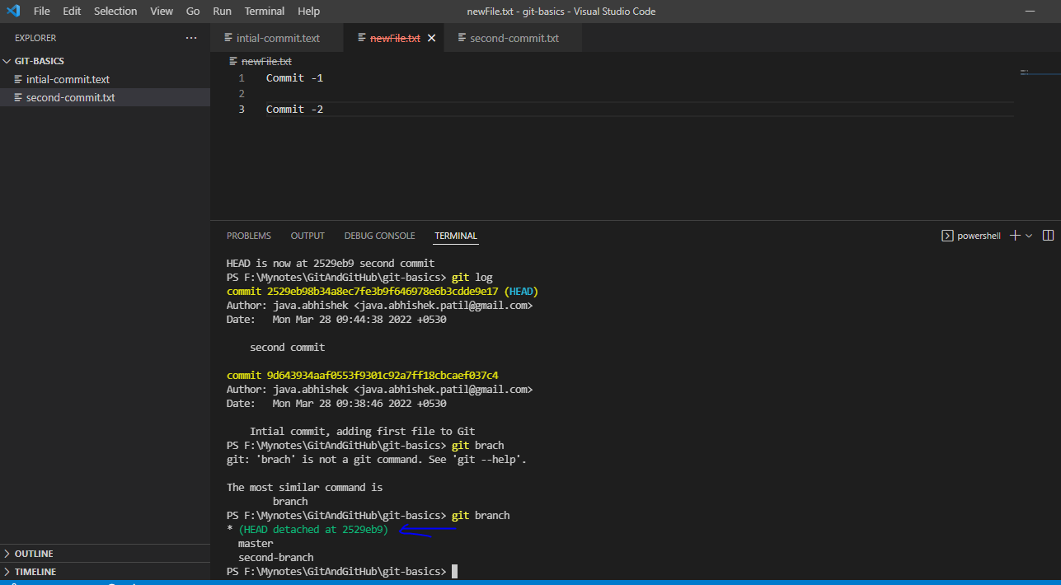

We are at detached head

Now make some changes in some file and add it to staging are and commit the changes in detached head area.

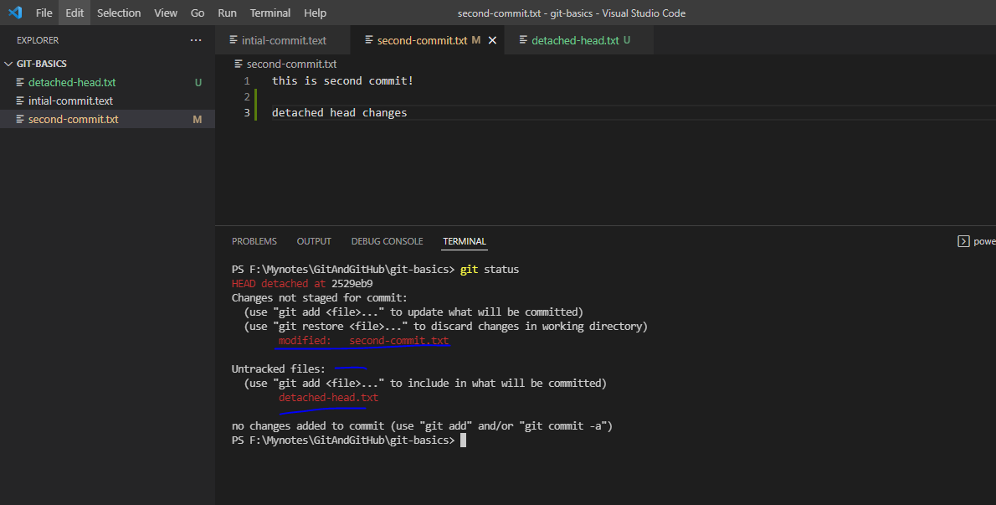One file is added and another file is modified

Add and commit

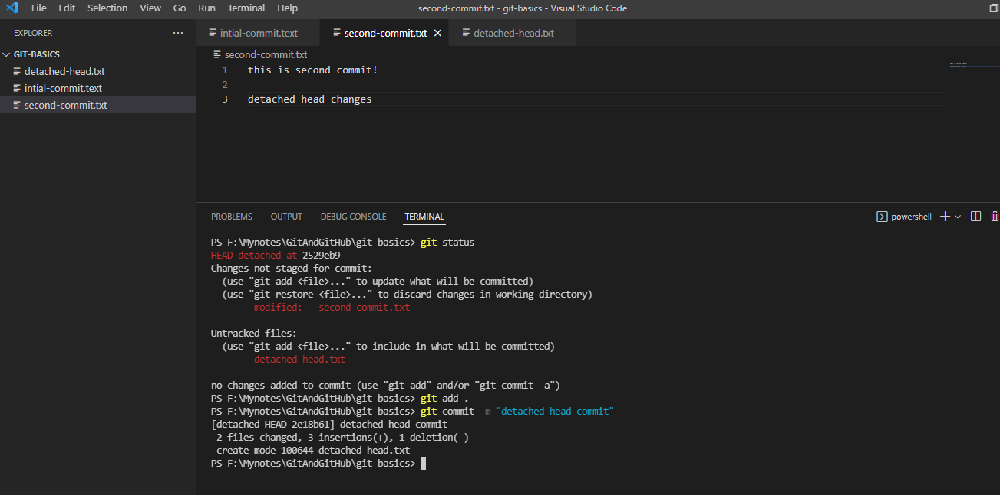

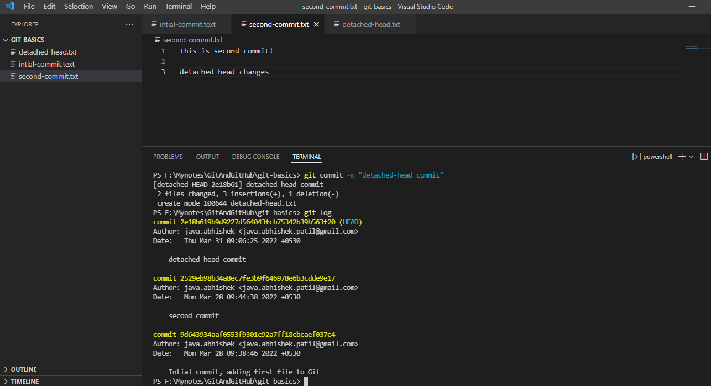

Now merge this changes to master branch

First we have to switch to master branch

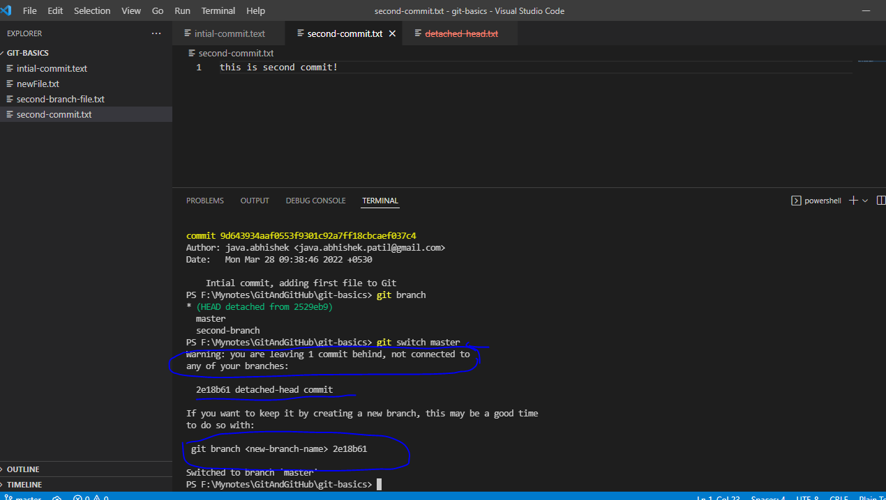

You will see the warning.

Now using git branch <branch-name> {detached-head-id} command we have to create new branch and from that branch we have merge our code to master branch

Branch creation

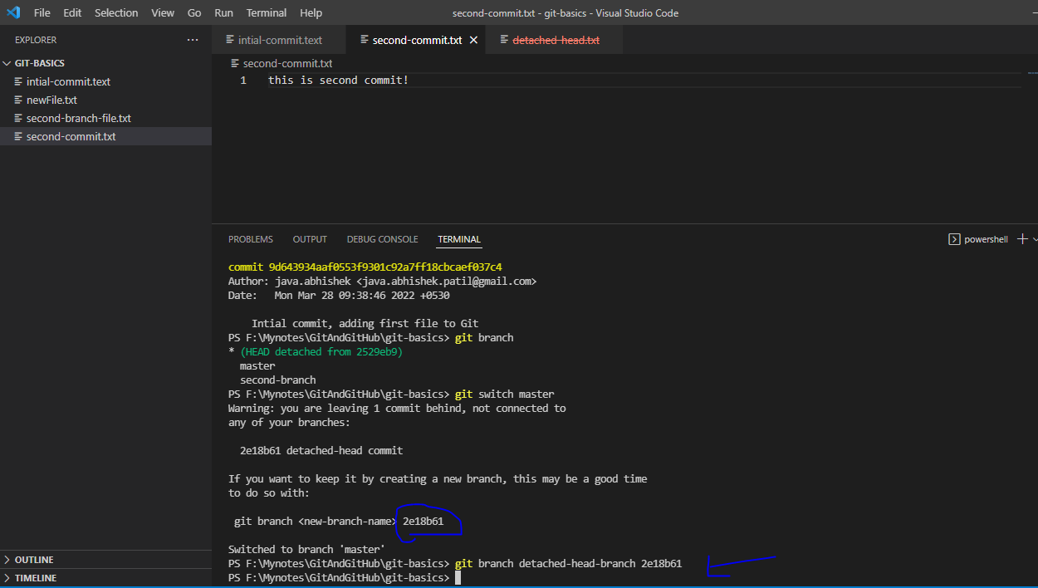

List the branches

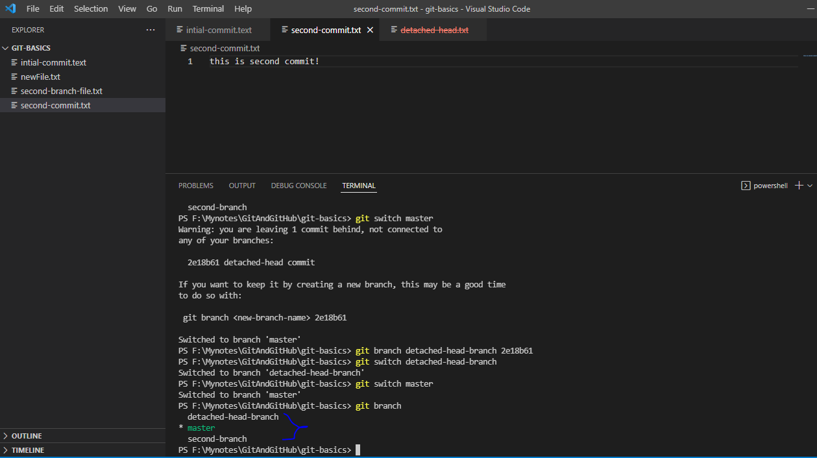

Merge those changes to master branch

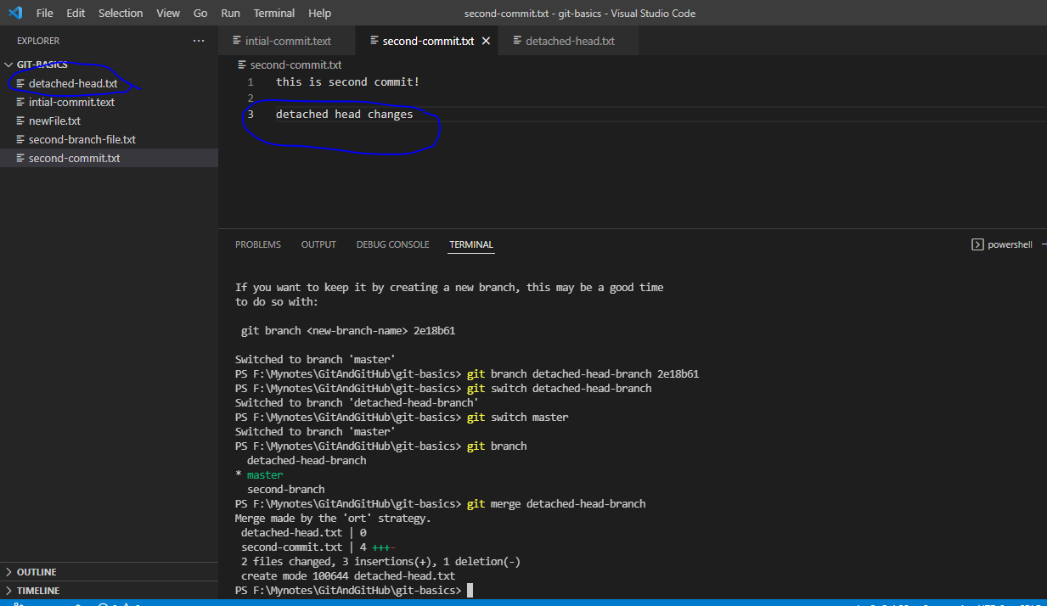

Understanding .gitignore

If you want to ignore some file that should not be tracked by git then we have to configure this file name and path into .gitignore file

NOTE: we have to manually create .gitignore file in our current working directory and we have to commit this file.

Ex:

We have test.log and test2.log and test3.log but have to ignore all log file except test3.log

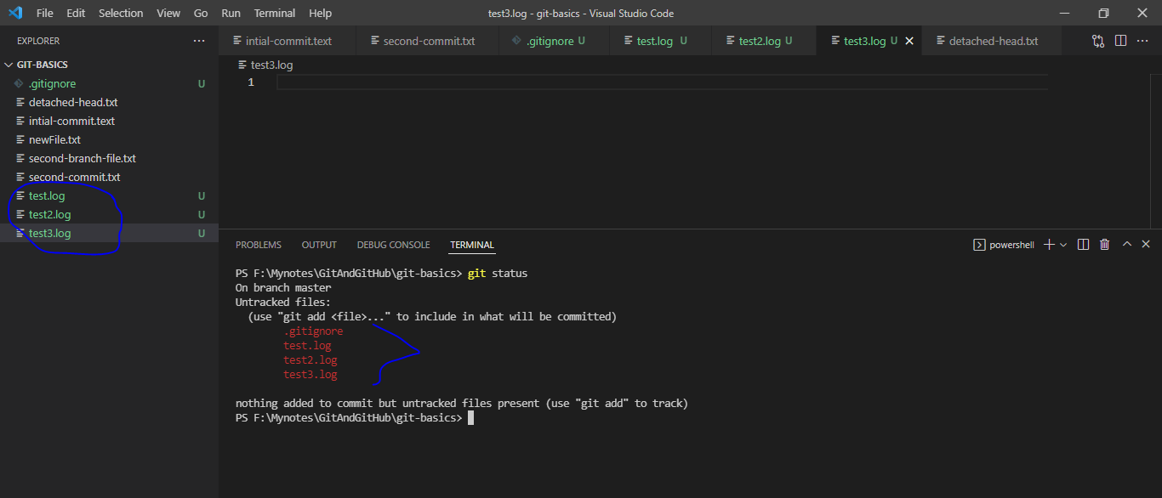

We will see all files have been tracked

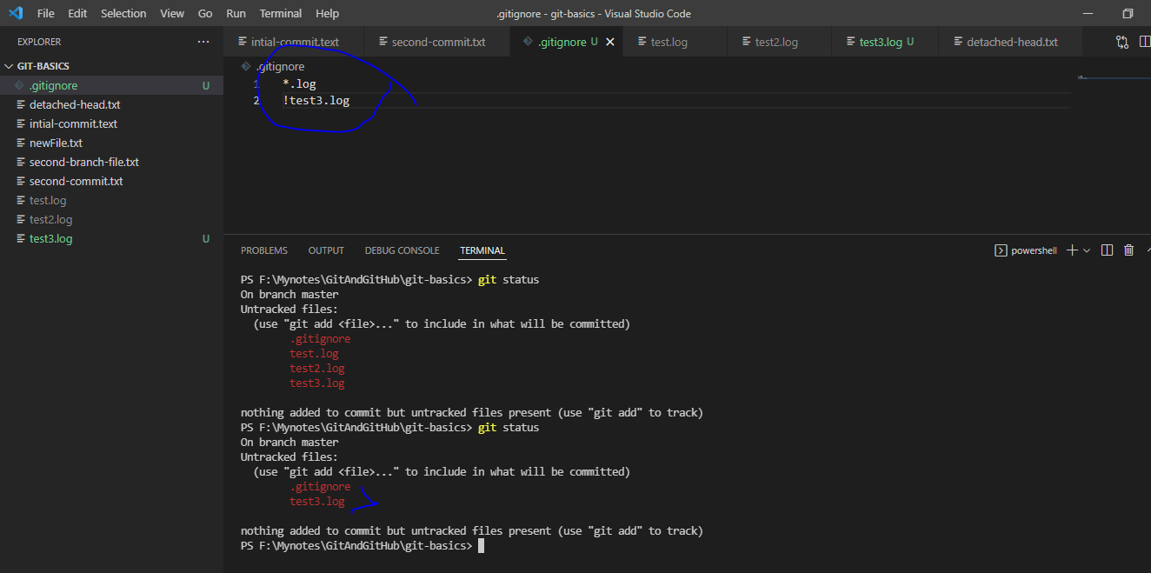

Now see test.log and test2.log file are got ignored in tracking

Suppose you have to ignore some directory:

Added new web-app folder that we need to ignore

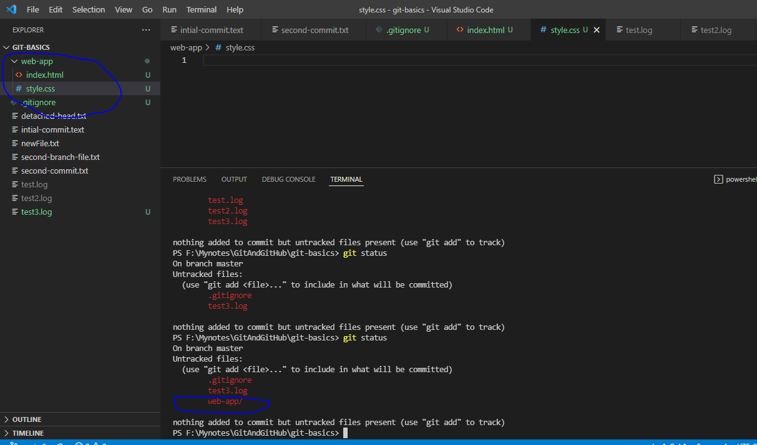

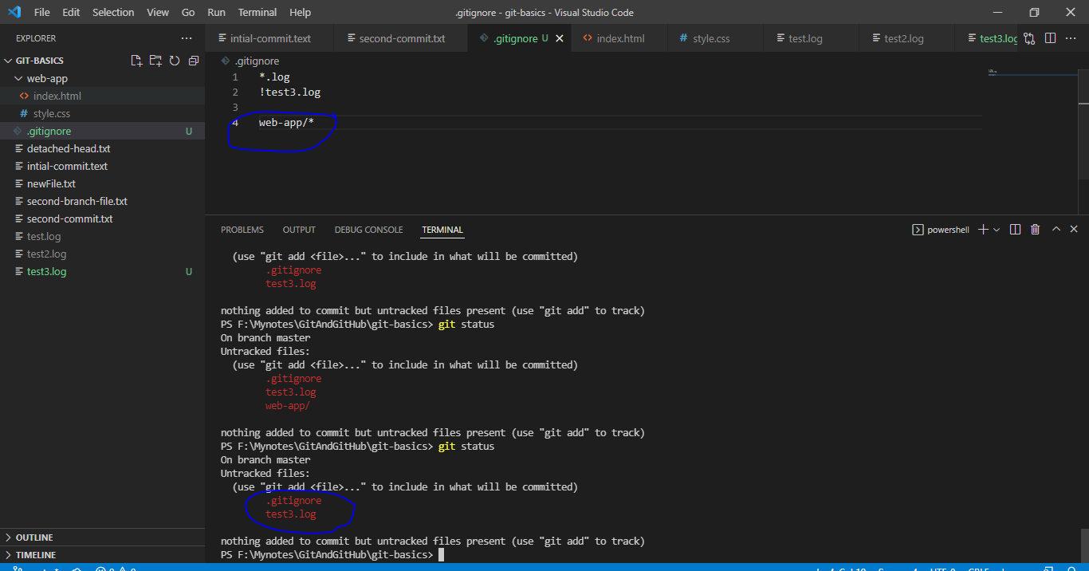

Summary of all command:

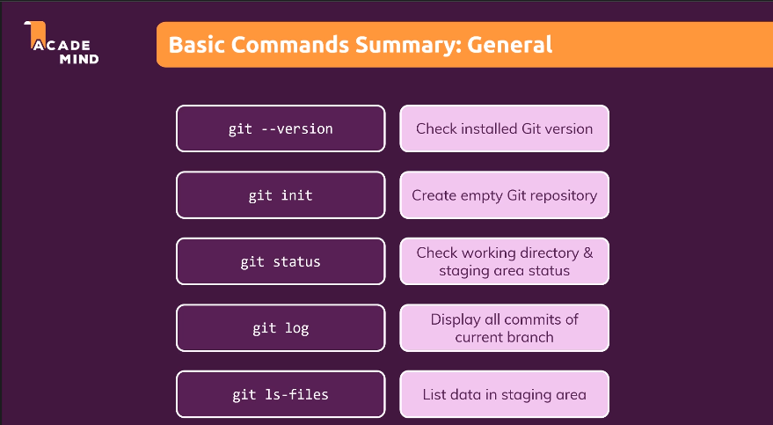

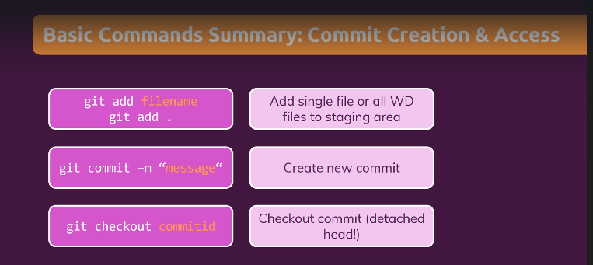

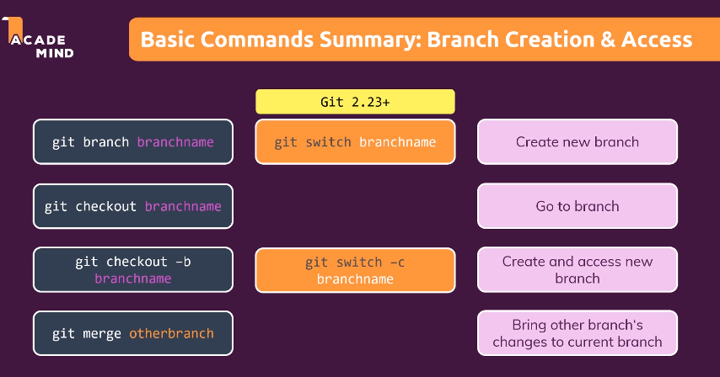

Correction in above screen: git switch –c branchname (note here –c is missing in screenshot)

Indicators for below screenshot:

WD File- Working directory

* 1. means– Version of Git

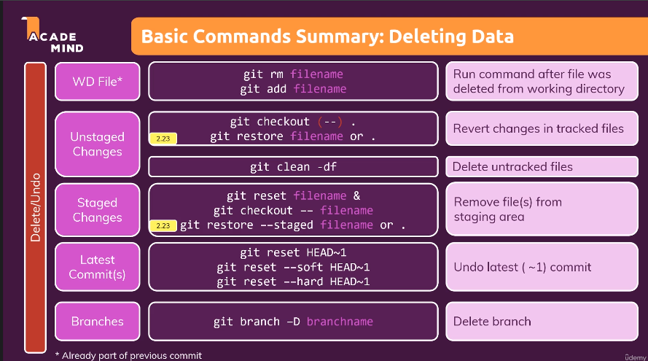

Git advance

Understanding **stash**:

Scenario: If user want to save the unstage changes the one can use stash command. It is like internal memory where someone can save their changes pull back those changes in main branch without creating any new branch.

EX: Create new project and created one file name File.txt and without making any changes add that file to the git.

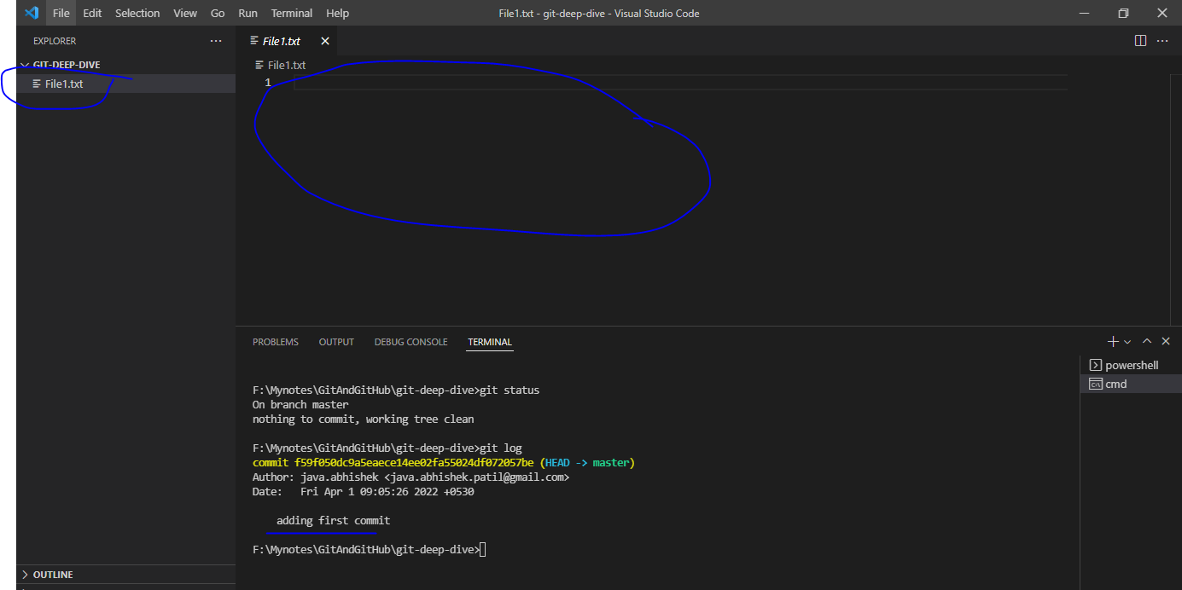

Now make some changes and stash it.

Made changes:

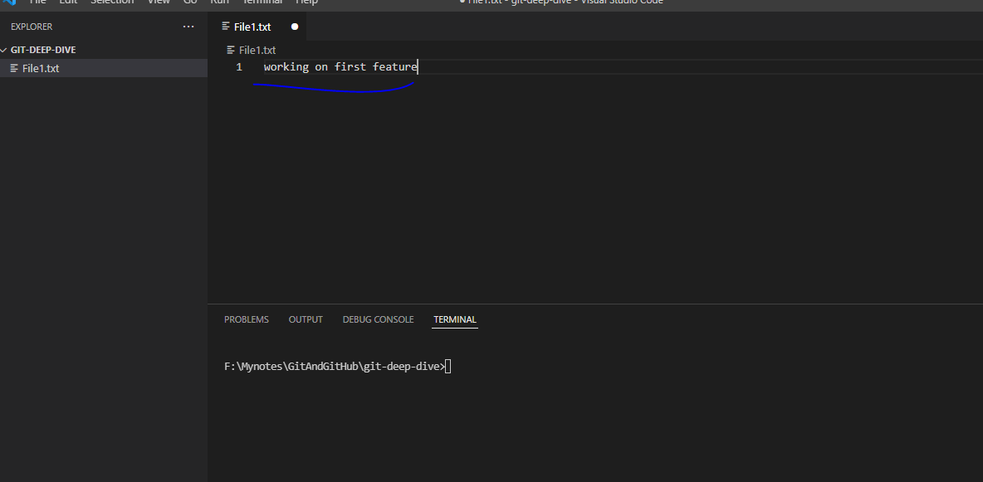

Now stash it

“git stash –m “message”

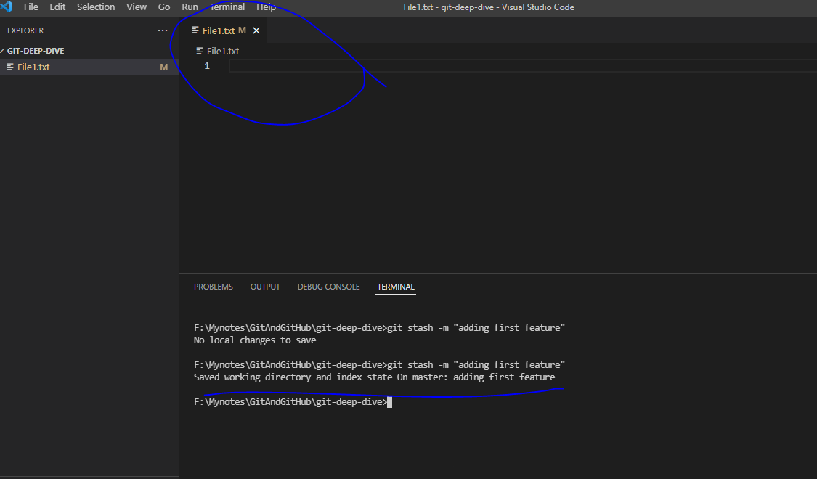

NOTE that the changes what we did those are stashed and file is come back to initial state.

Now list the stash

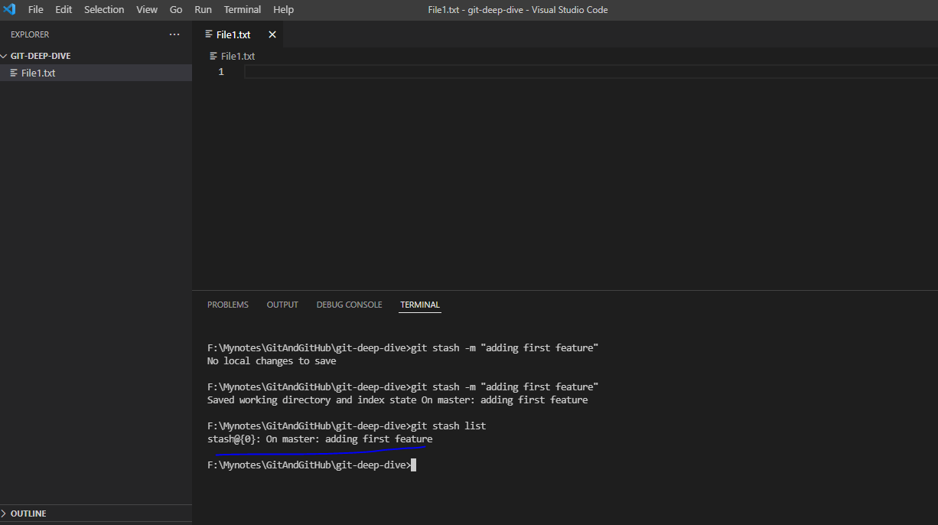

Bring back those changes to main file

“git stash apply 0 (here 0 mean version no of stash)

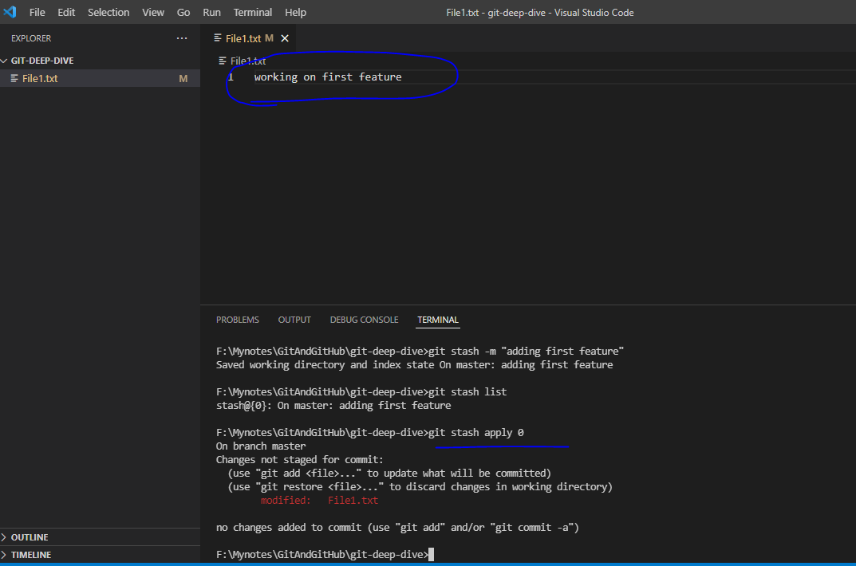

Command to clear stash: git stash clear

Command to drop particular stash version: git stash drop {version_number}

Bring back lost data

Scenario: Let say you have reverted your file using hard reset and somehow file get deleted and now you are expecting that file again then how do u bring it back?

Ex: Now added new file called File2.txt and added it to staging and committed this file.

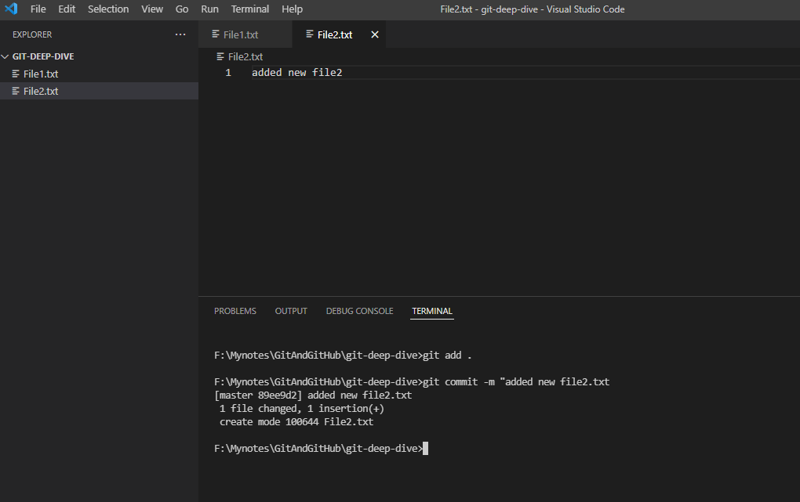

Now revert back this file using hard reset command

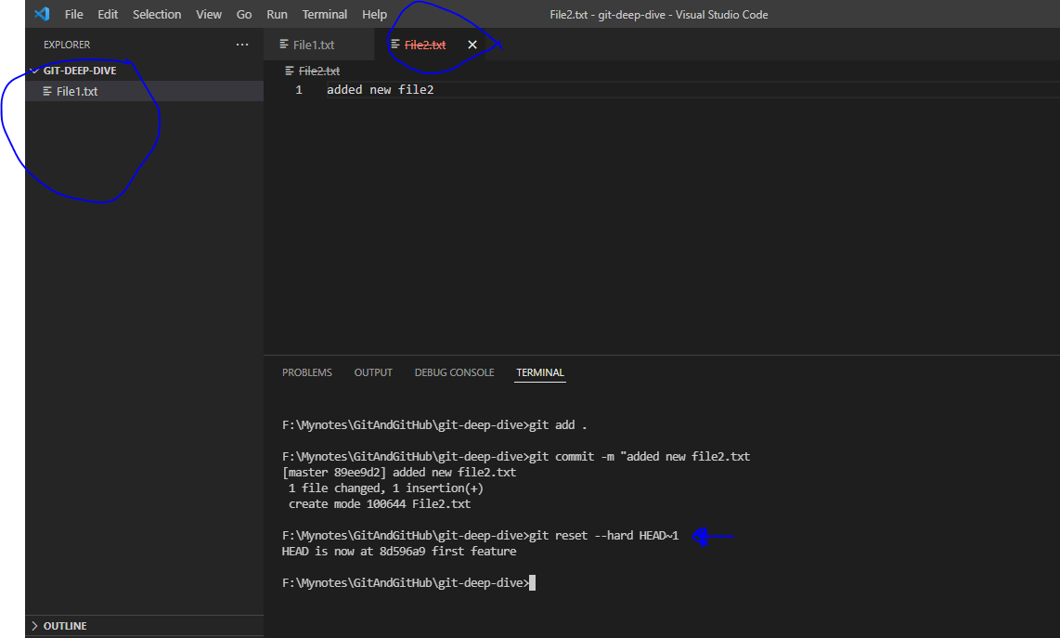

Note that File2.txt is got deleted as we have reset our working directory to intial commit

Now we have to bring back those commit:

Run “git reflog” to list out all commit history and find your commit and reset

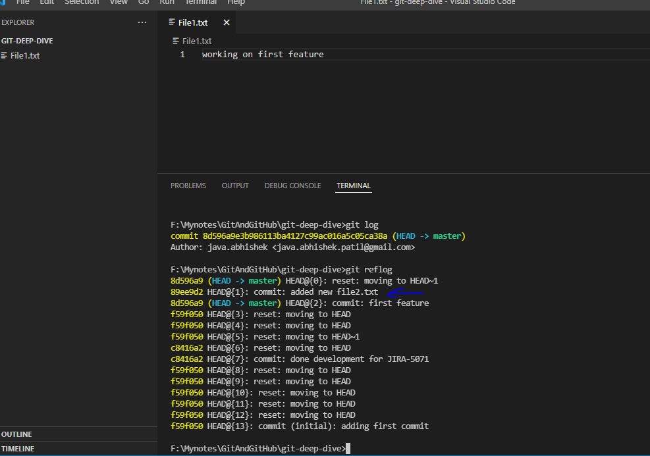

Reset commit back using

“git reset –hard {hash_value}

Ex: git reset –hard 89ee9d2

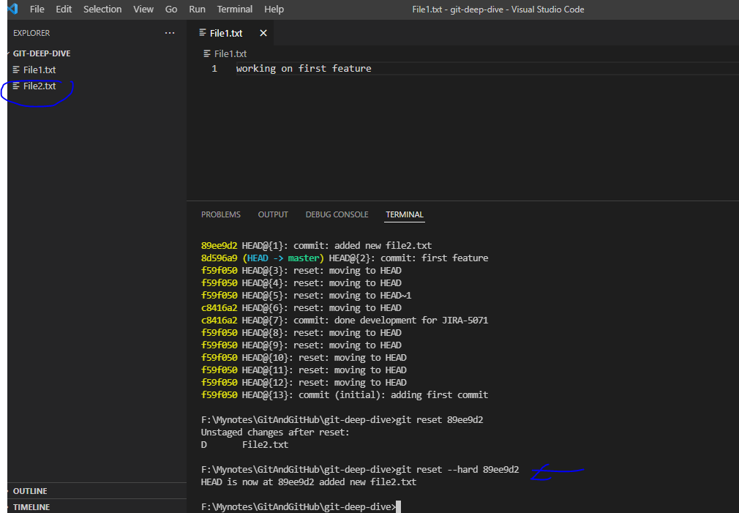

Merge Type

Fast-forward merge:

It means, Let say you have create master branch and having commit-1, commit-2 on File1.txt. After these commit you branch called “feature” from master branch to develop one small enhancement. Now have commit-3, and commit-4 on File1.txt in “feature” branch but still you don’t have any changes in master branch in that File1.txt file. In this user can easily merge “feature” branch code into master file as there will not be any conflicts as no changes has been done in “master” branch.

Ex:

Develop a branch

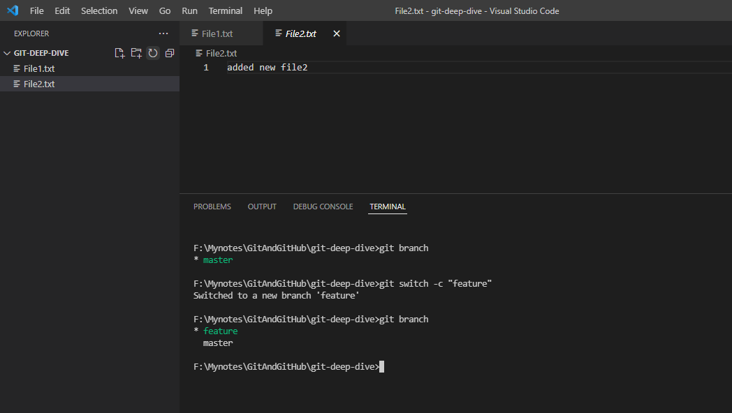

Now made some changes in File2.txt

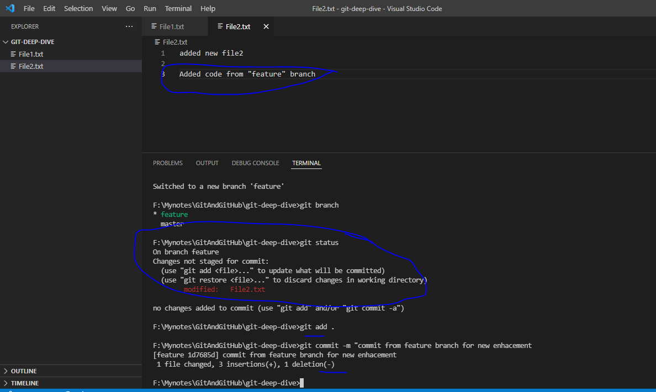

Check the log of “feature” branch

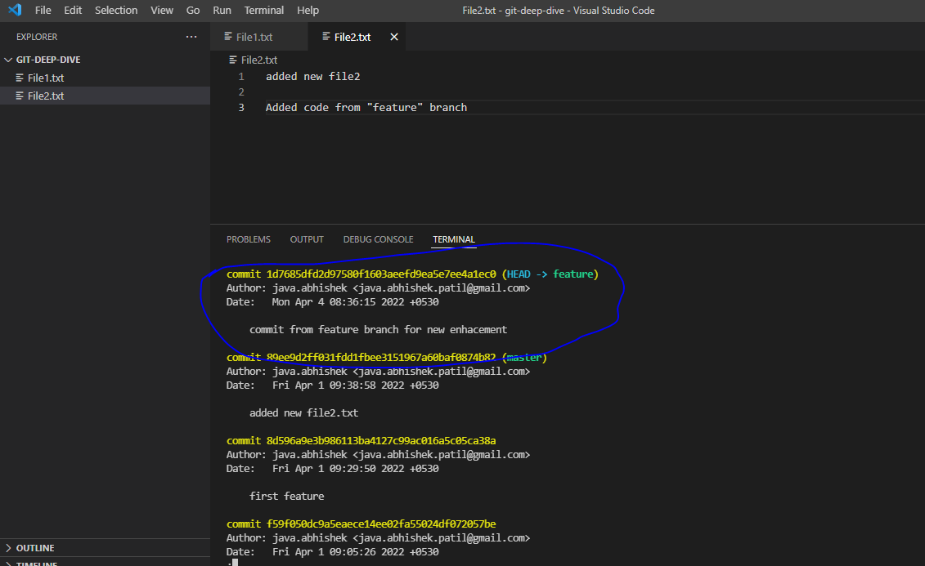

Switch to master branch and merge the changes directly from feature branch

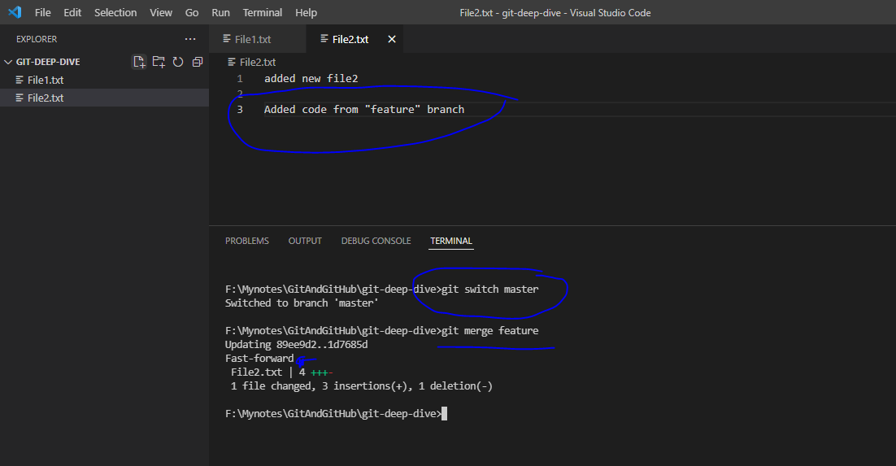

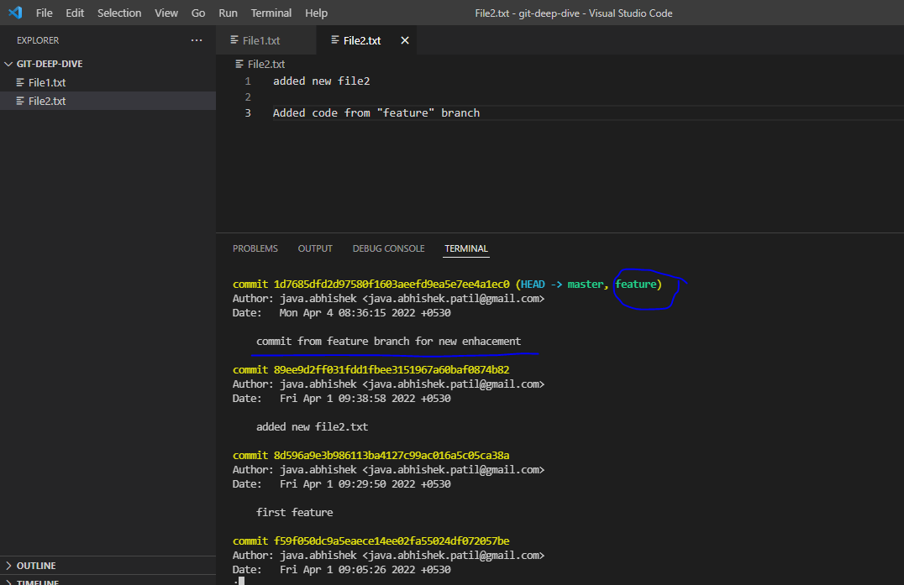

NOTE that on fast-forward merge *no new commit is created* as it is directly forward the head of feature branch.

What if we want to make a commit of all “feature” branch all changes? Or what is –squash option with merge command.

Ex: created new branch called “feature” and create a new folder called feature and new files f1.txt and f2.txt under it. And added and submit those changes to the feature branch.

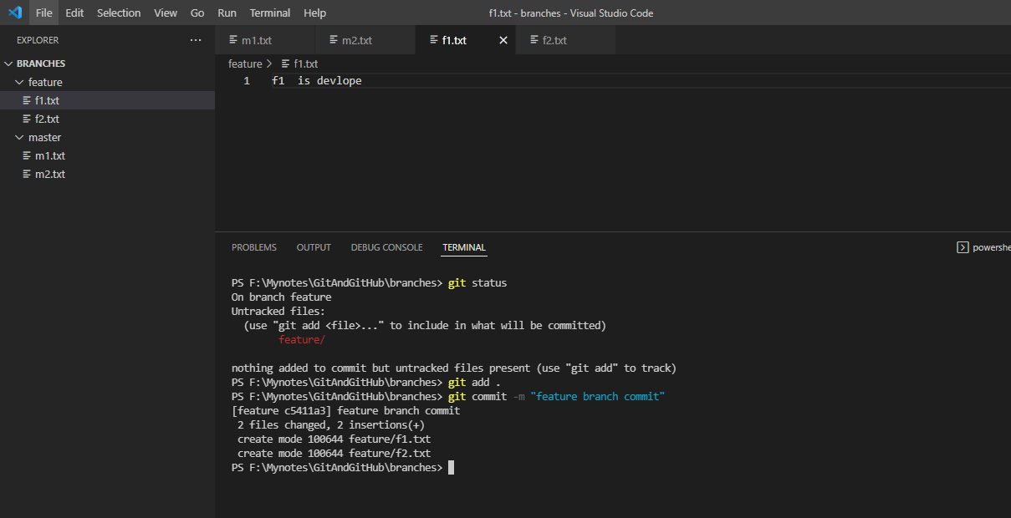

Now switch to the master branch and using merge changes with “git merge –squash {branch_name}

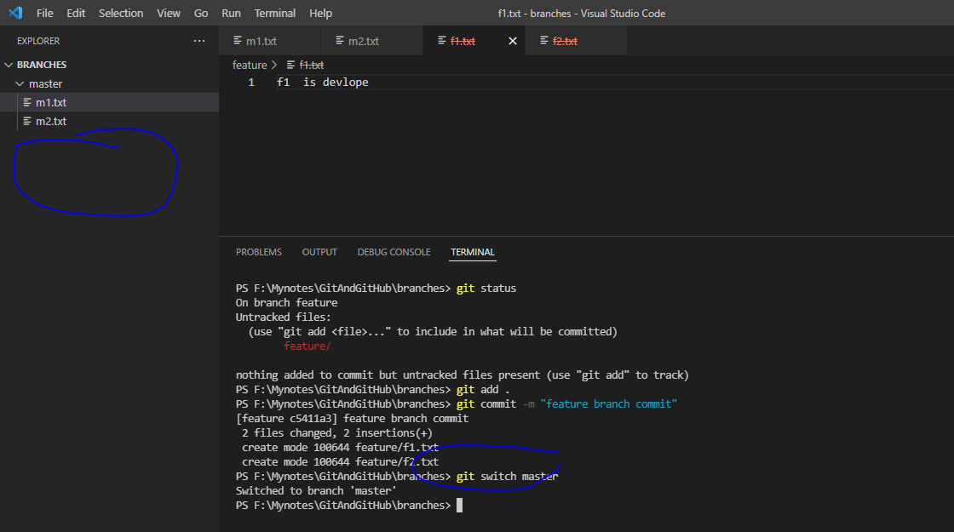

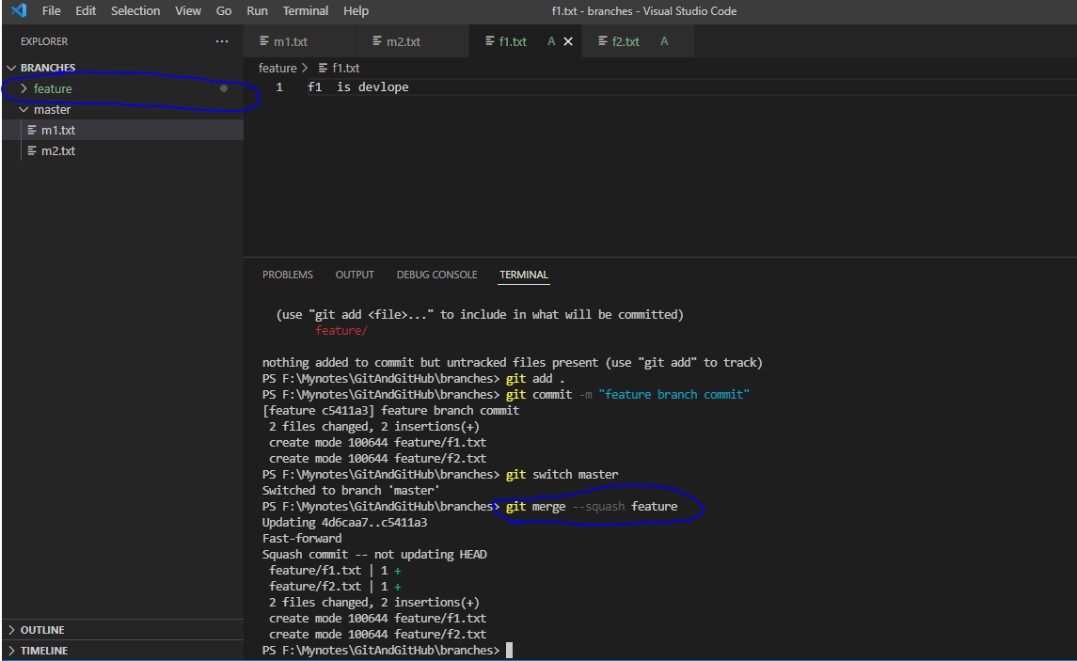

Check status in master branch, will see the merged changes from feature branch will not committed in master branch directly

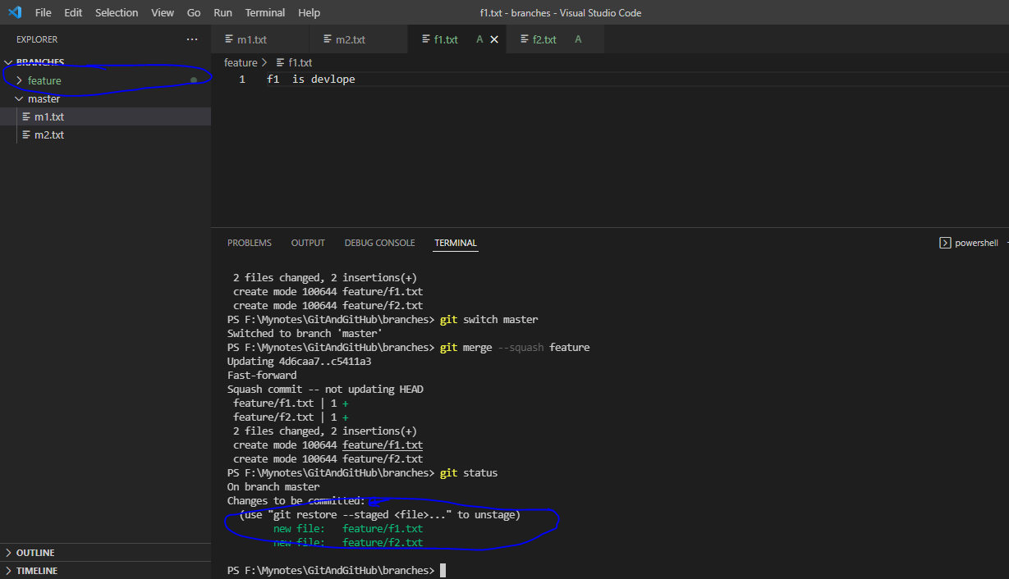

So now you can submit those changes in master branch as a single commit.

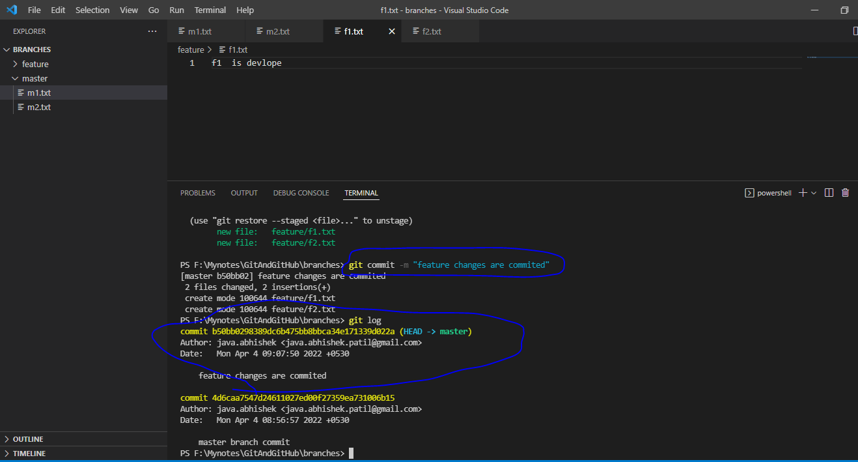

Note here that only single commit is created in master branch.

Now for practice sake just revert those changes using

“git reset –hard HEAD~1

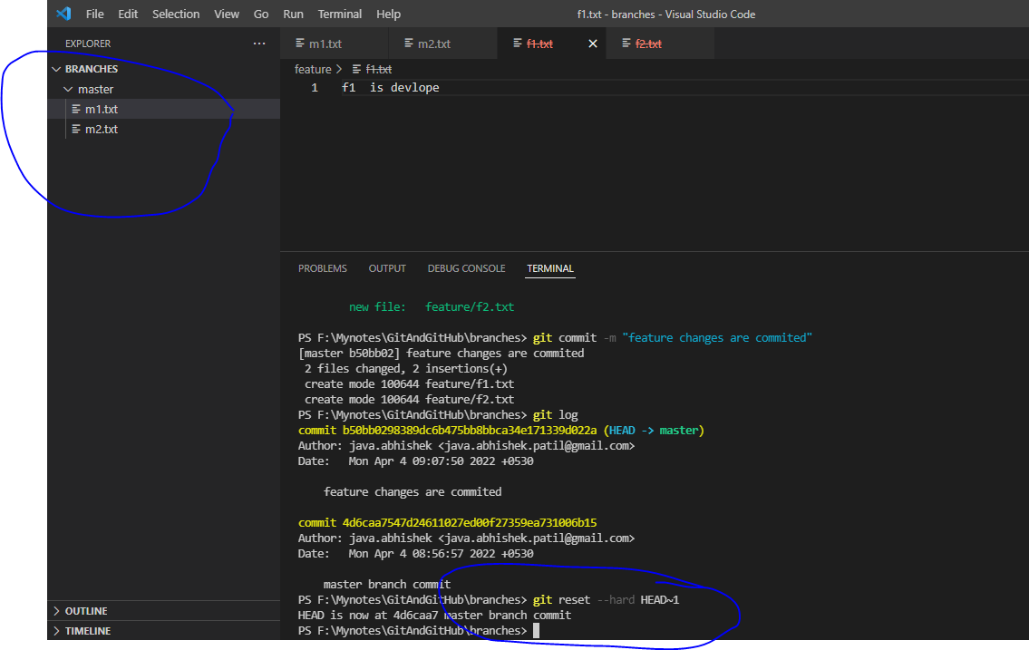

Recursive merge:

Scenario: Let say u have master and feature branch, and while developing feature in feature branch simultaneously made changes in master branch, then user can use this option. With this option feature branch all commit history will be merged into master branch

Command:

git merge no-ff {branch_name}

OR

“git merge {branch_name} >> Git will apply automatically recursive merge.

Ex;

Feature branch:

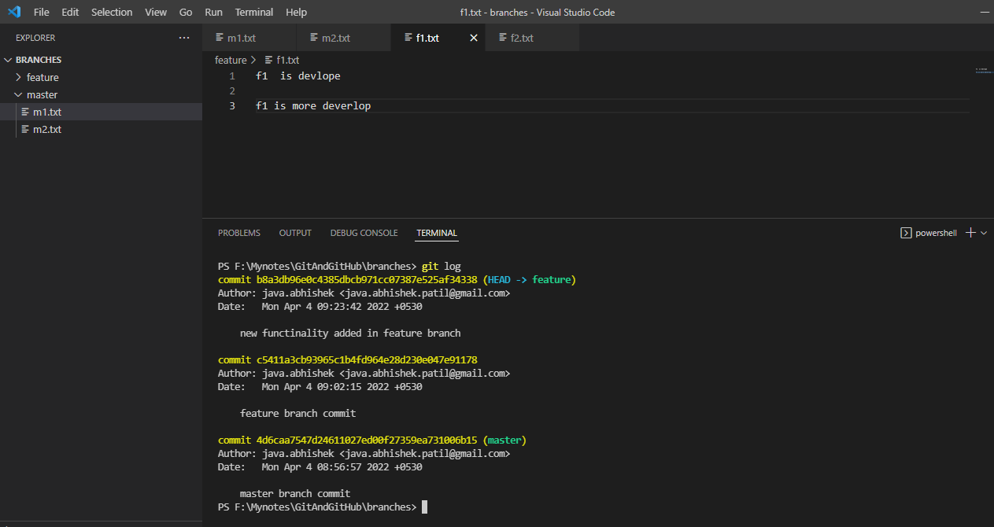

Meanwhile master branch:

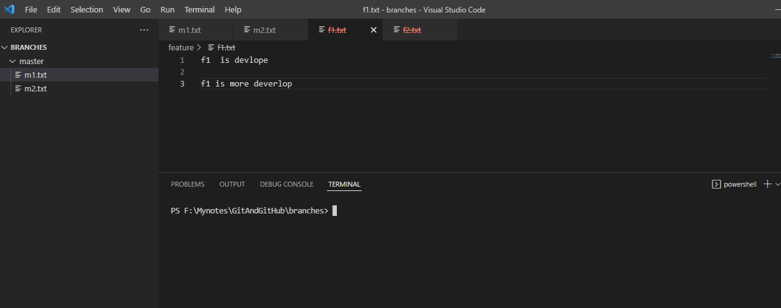

Add new file in the master branch and commit it

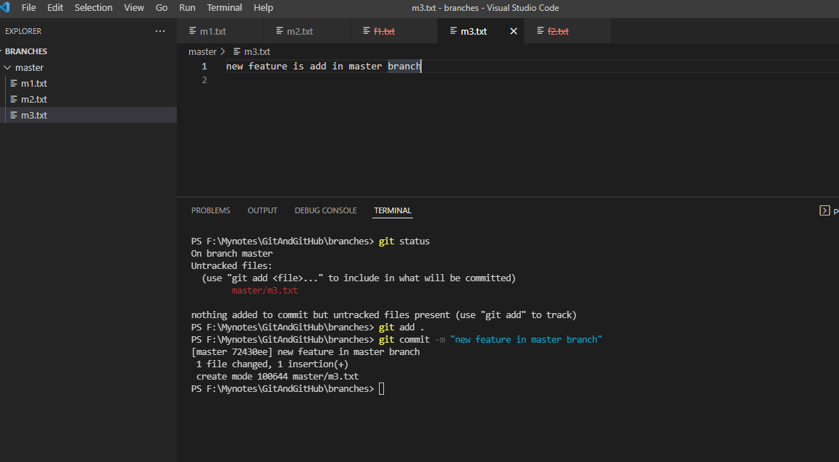

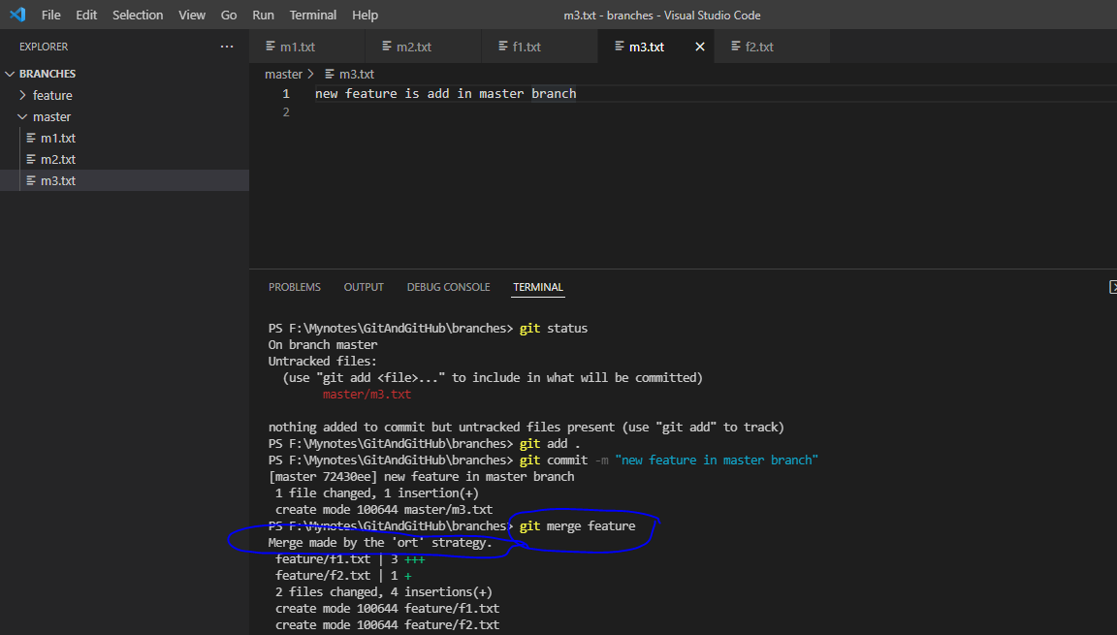

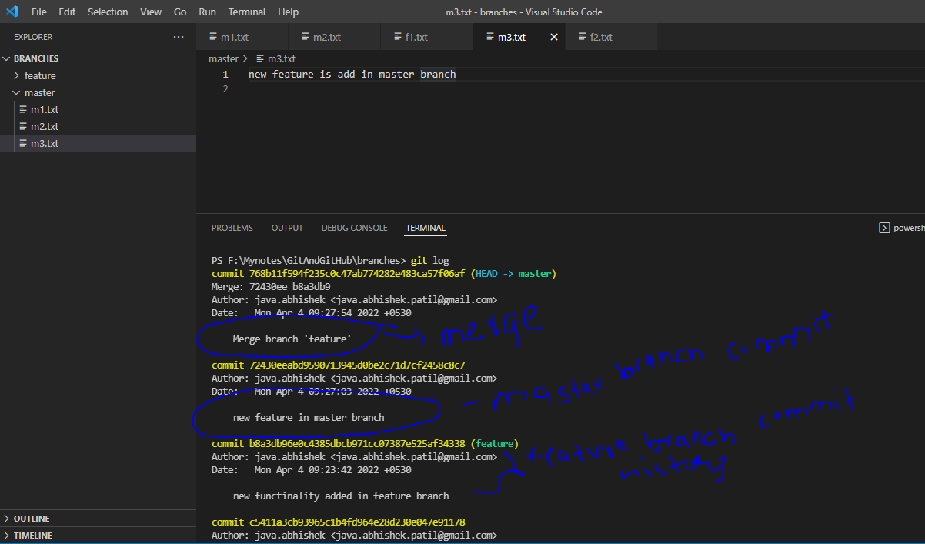

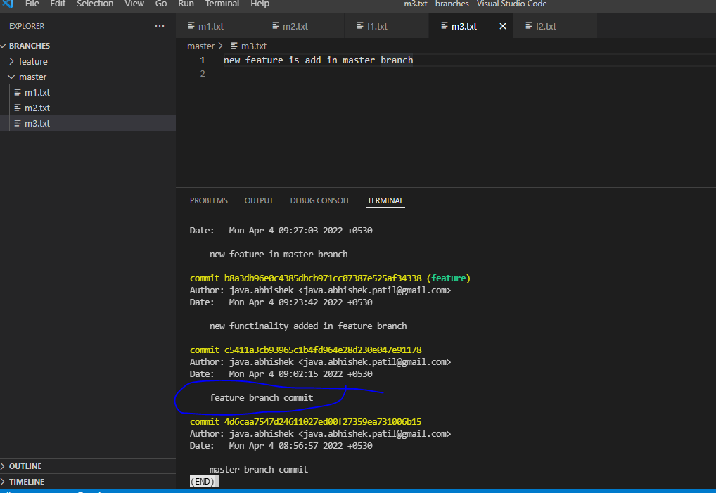

Rebase: Not recommend to use, it is creating new commits

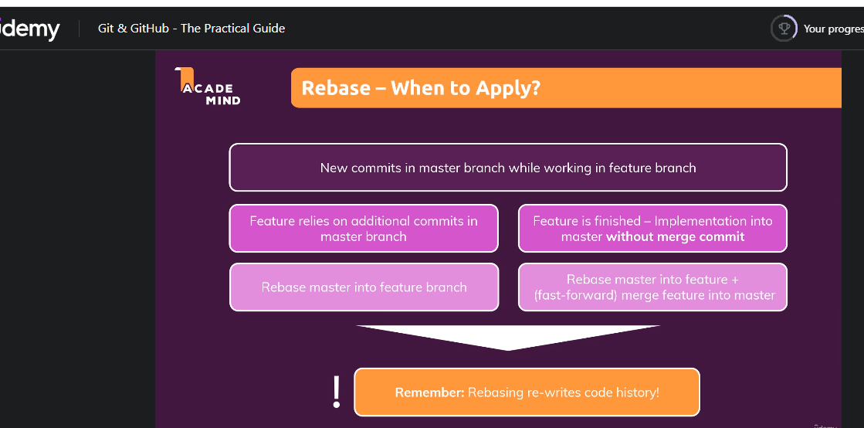

Conflicts:

Conflicts occurs during the merge

Example:

Let’s make changes in m1.txt file in master branch and commit it

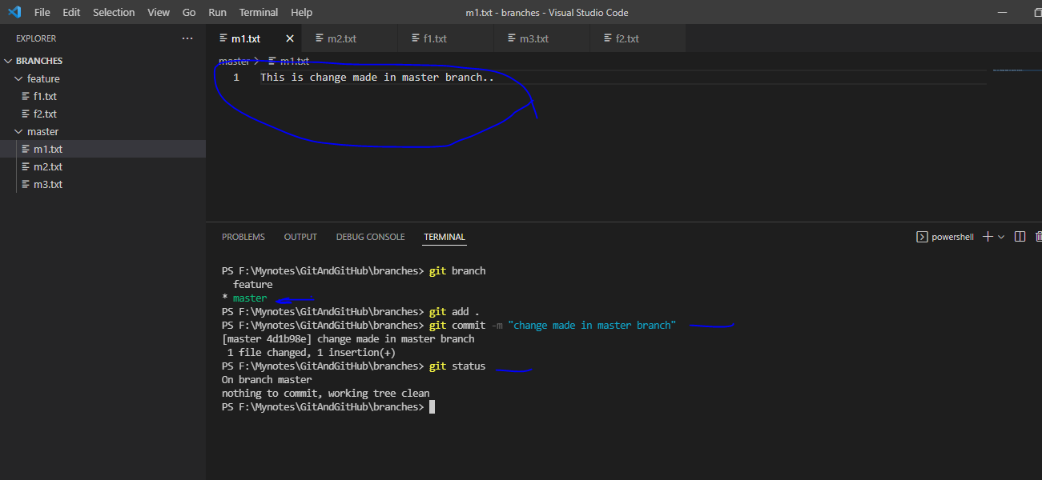

Now switch to feature branch and make some other changes in same file at same line and commit those changes in feature branch.

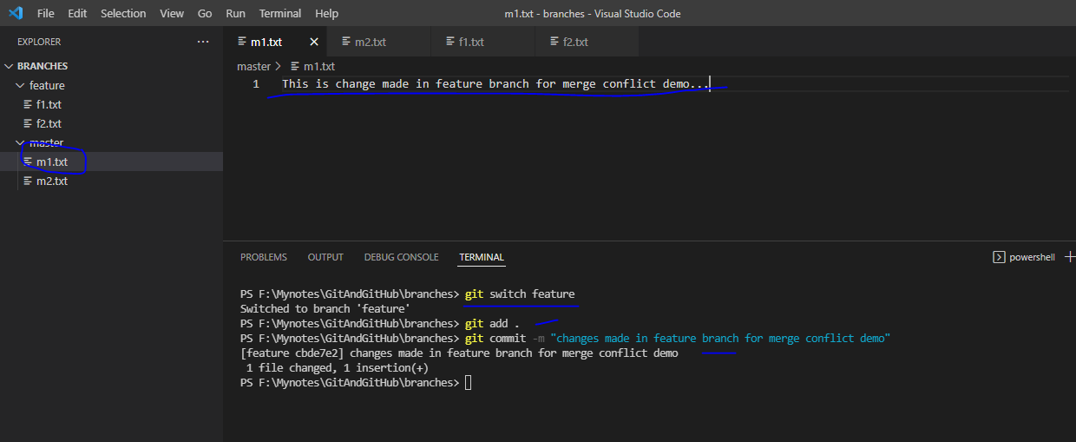

SO far so good, now merge feature branch into master branch

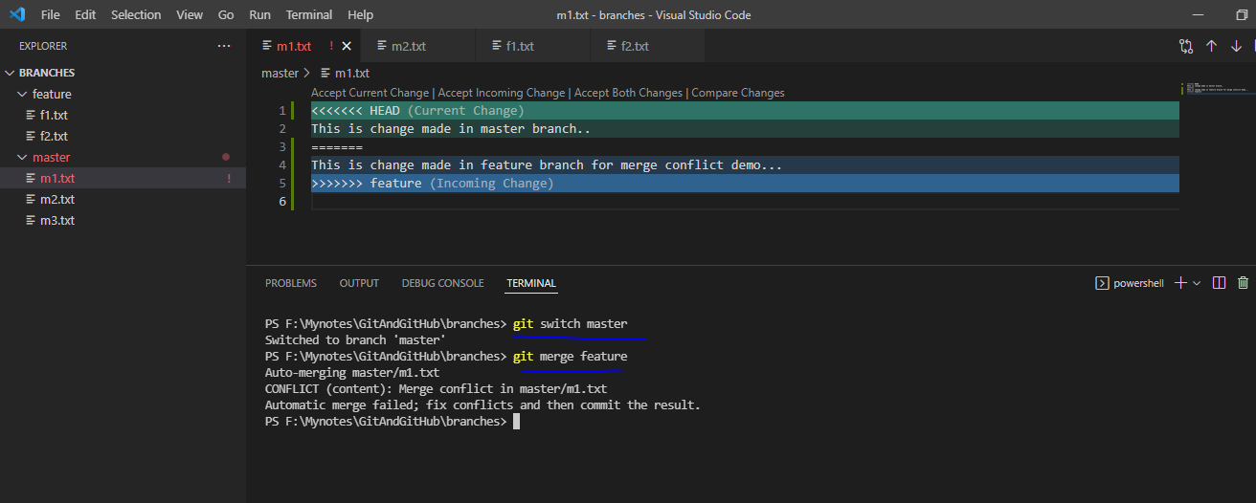

Here is the conflict

Q. How to resolve it.

To resolve this conflict one can use “Accept current changes” OR “Accept Incoming changes” … options from above

Just check git status:

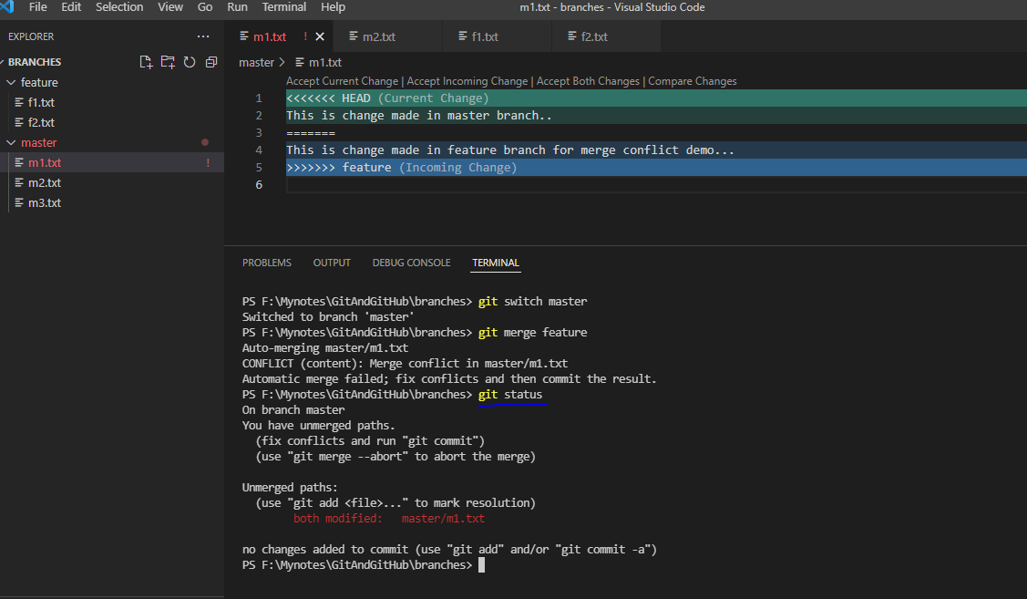

Resolve conflict by accept both changes

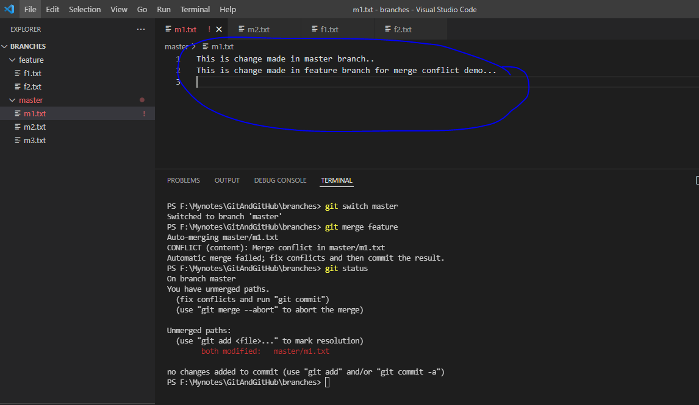

Abort the merge using git merge --abort

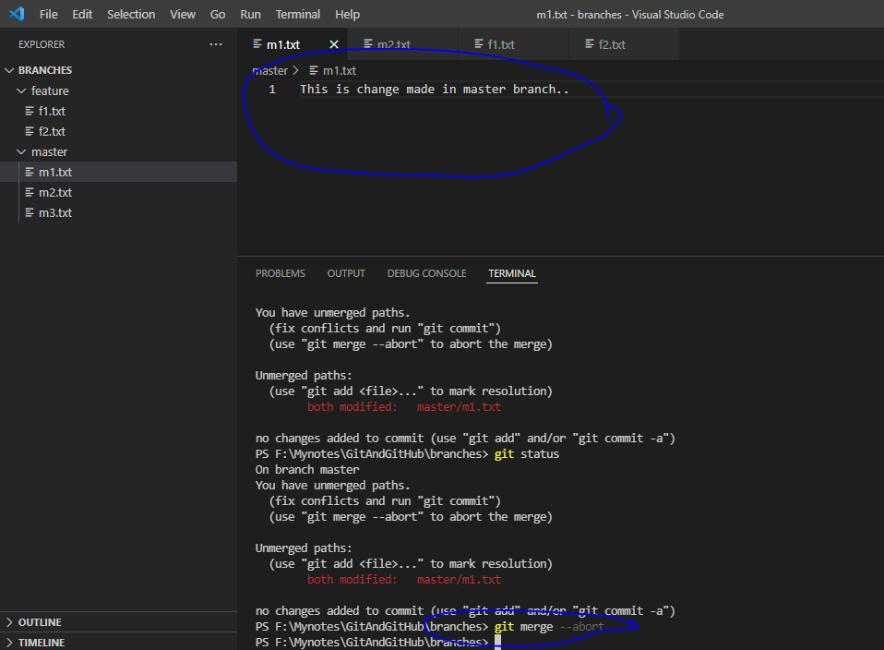

Now for demo sake, merge again resolve conflict with “Accept both changes” and commit the file

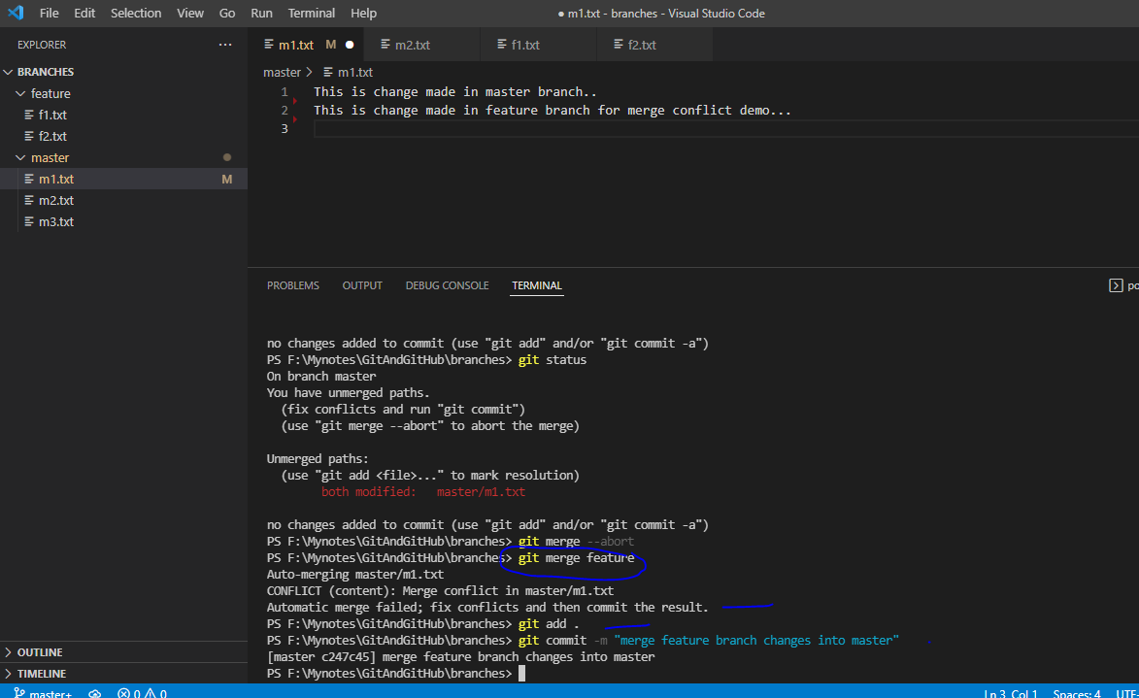

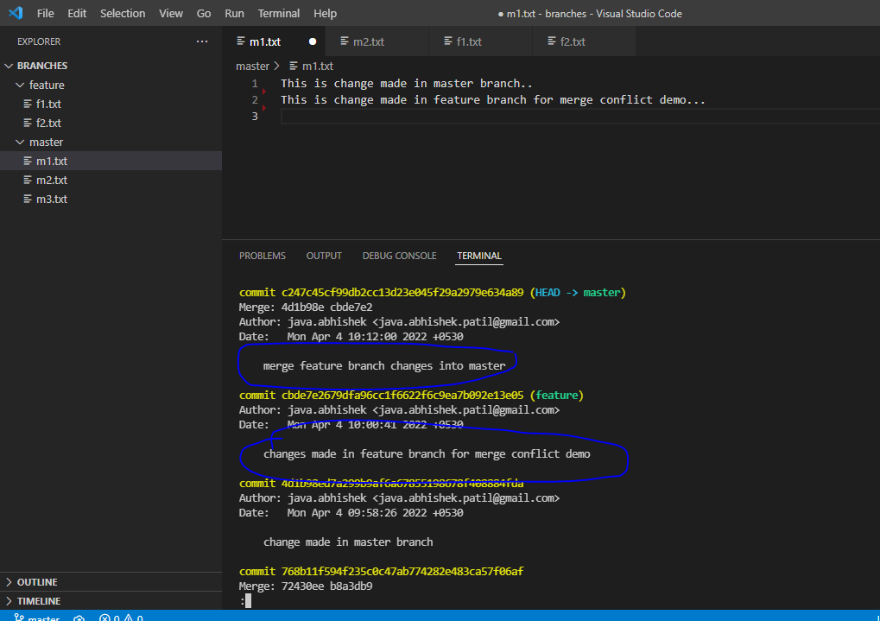

Cherry-pick:

When to use: When you have to merge specific commit, in simple merge all files are got merged.

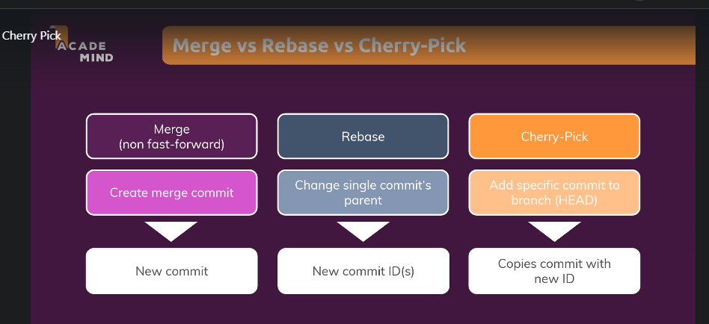

Ex: Modify m2.txt file with some typo and commit it after committing create new branch called feature-2 and add new files into it and commit those changes. Now make typo correct into m2.txt in feature-2 branch after correcting typo commit the change

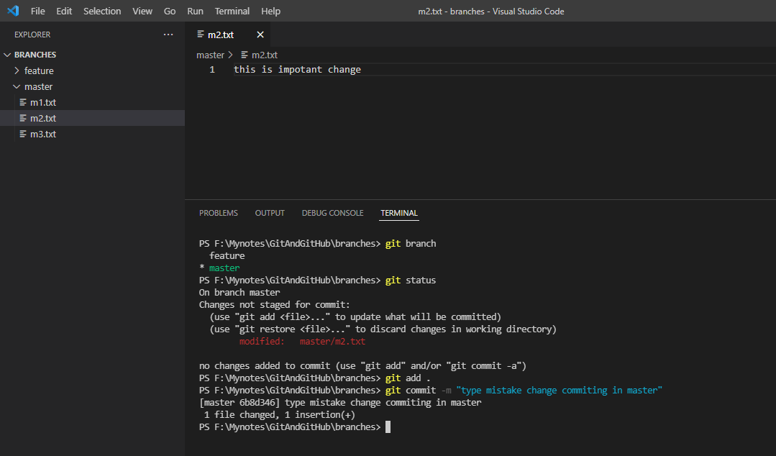

Created new branch and add folder and file now commit it

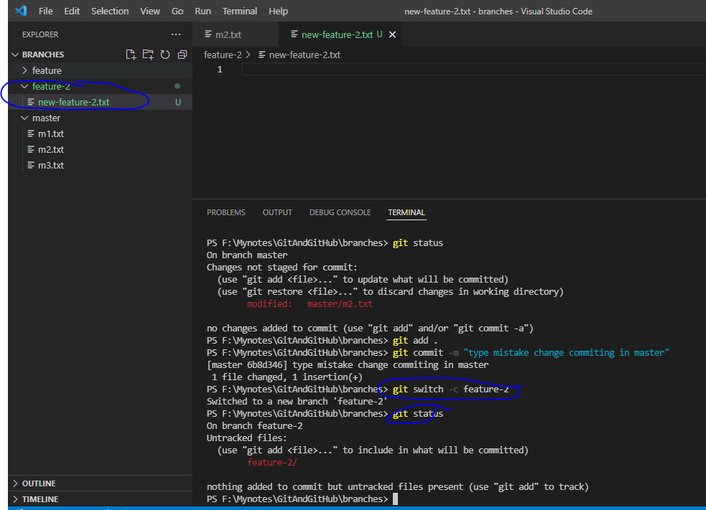

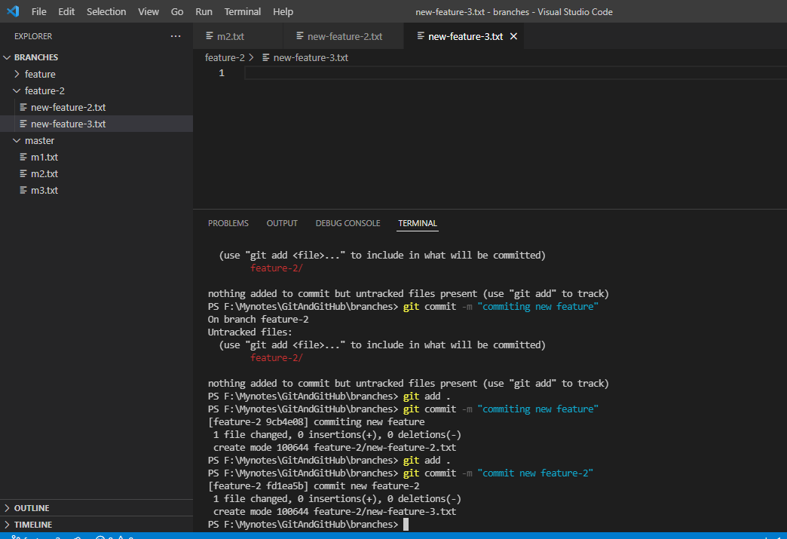

Now correct the typo:

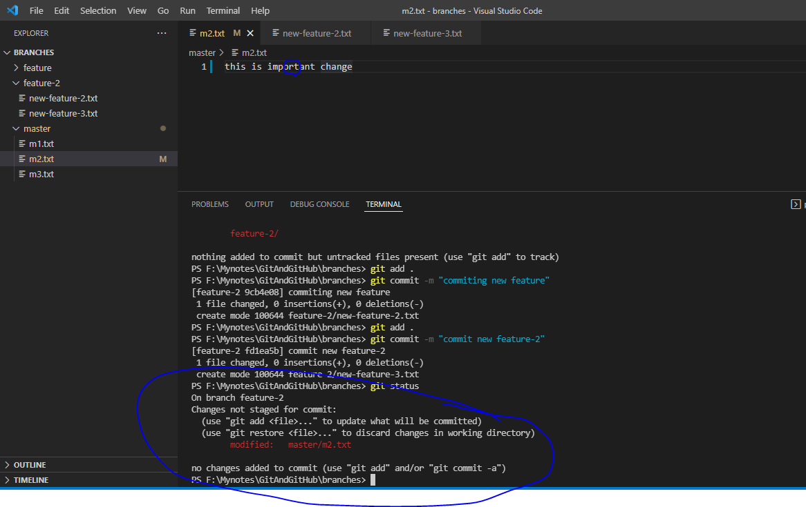

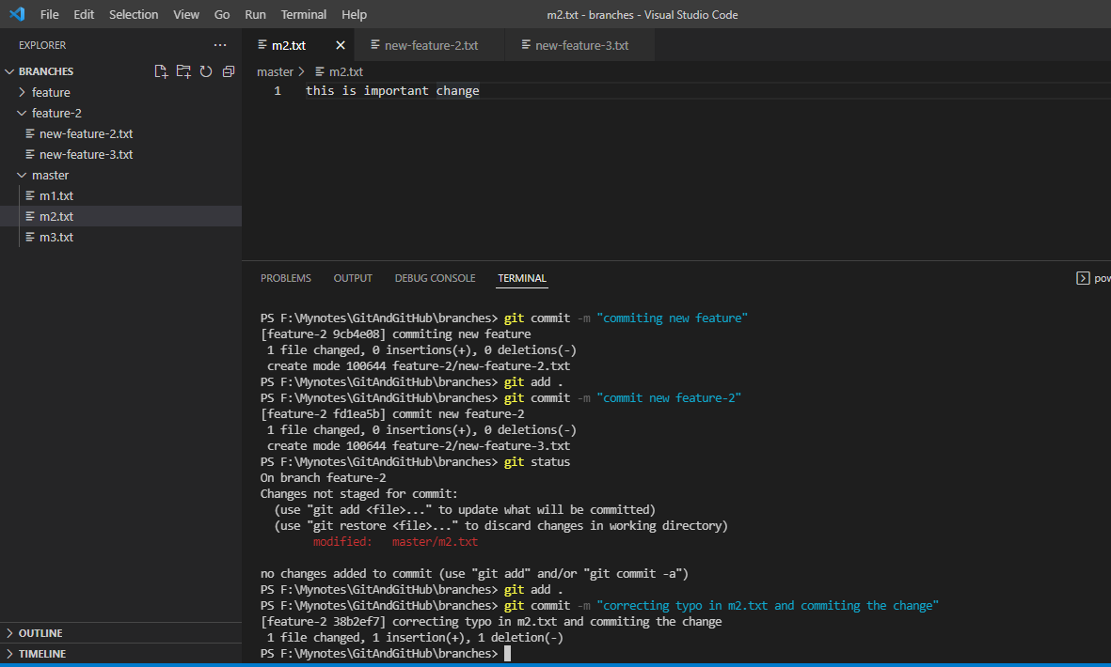

Now have to only highlighted commit to the main/master branch

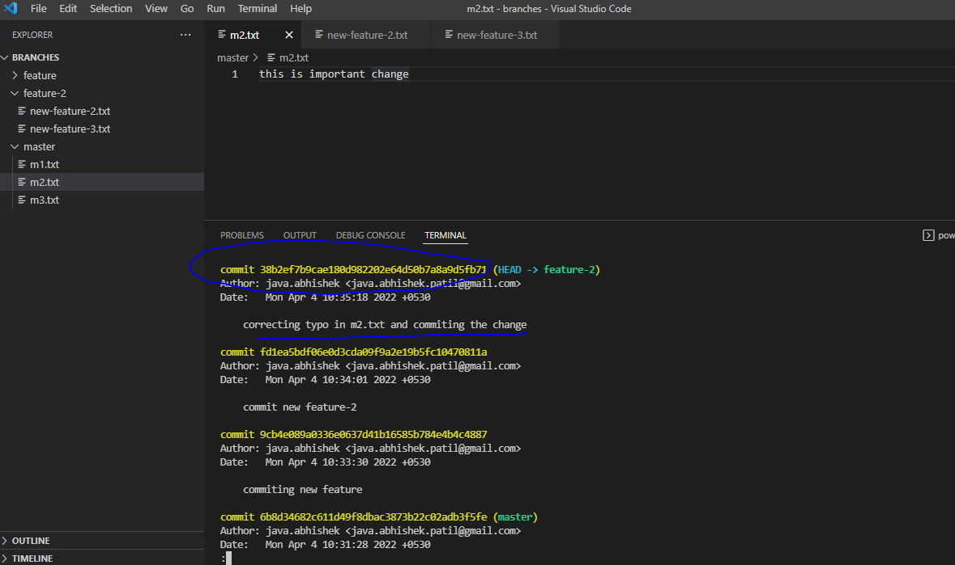

Switch back to master branch and use below command:

“get cherry-pick {commit_id}

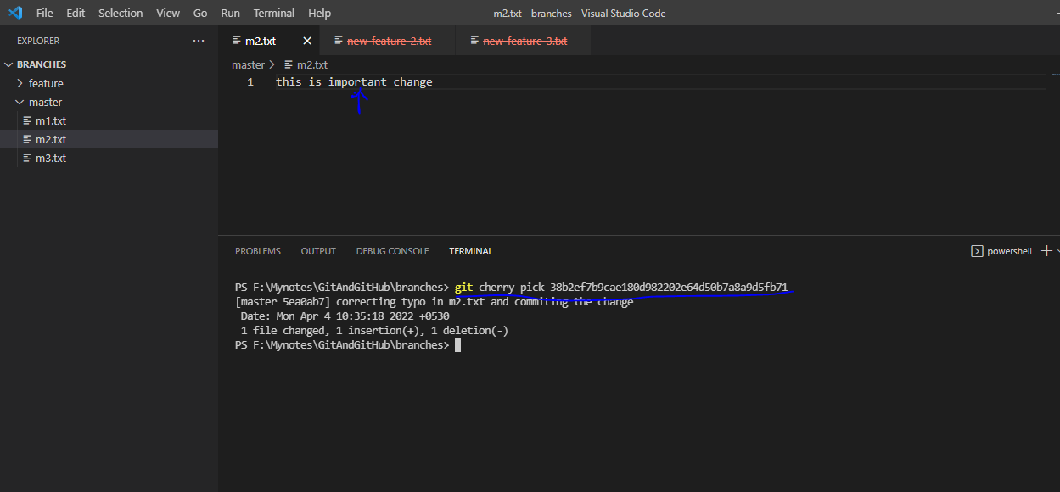

Note that no other file is got merged

Now log the changes

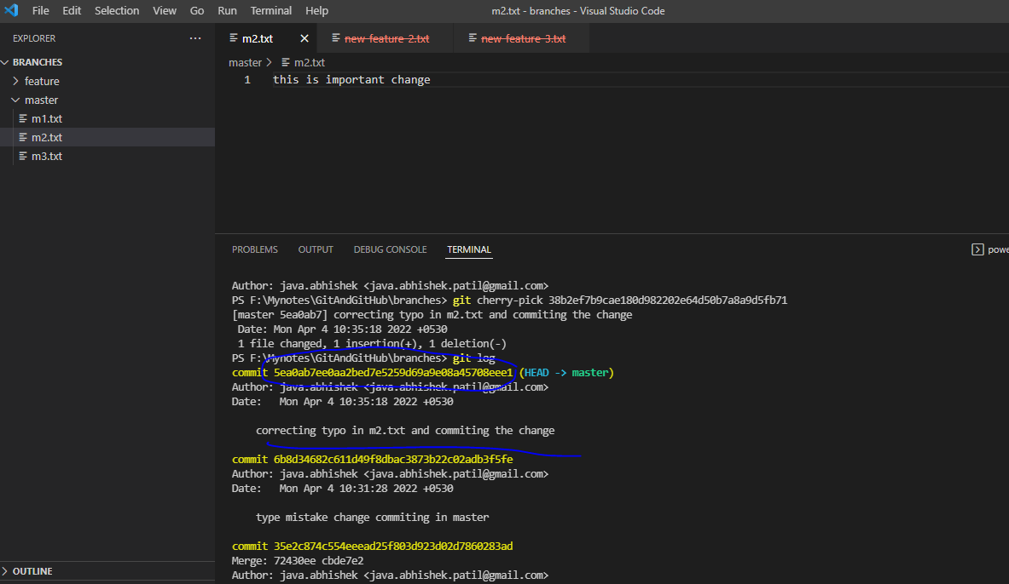

Note that new hash is get created.

Now check if same hash is present in the feature-2 branch

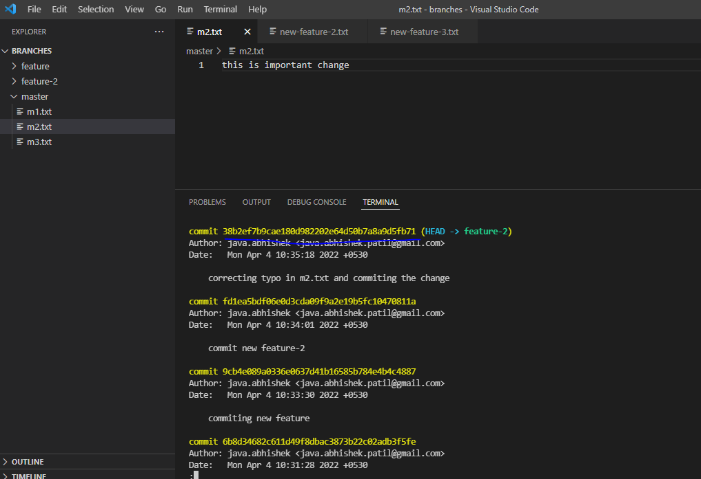

No hash code got changed

Working with tags

Concept: tag comes into picture when we have release, like you have xyz project and you have first release, once you done with first release then tag the code with “release-1”. Once first tag is done then start working on same code till next release date. As soon as release-2 development is finish then tag the code with “release-2”.

Example:

Adding and committing 3 files in the workspace.

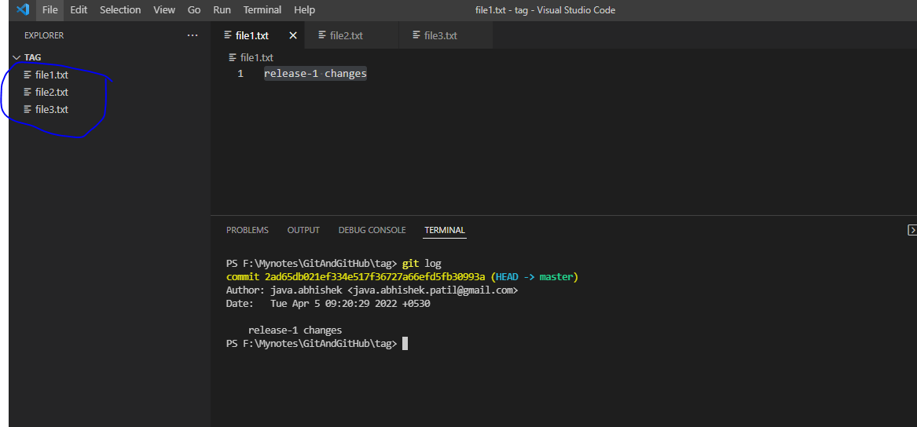

New command:

List all files in the specific commit OR if you want to get the list of all files in a commit, you can use

>> git ls-tree –name-only –r {commit-hash}

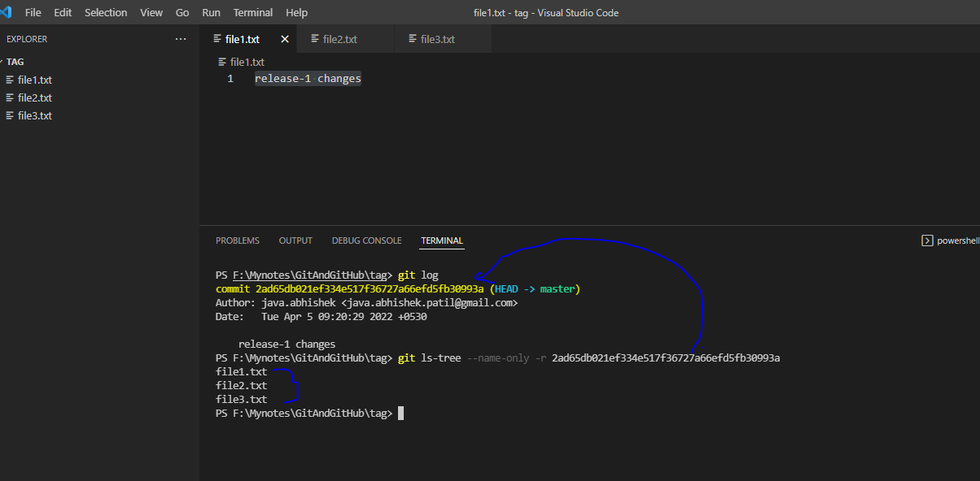

Now tag the changes with “release-1”

Check any tag is present?

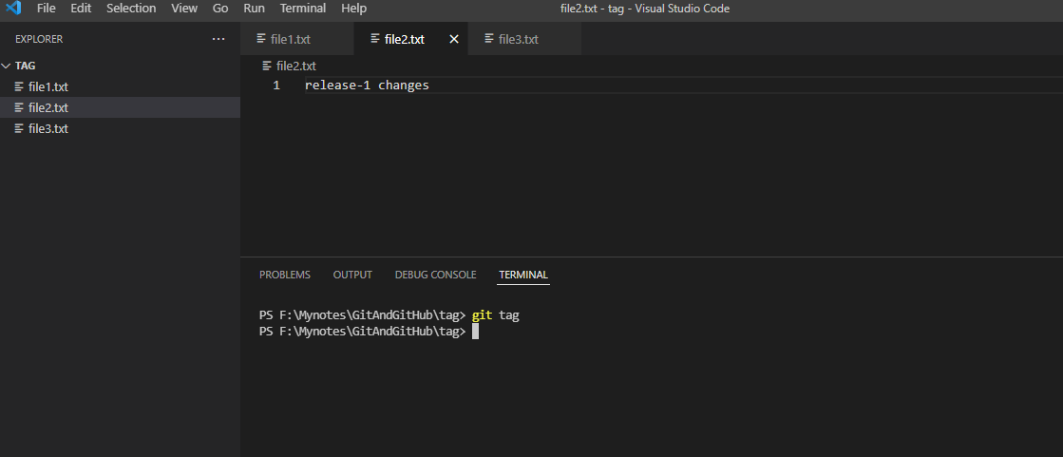

Create a tag with “git tag –a {tag_name} –m “{message}”

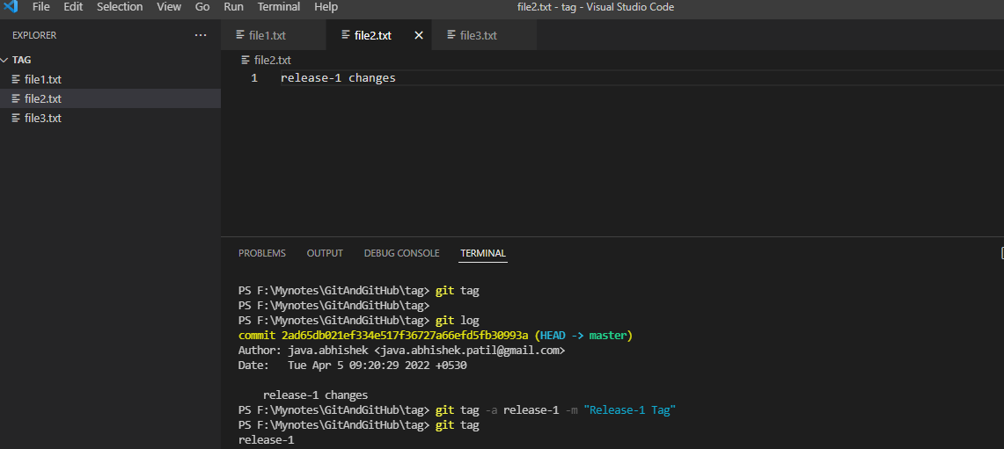

To list out tag we can use “git tag” command or “git show {tag_name}

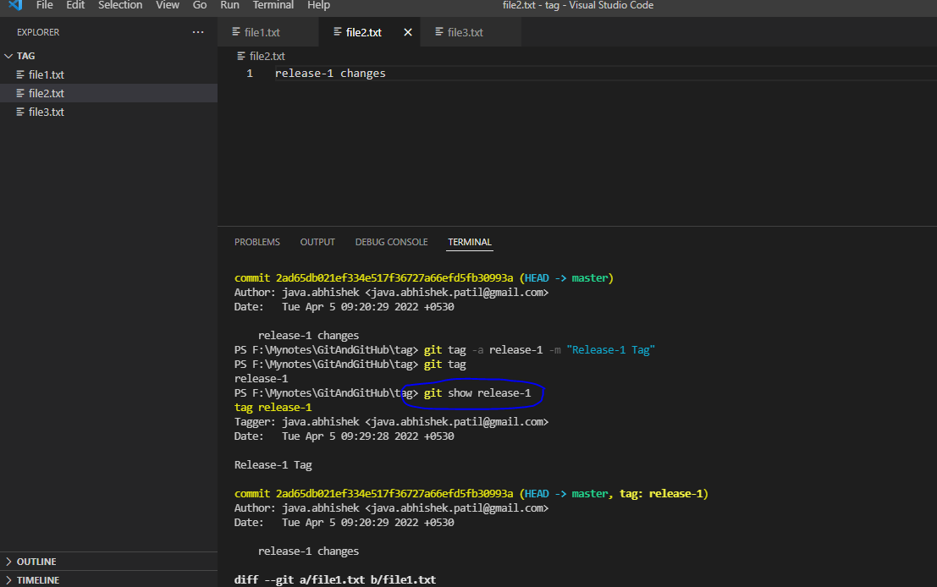

git show {tag_name} : It will display all details in that tag , like what are the files and all these kind of stuff.

Now let’s make changes regarding “release-2” and tag those changes with “release-2”.

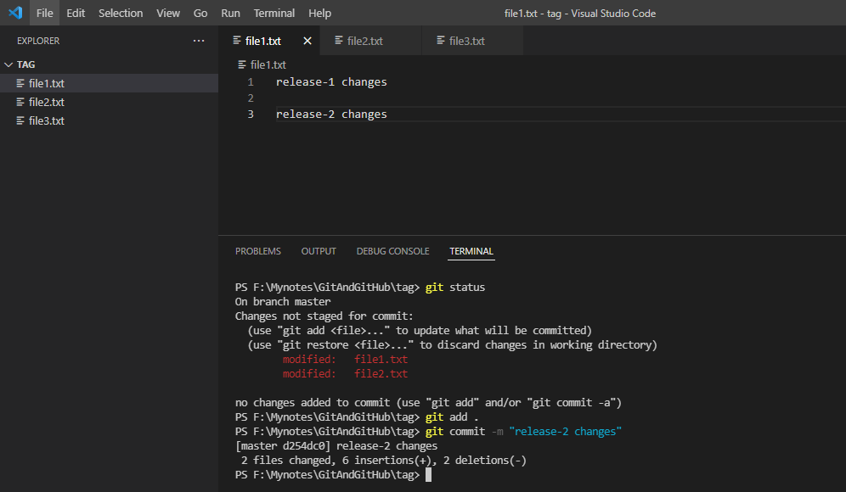

Now tag those changes and list out tags

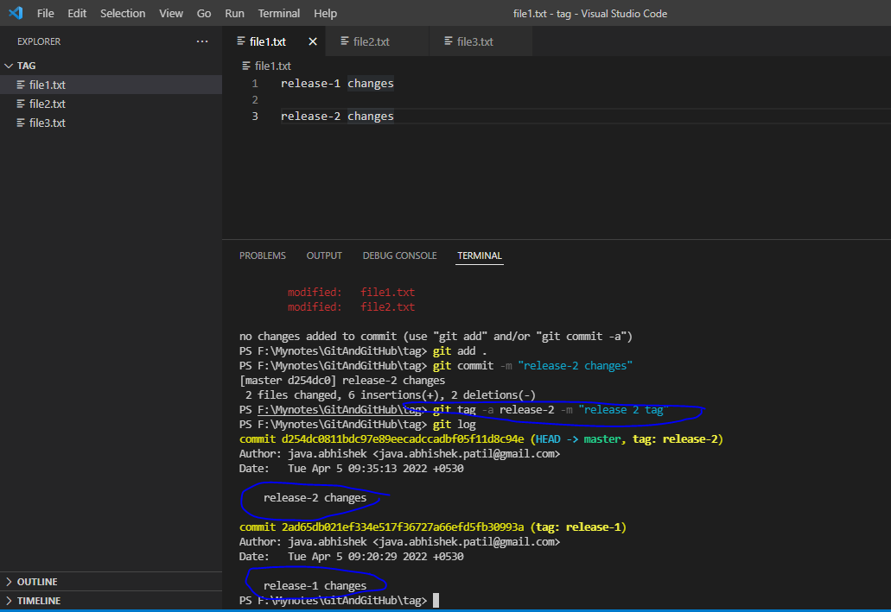

Now take a scenario, just assume on any customer environment release-1 is deployed and customer found one issue then how do we make changes in that code base and release those changes as release-1_.1.Hot_fix.

>> So in this case we have to check release-1 tag in separate branch and have to make changes in that branch. Once we done with those changes then release it as release-1_.1.Hot_fix.

Command: git checkout {tag_name} –b {branch_name}

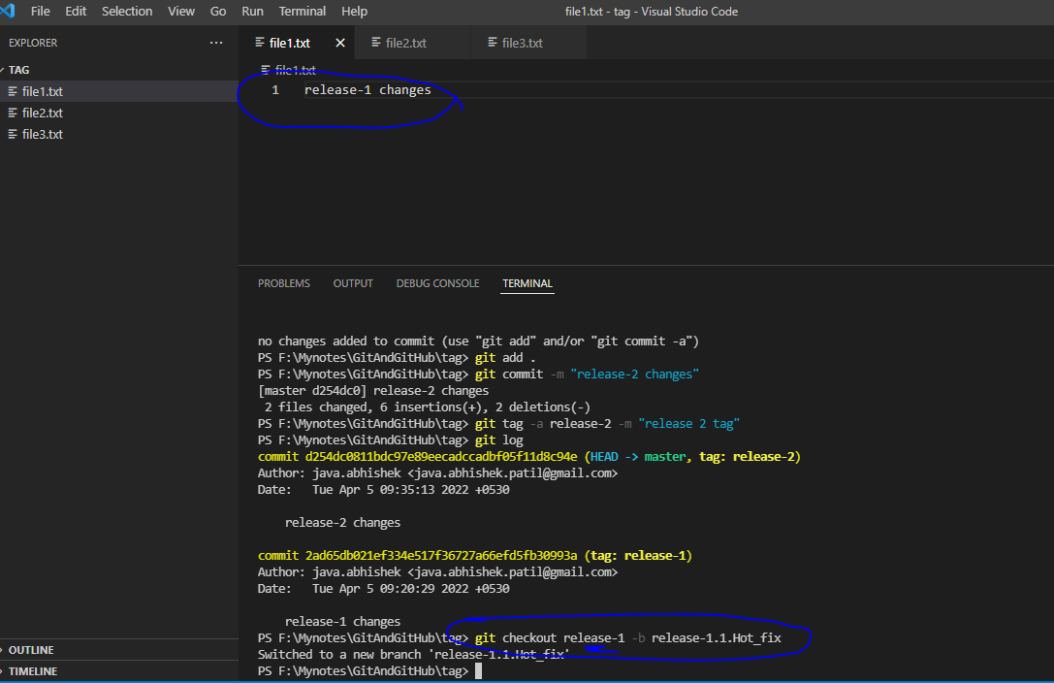

Now made some changes and committed to same branch

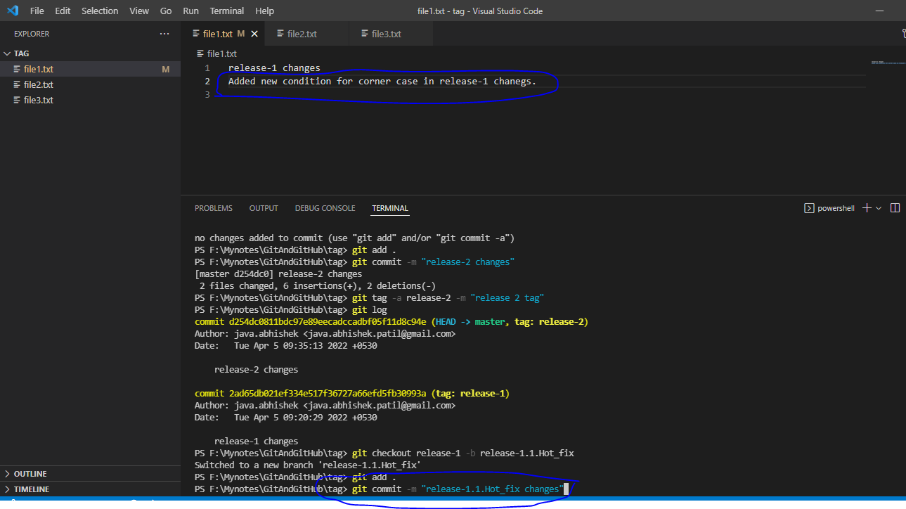

Now merge those changes to master branch

Before merge

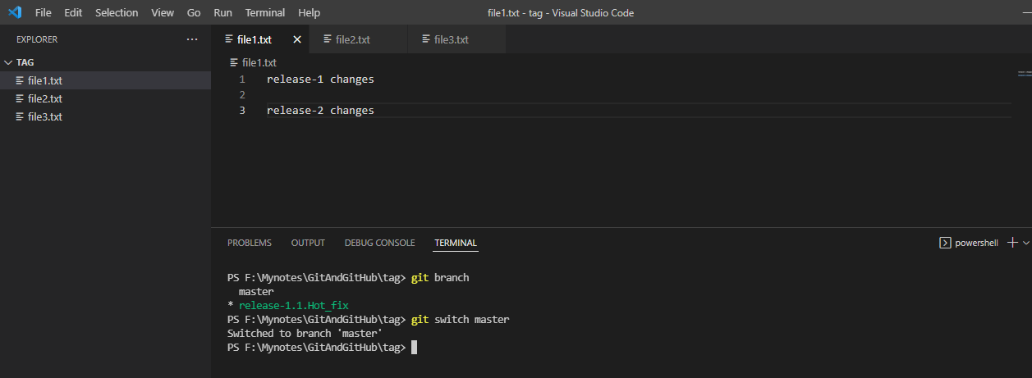

After merge

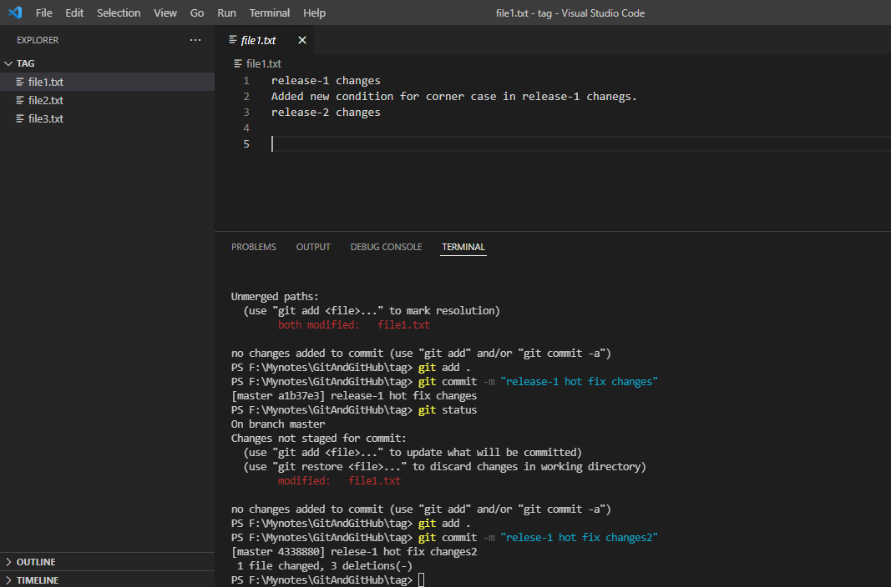

Understanding GitHub

It’s time to leave local repository, and move to remote repository.

How to connect local repo to report repo

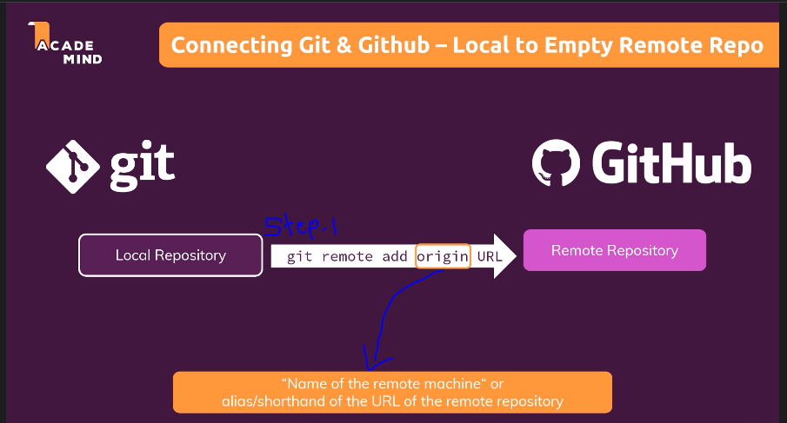

How to push local repo changes to remote repo

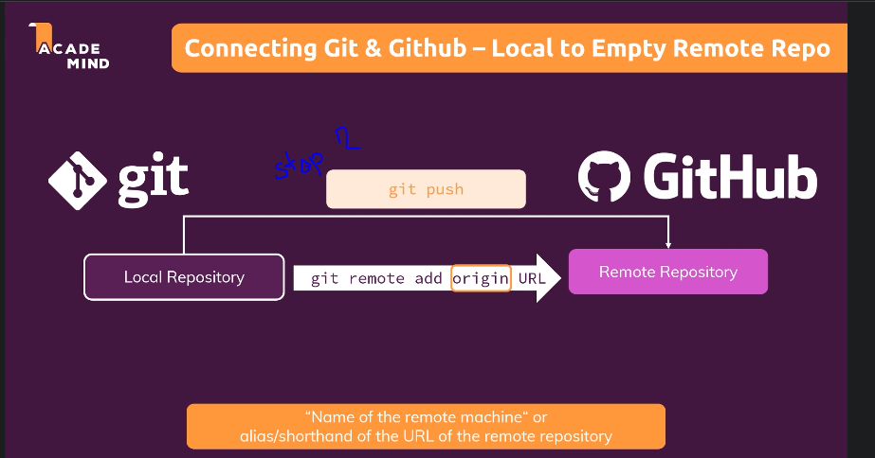

How to pull changes from remote repo to local repo

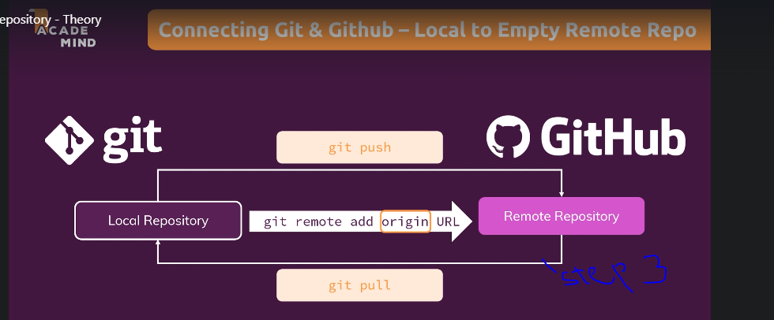

Scenario:

Let say you have a developed a one project and that project you want to push it to git hub then you have to perform below steps:

1. create new project and commit it to the local repo

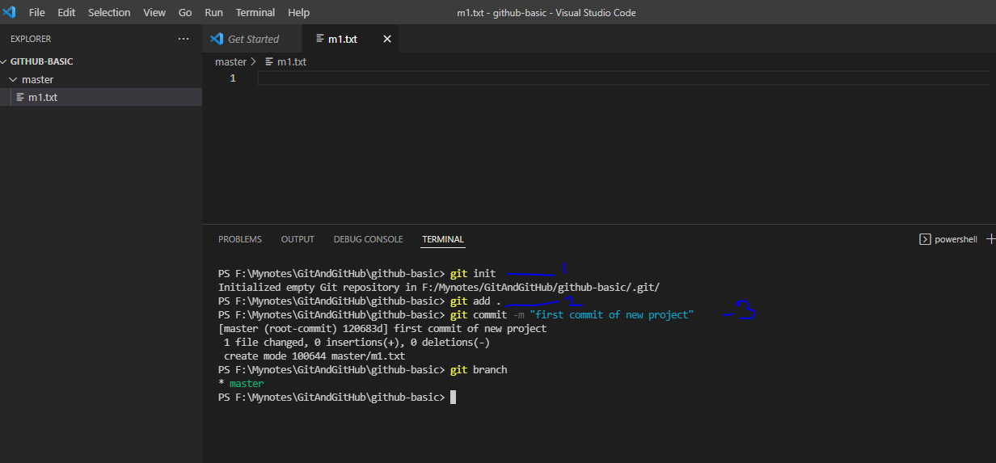

1. Login to git hub

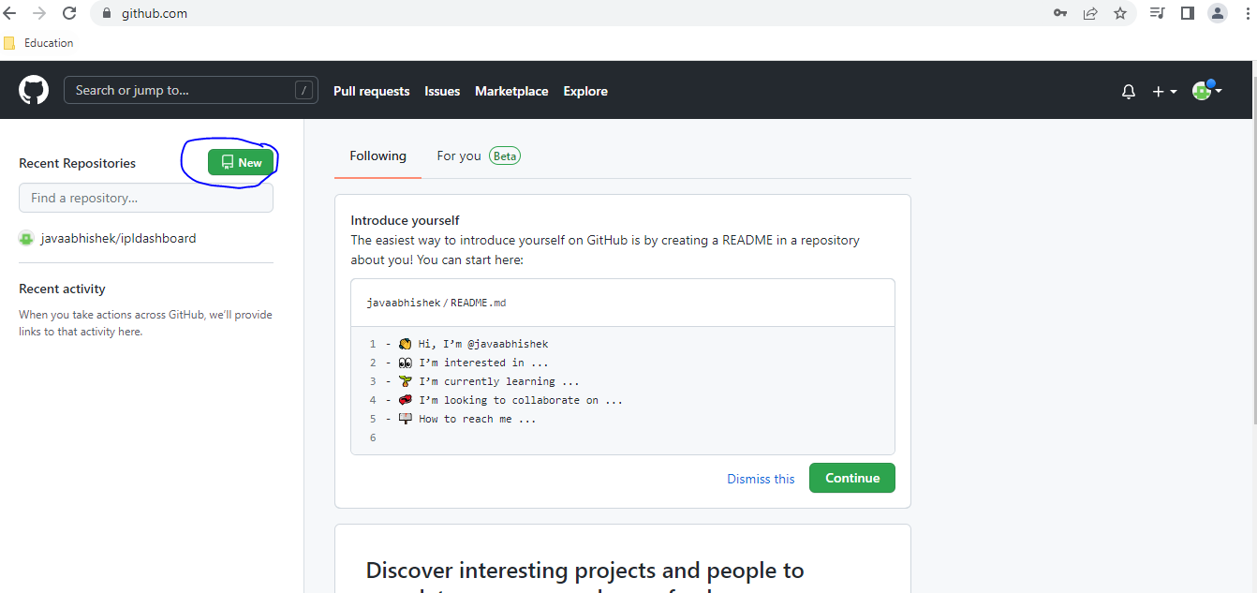

1. Create new repo with same name as local repo name like in our case “github-basic”

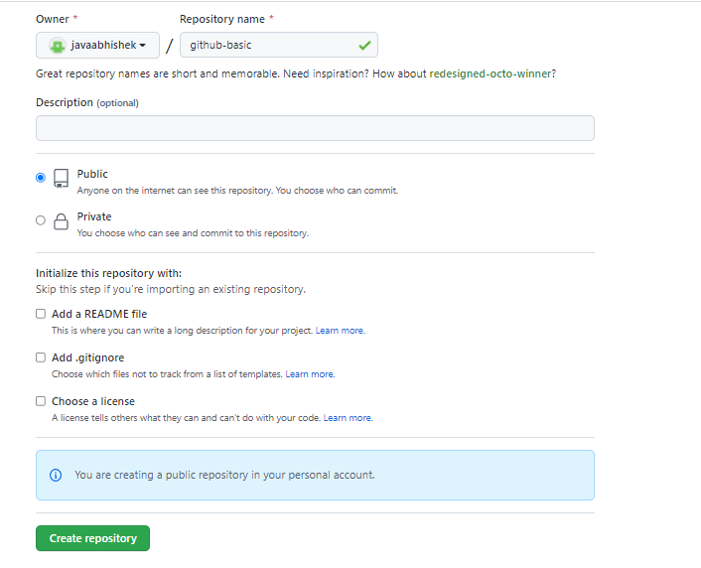

You will get redirected to below page

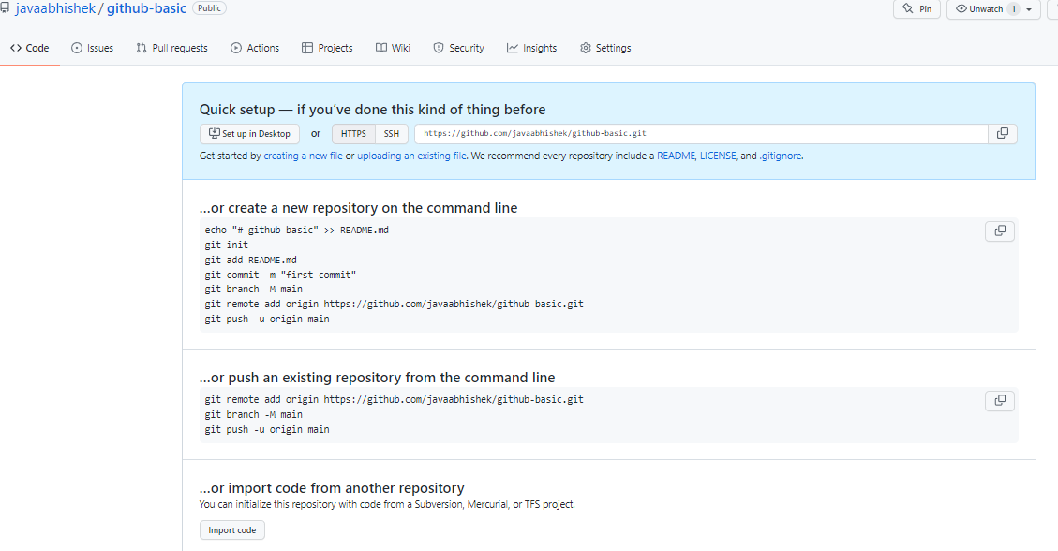

1. Now connect local repo with remote repo : git remote add origin {remote-repo_URL}
   1. Note here “origin” is a text given to remote-repo_URL, It is just alias given to remote-repo_URL , you can use any text instead of “origin”

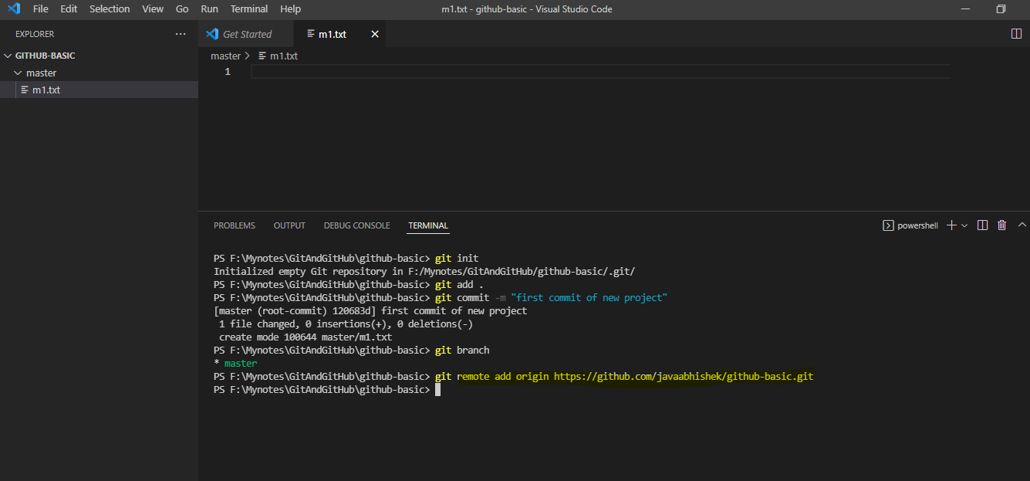

1. Now try to push the local changes to remote repo: git push origin {branch_name}

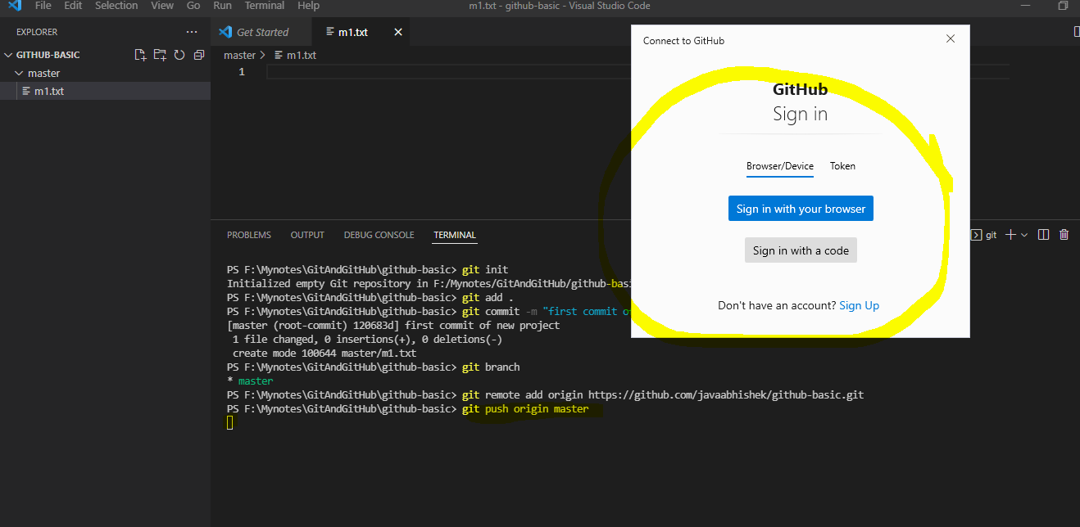

As soon as you git the push command first time, github signup popup will get appeared to fill your credentials.

To push the code we must have to generate the token on github and put that token into appeared popup for the first time.

1. Generate token

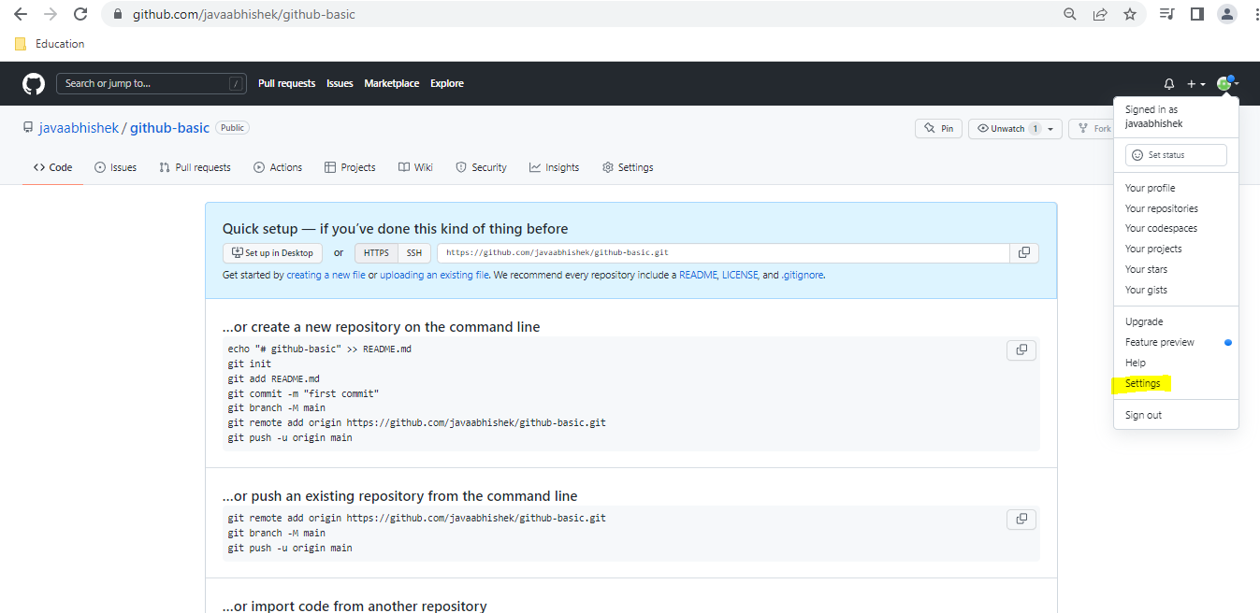

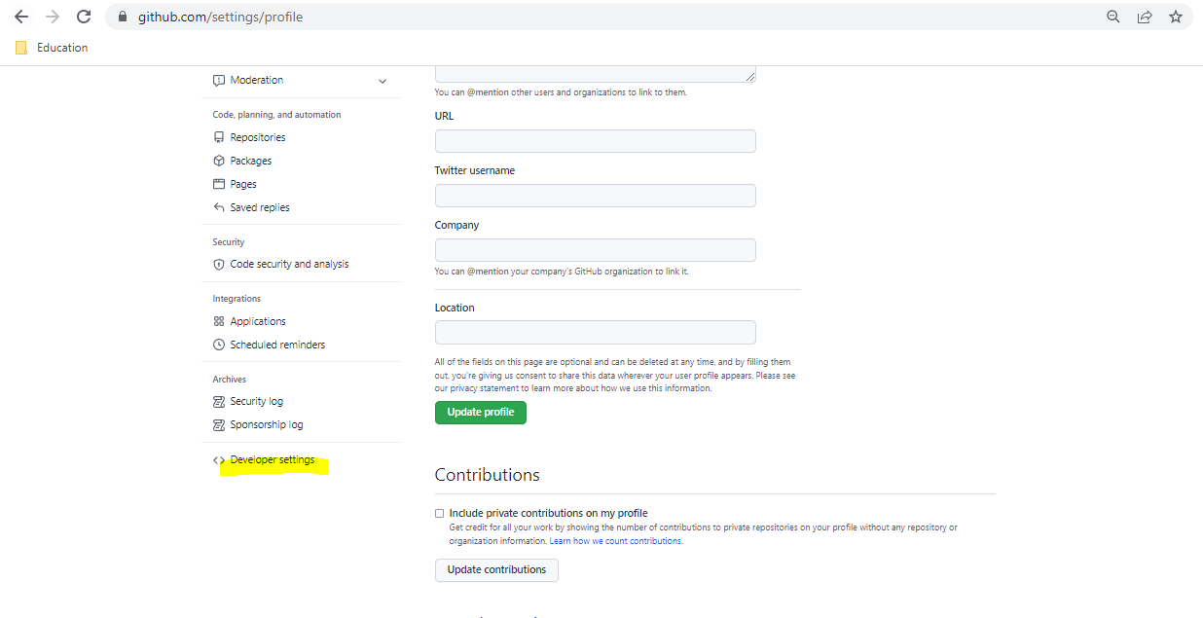

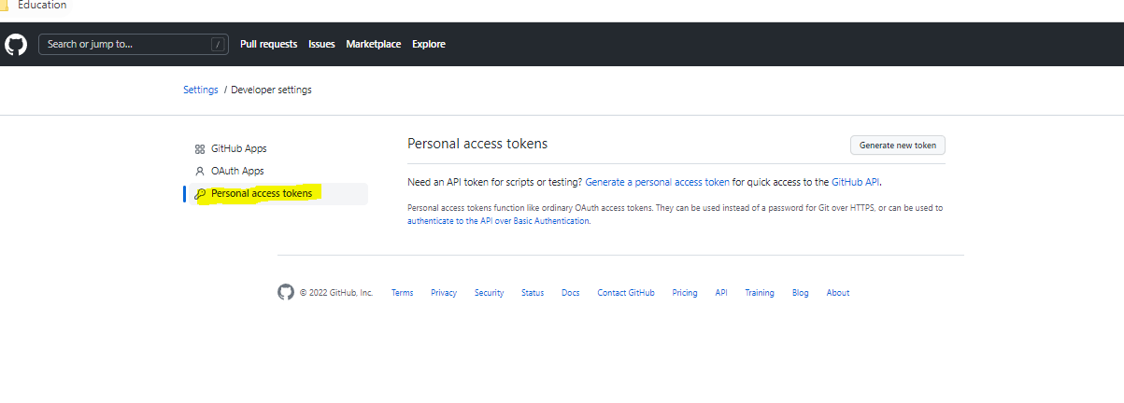

Click on Generate Token

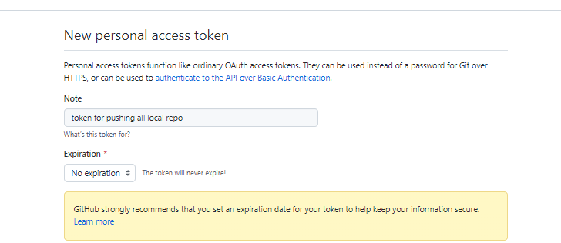

Click below checkbox

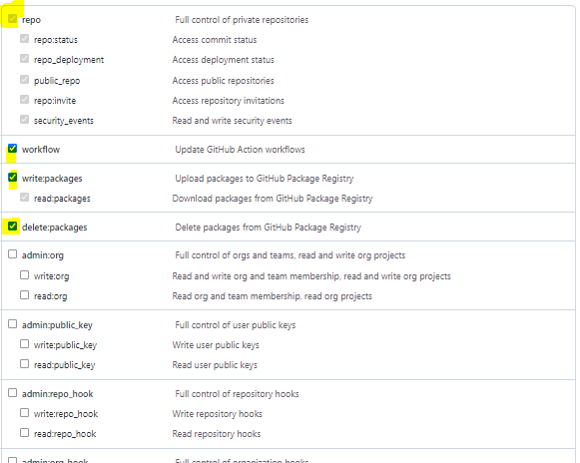

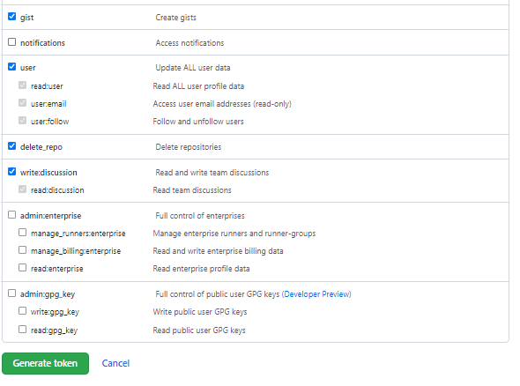

Now generate token

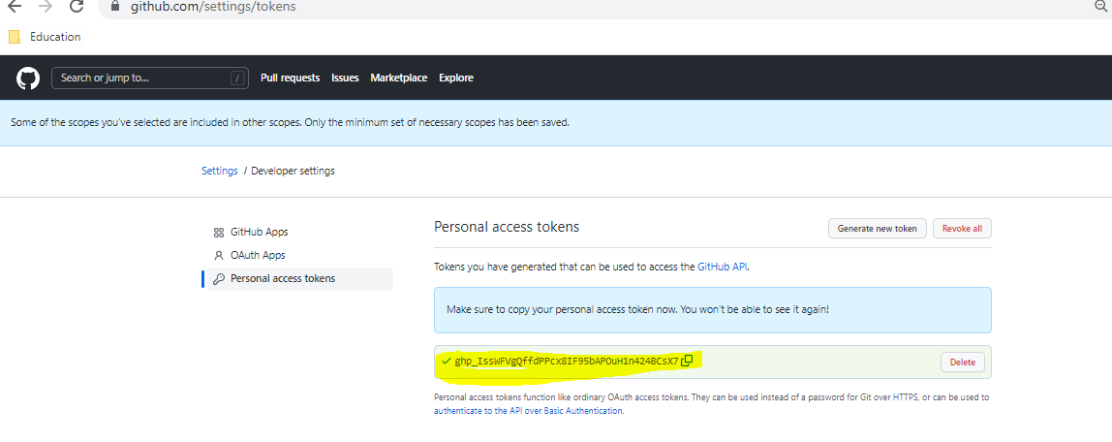

Copy that token and past in popup

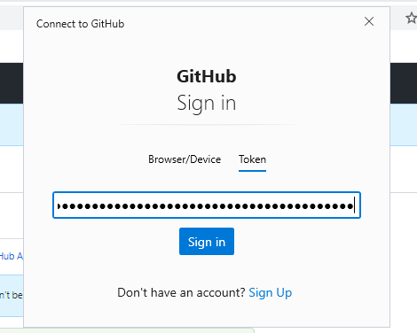

Click on sign in, once sign in done you will see code is get pushed on github remote repo

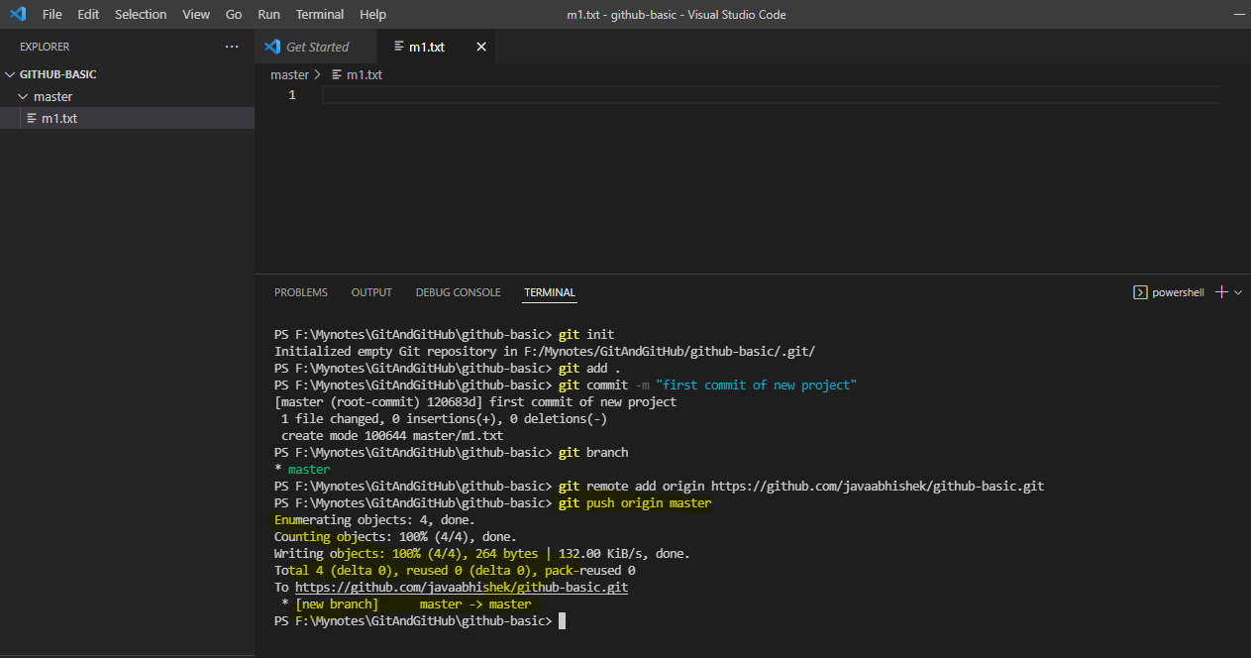

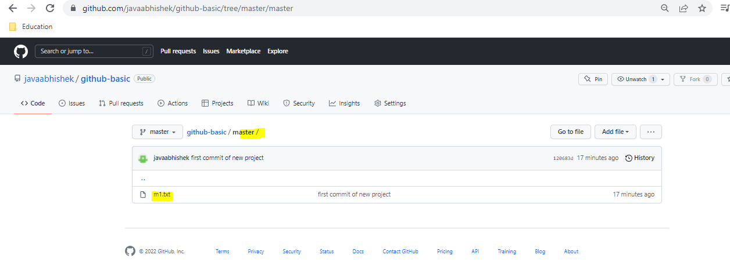

Where credential is get stored

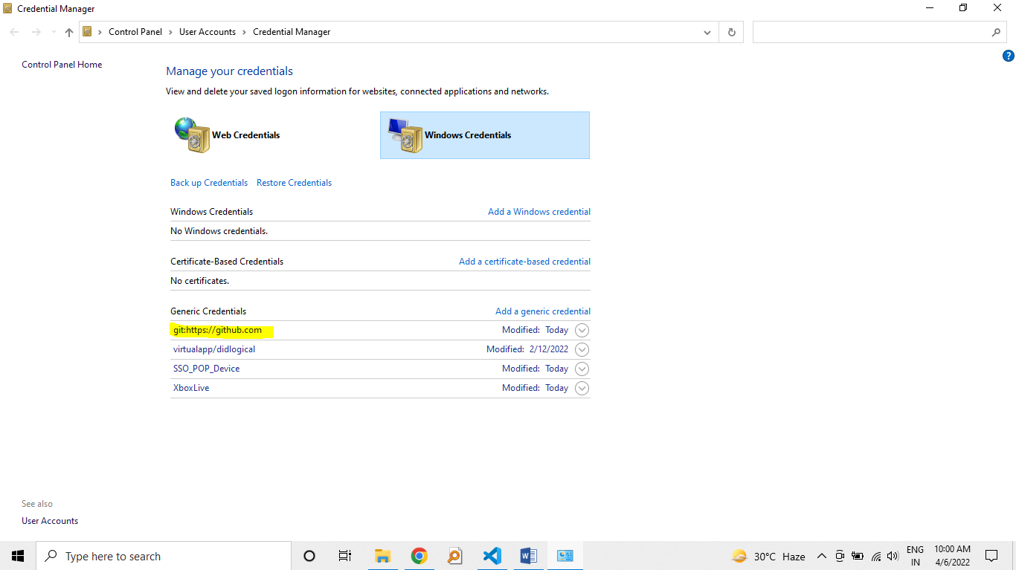

Understanding how local and remote repo works?

If run the branch command with –a option then u will see

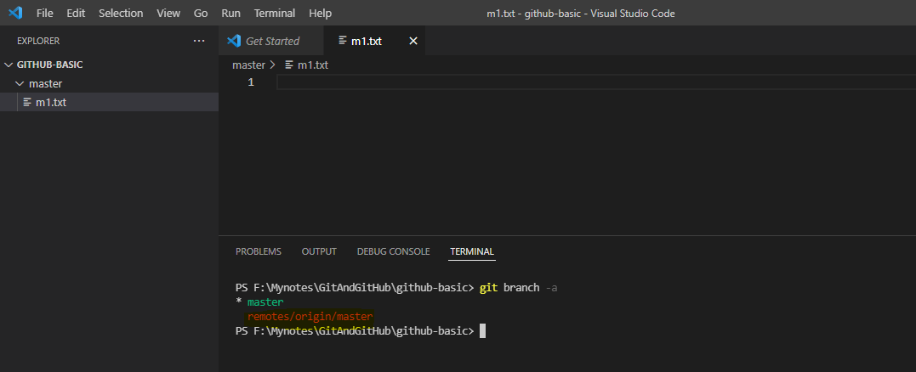

What is this “remote/origin/master”?

Well when someone run “git push” or git pull command that time git creates the remote branch copy on your local computer and in our case it is “remote/origin/master”.

But why we need this?

Well whenever we push the code from our local master branch then it first push it to the remote local master branch and then it is got actually pushed on actual remote cloud repo. In same way it happen in case of pull. When we do pull request, the code first get pulled at remote local master repo and then it is got merged into our local master repo.

Note here that there is no direct connection between remote repo which is reside on cloud/internet and local repo which is reside on our local laptop or computer.

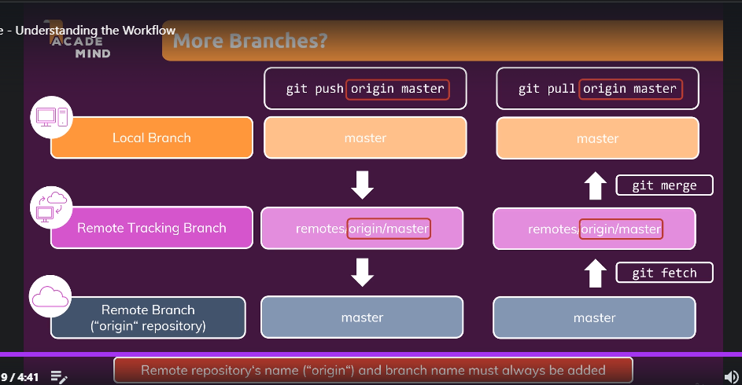

Let’s create new branch called “feature” and push it to the remote cloud repo.

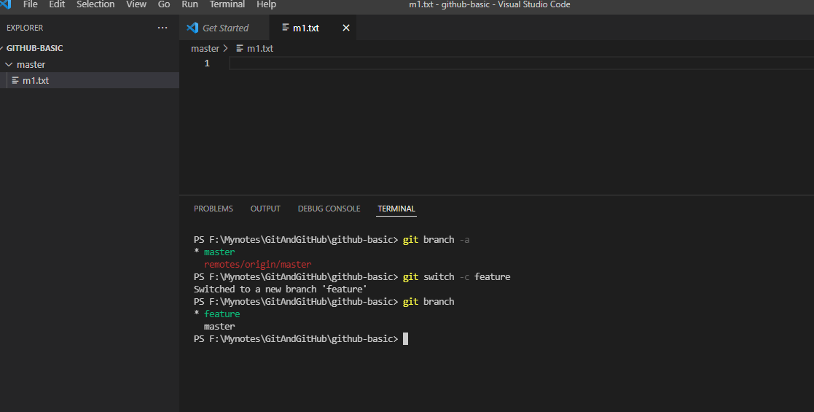

Now create new files under feature branch and commit those changes to the local repo

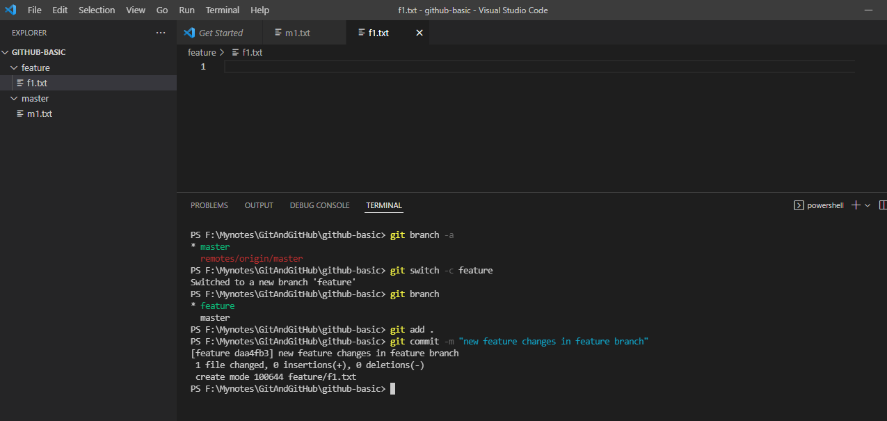

Before changes push to remote repo

List all branch on local

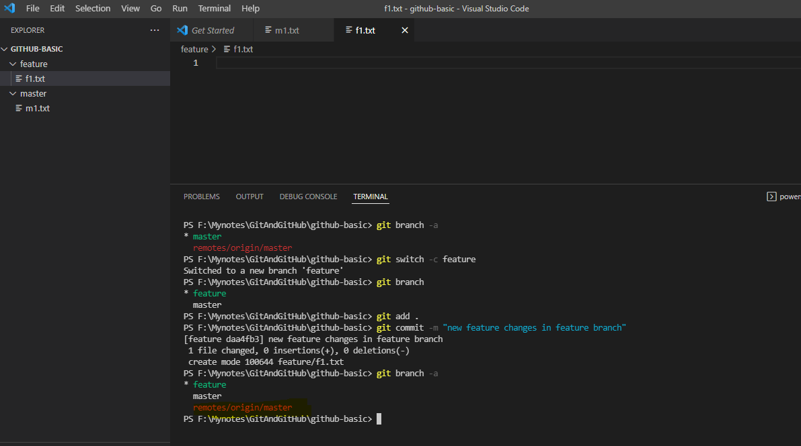

Now on remote repo

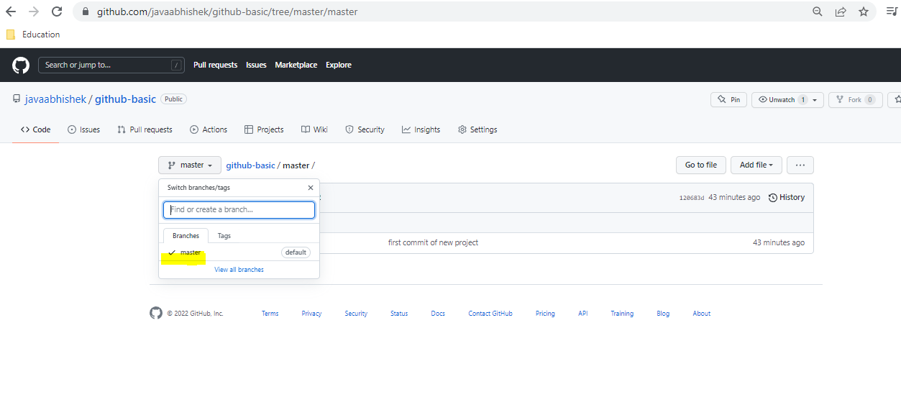

Note that only master branch is present

Push the feature branch

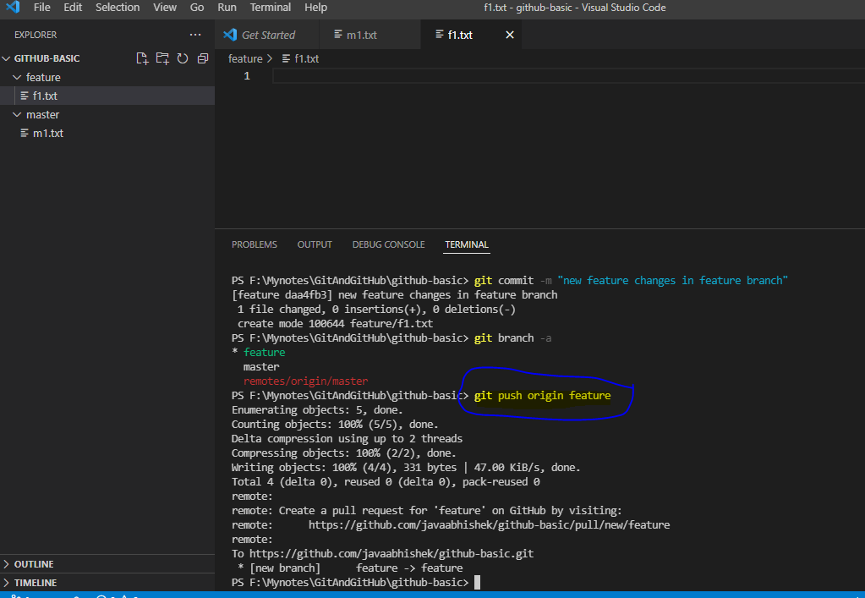

After push

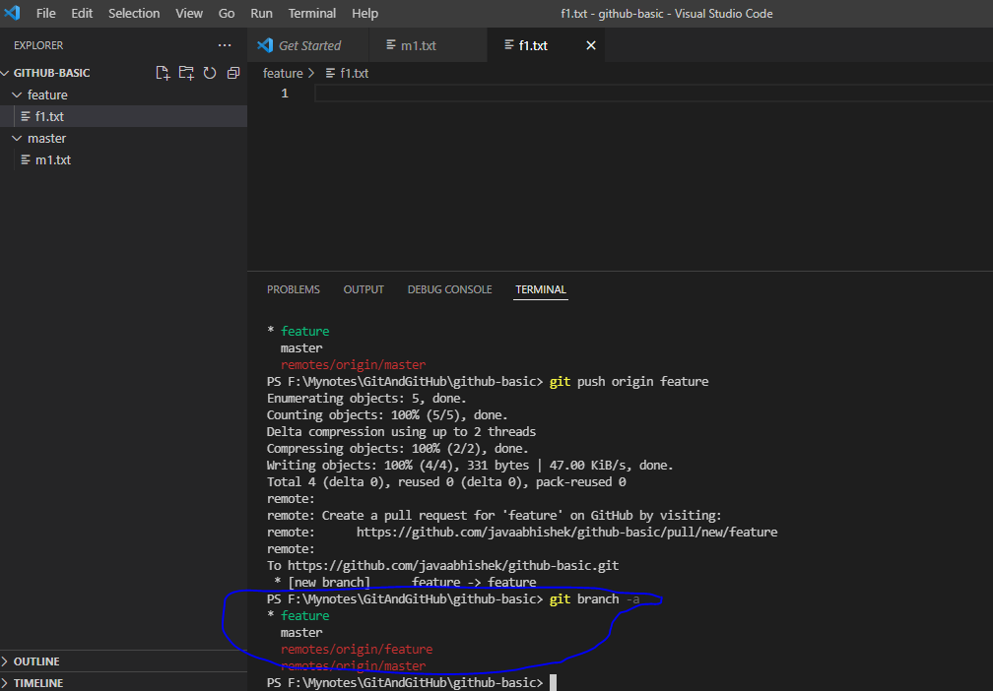

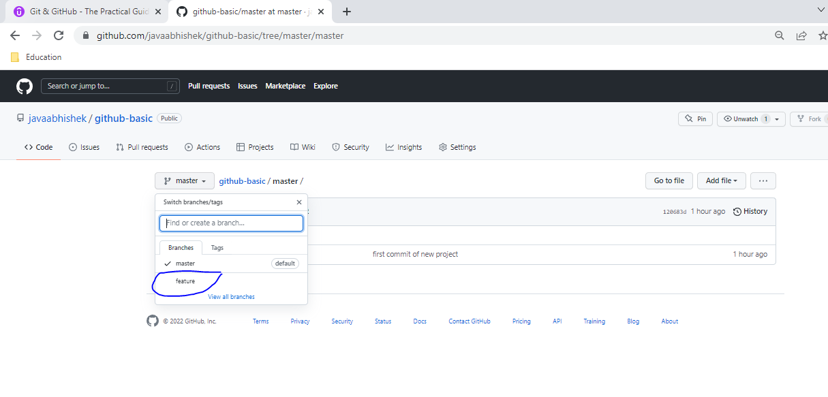

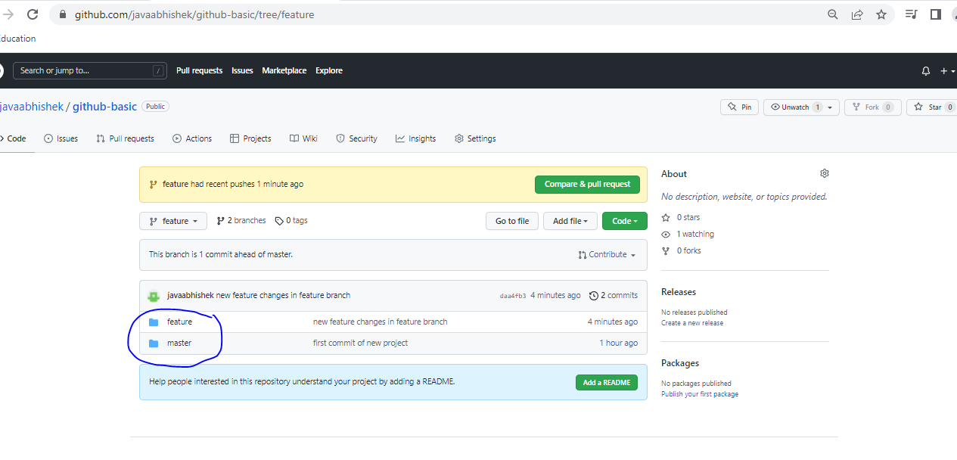

Pull and fetch remote repo changes into local repo

Let’s create new branch in remote repo

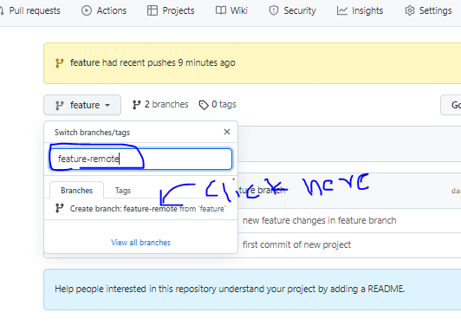

Add new file

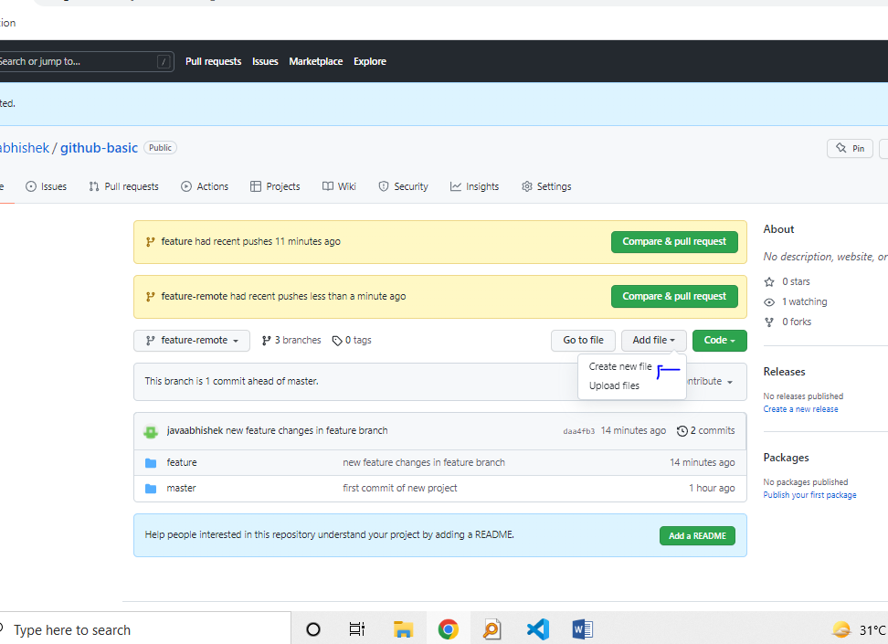

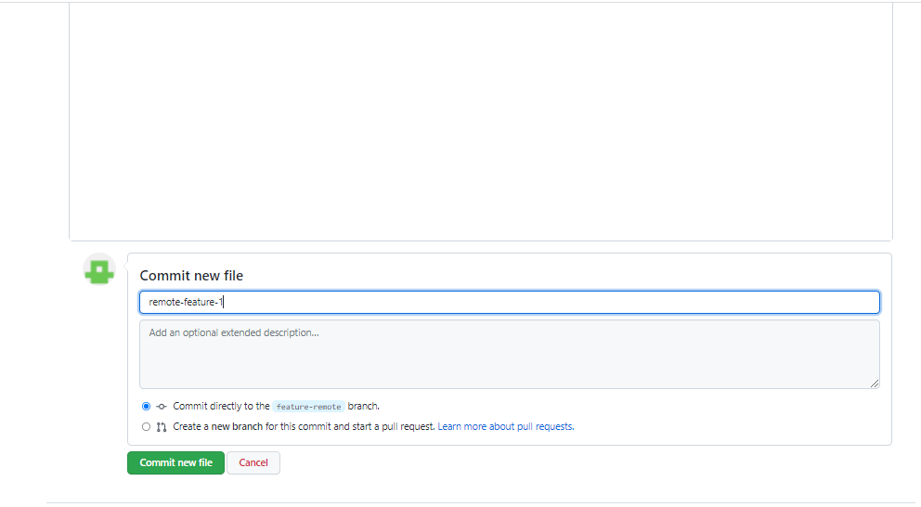

Now check from local which the branches present on remote repo: git ls-remote

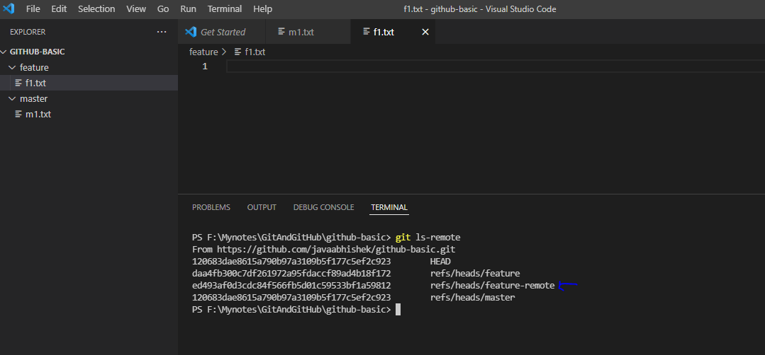

Now the question is how to get these changes on your local PC?

>> If you want to get remote repo changes without merging it then use git fetch otherwise use git push

“git fetch- just fetch or take down the remote changes on to local pc

“git pull- it is combination of fetch + merge remote changes on to local pc

“git fetch: example

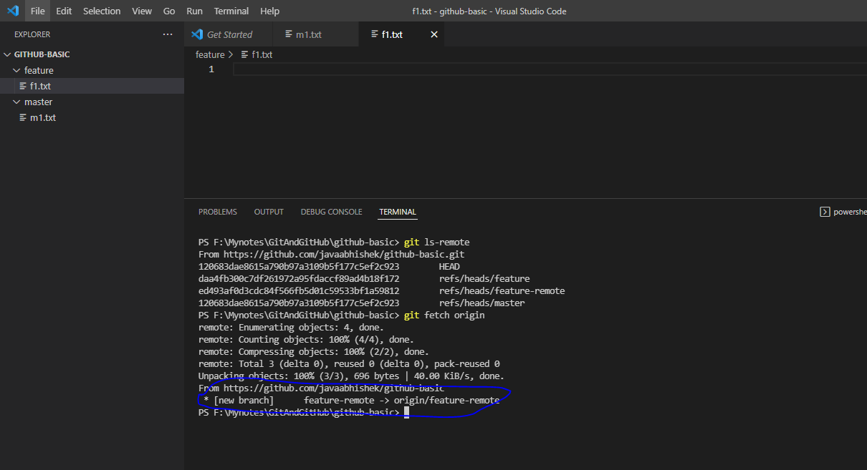

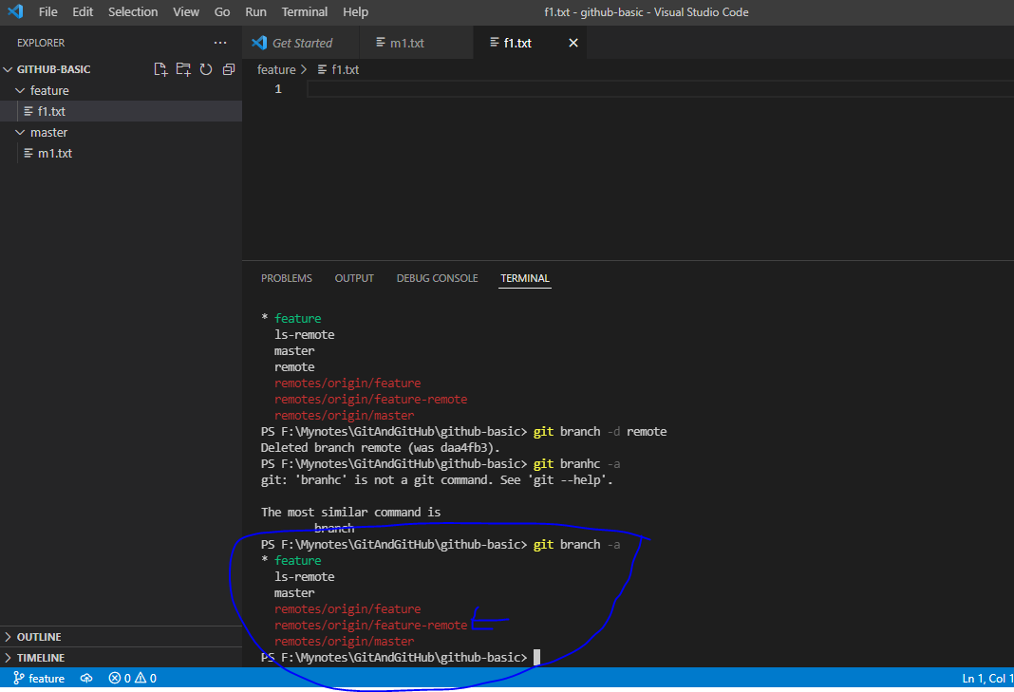

Now how can you get changes from remote local repo to local repo?

>> Before that have some concept

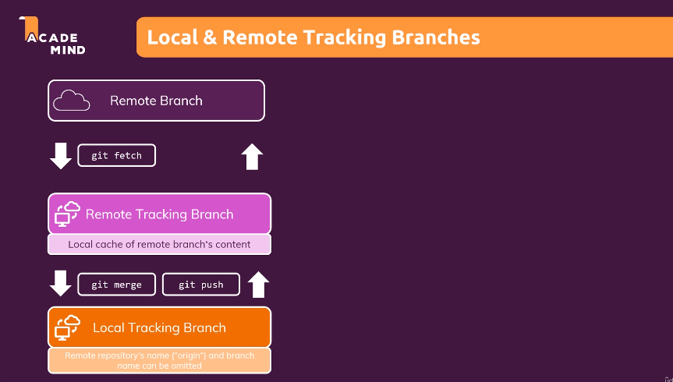

Steps:

1. Creating a local tracking branch (branch name should be same as remote tracking branch)

Command: git branch –tracking {branch_name} origin/{remote_tracking_branch_name}

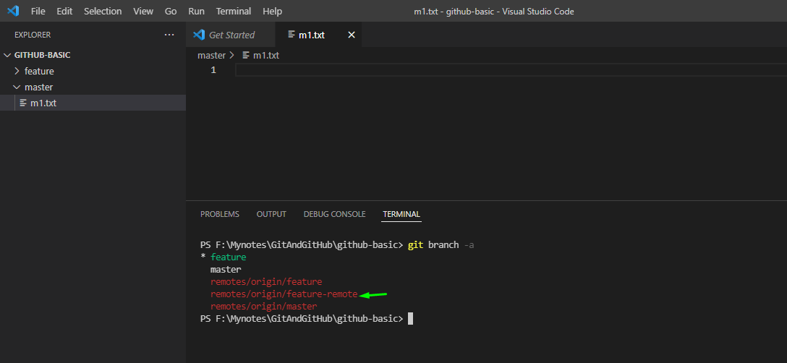

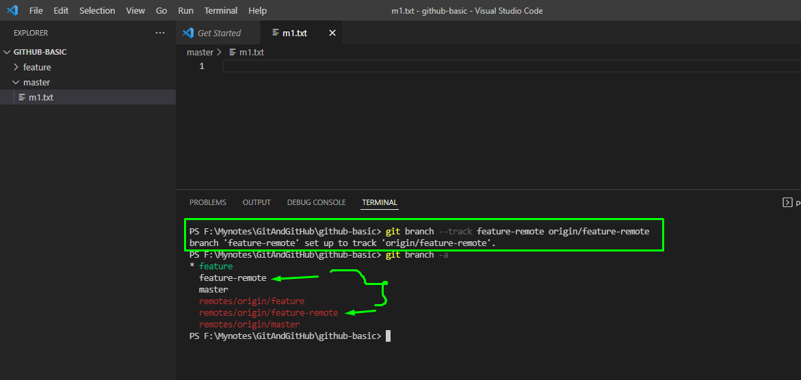

Note here now we have created new local tracking branch with same name as remote tracking branch.

Now you can switch to local tracking branch and make any changes what you want and directly push to the remote repo. Let’s do that in below steps

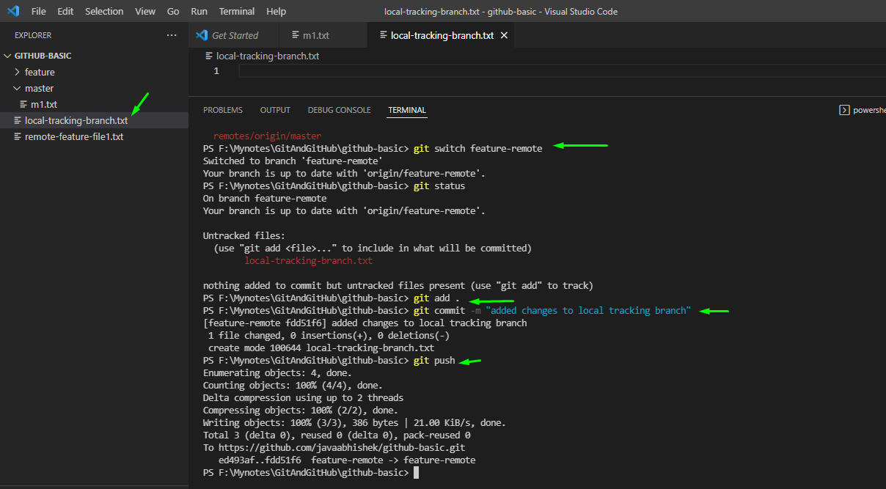

Before pushing file to remote repo:

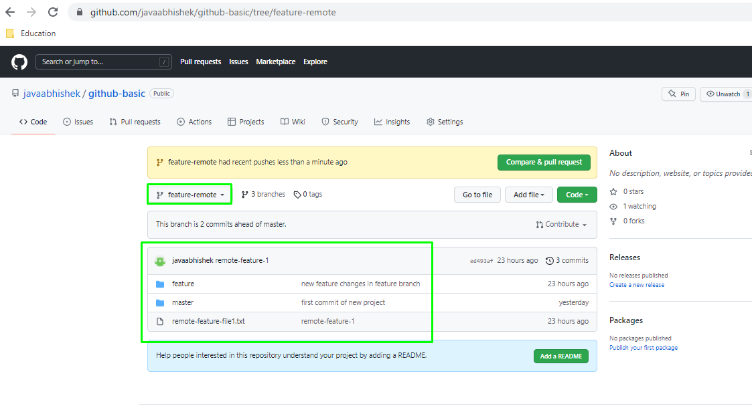

After pushing file to remote repo

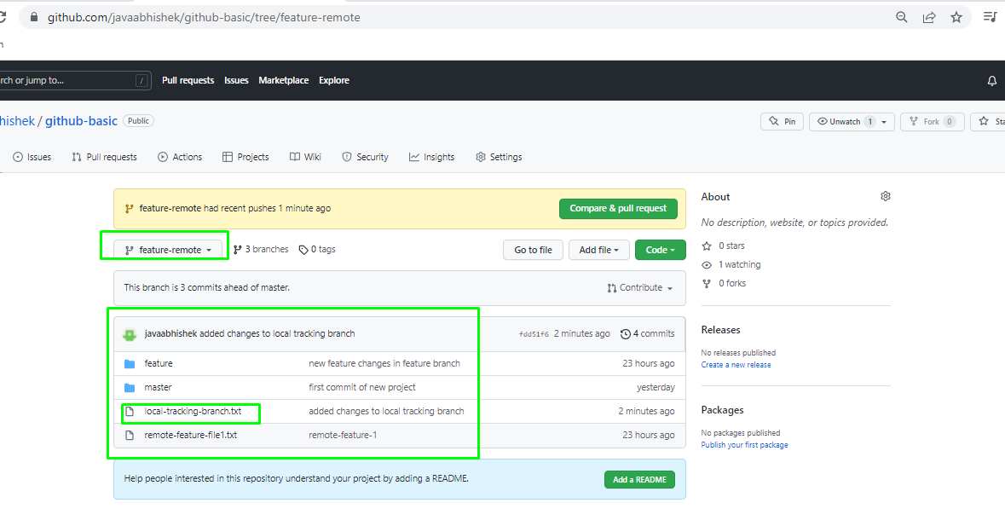

Now let add file into remote repo

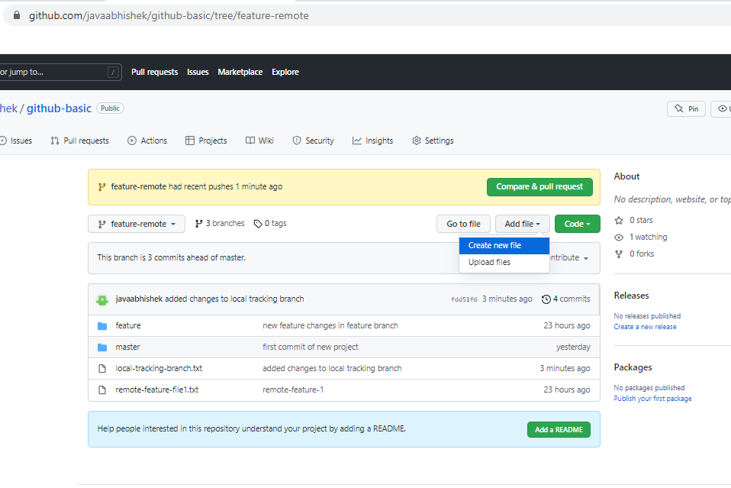

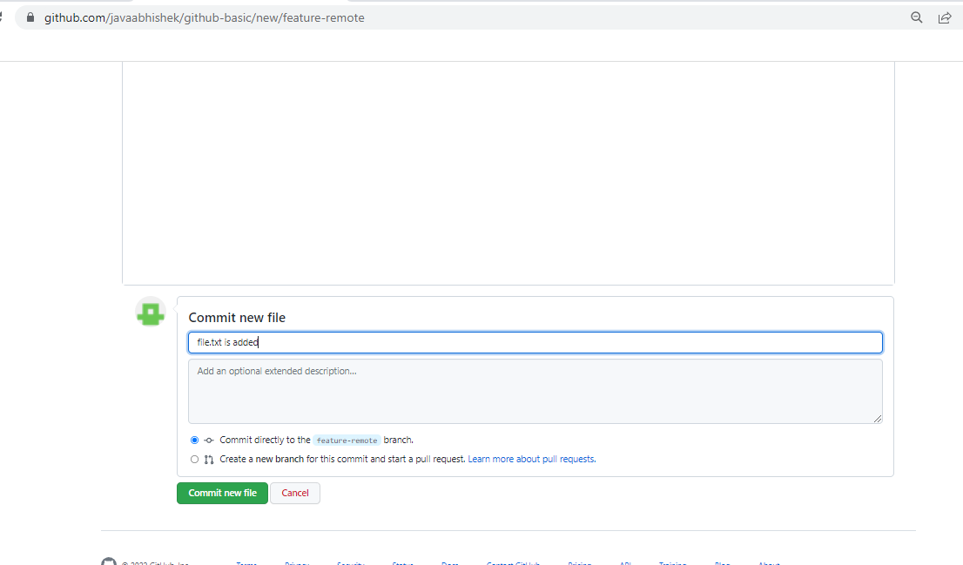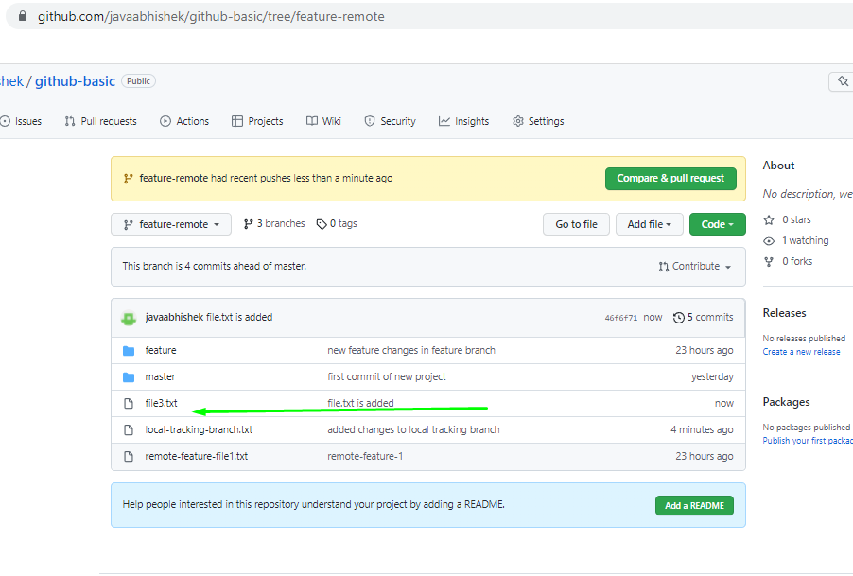

Now pull this file to local remote tracking branch

Before pull:

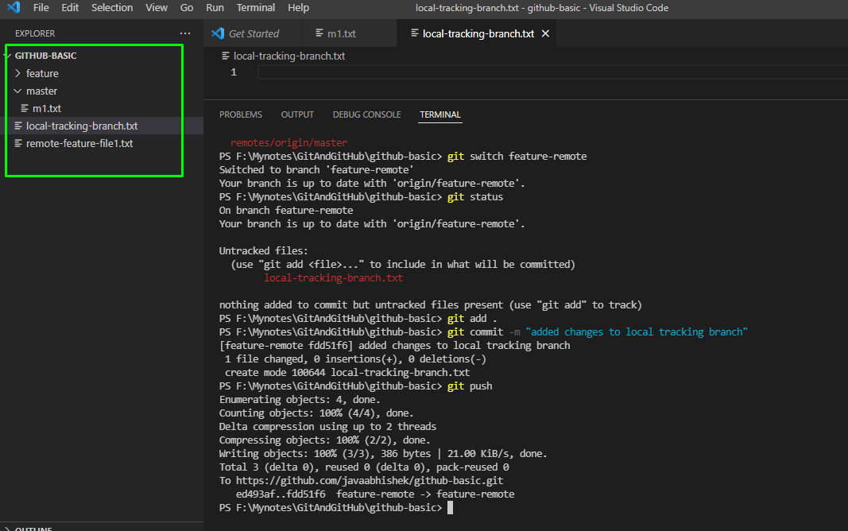

After pull

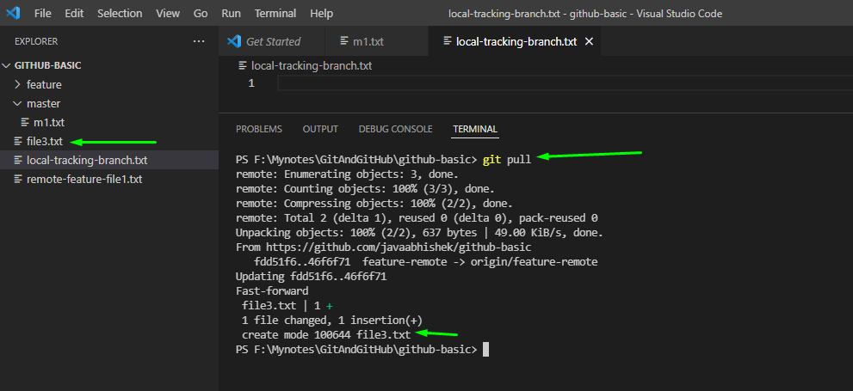

Command to find which local remote tracking branch is tracked to remote tracking branch

“git branch -vv

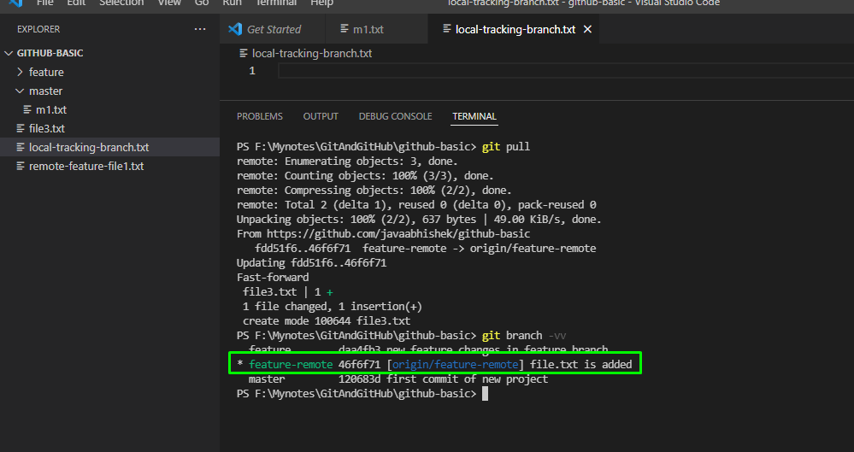

Commands:

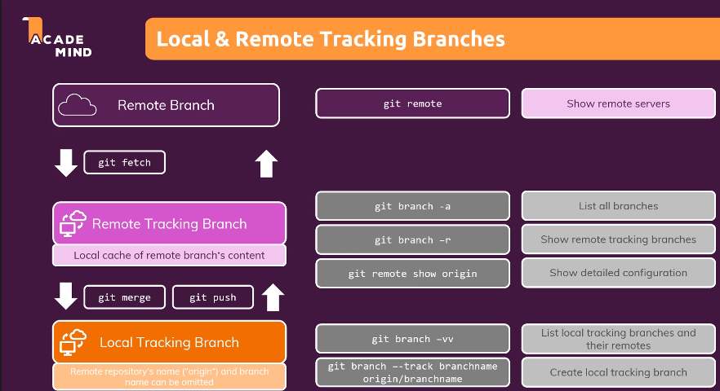

Summary of push and pull:

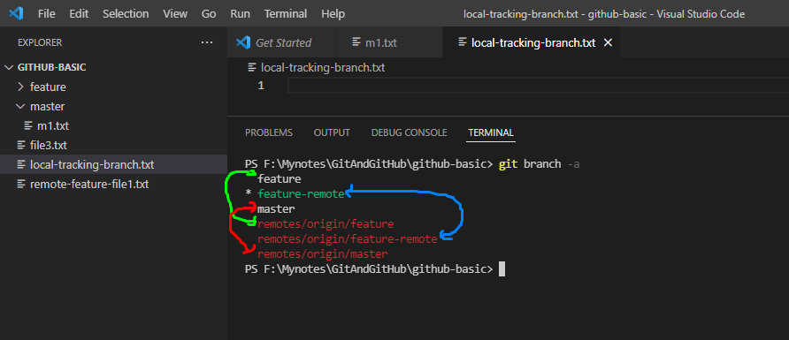

Note here that when you create new branch on local which is not present on remote repo then we simple use “git push origin {branch_name}” this command will create new branch on remote cloud repo and in addition to that git will create local tracking branch for same. In our case “feature” is branch that we created and push it to remote repo cloud and “remote/origin/feature’ is the branch automatically get created.

When some else create new branch on remote cloud repo then we have first fetch like “git fetch origin”. Once you hit that command then git will fetch all files from remote cloud repo & create remote tracking branch at your local. BUT there we need to create local tracking branch for it, using “git branch –track {branch_name}/origin {remote/brach_name}. In our case we done it for “feature-remote” branch.

“git pull with example

Note that as pull command always works with branch name as it deals with merging

Hence it would be like: git pull origin {branch_name}

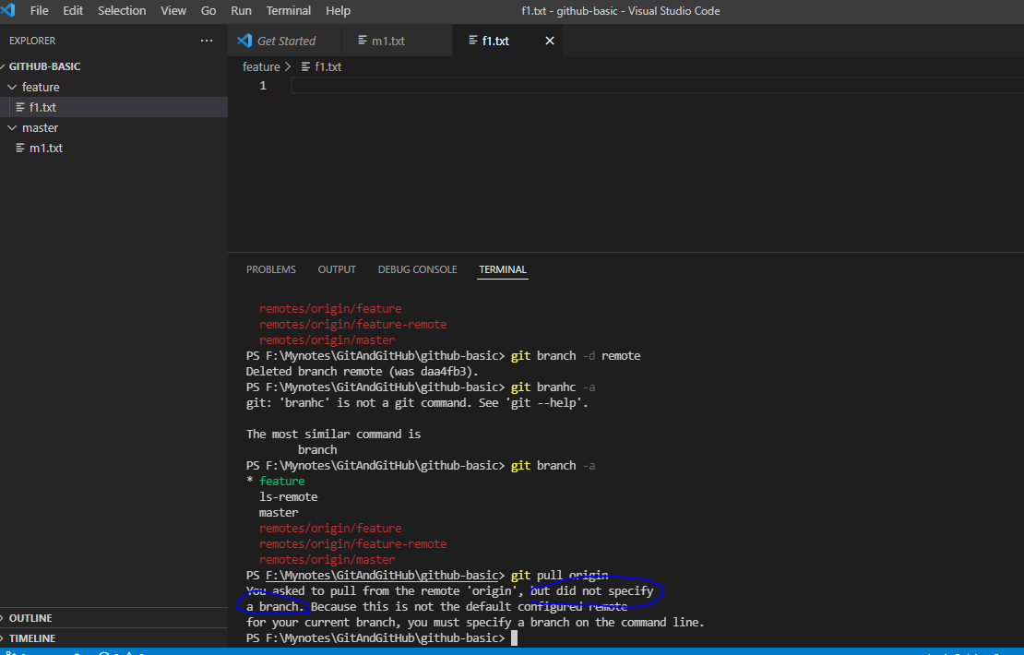

After specifying branch name

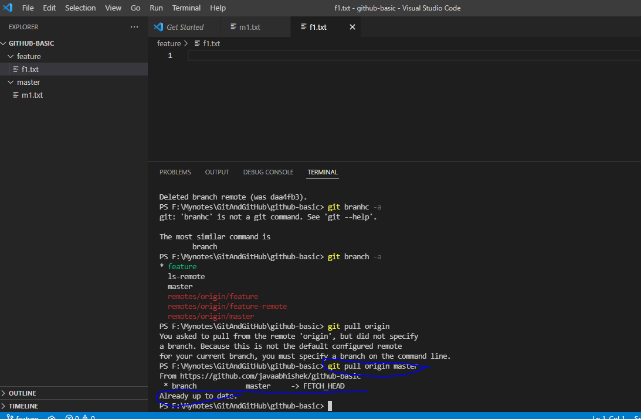

Clone

Clone the remote repo from cloud

Step

1. Login to git hub and copy the URL

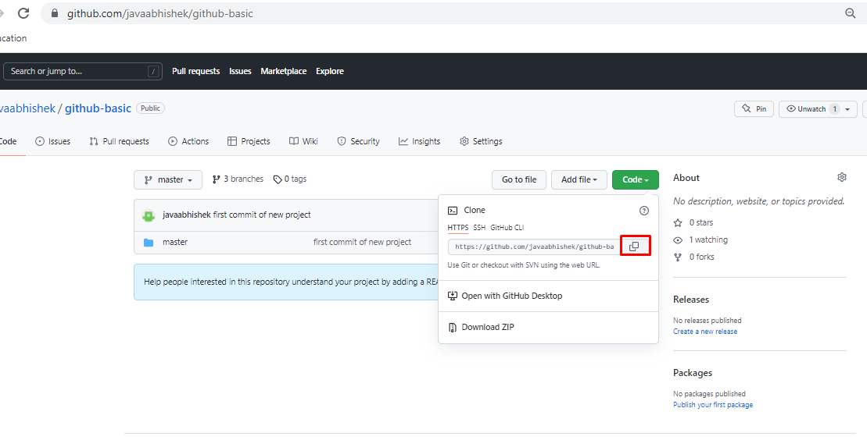

1. On local created new directory called “clone” and open it from IDE and run the below command

“git clone {URL}

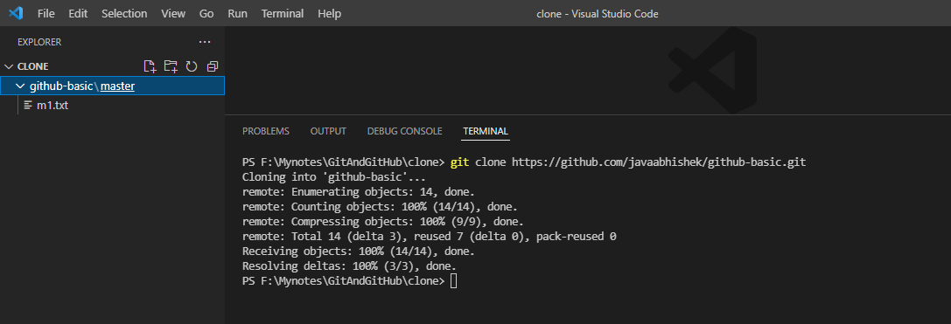

1. Now cd to github-basic directory to check all command
2. Check status

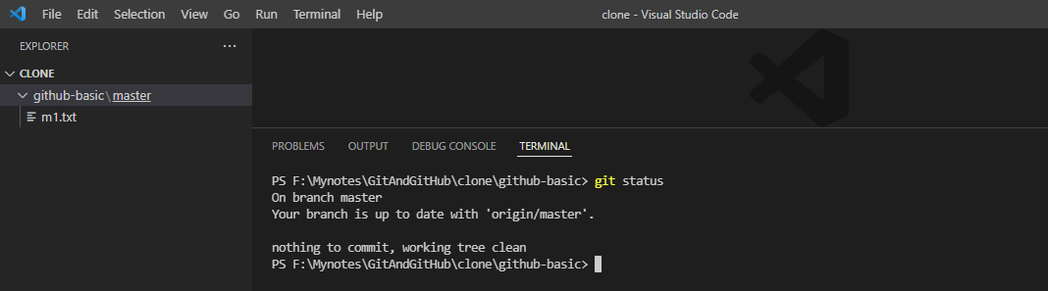

1. Check branch

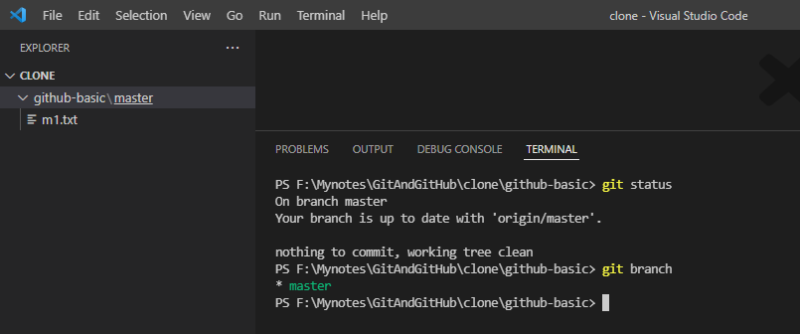

1. Check all branches

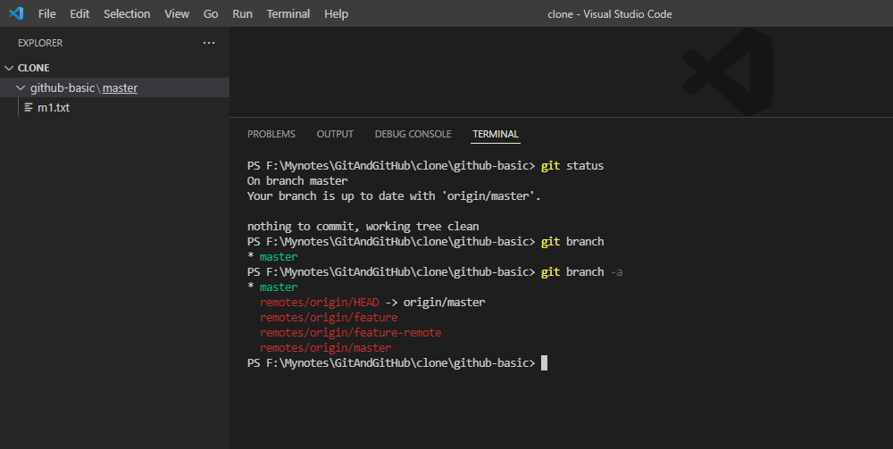

Note here we have only remote tracking branches

1. Now create a local tracking branch for “feature” branch

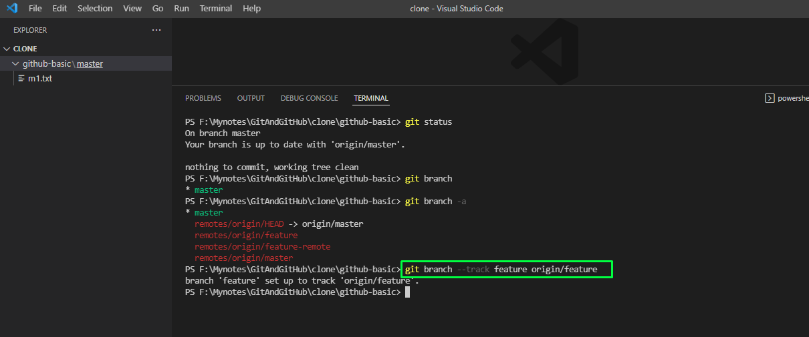

1. Check the all branches

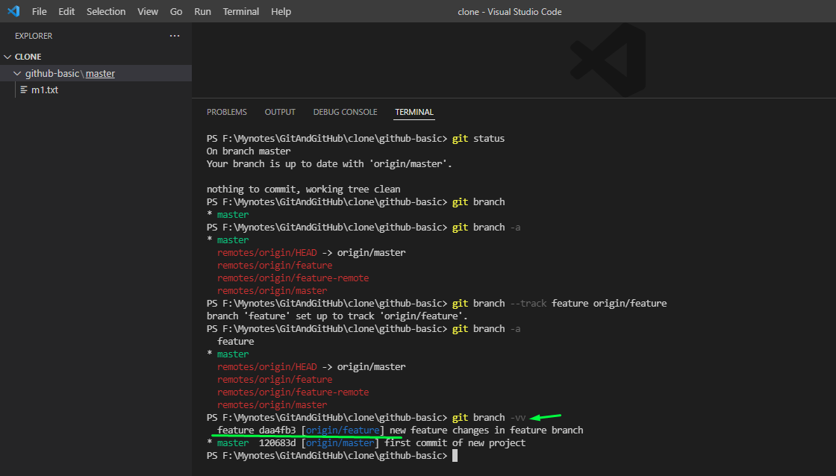

1. Switch to feature branch and make some changes and commit it to the feature branch

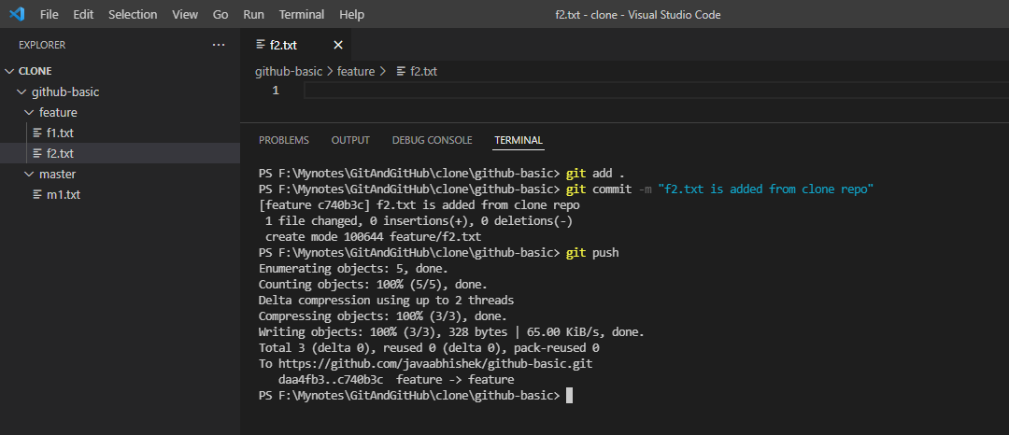

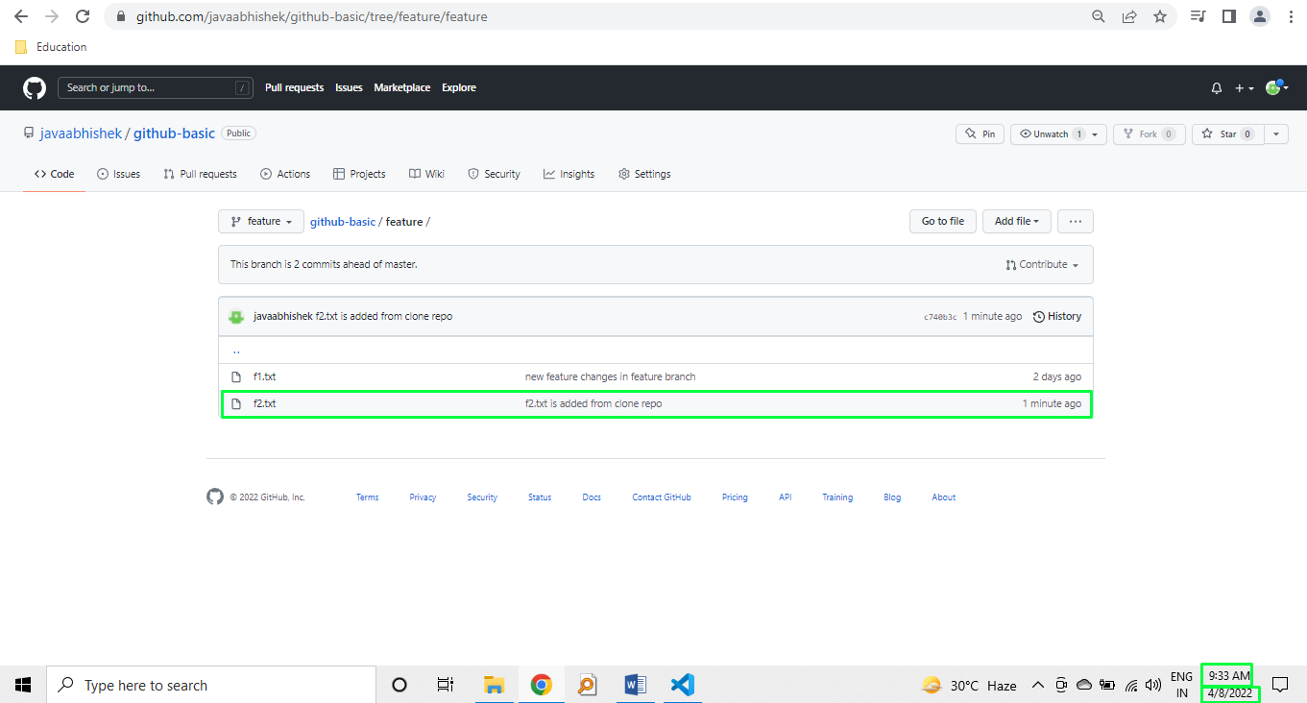

1. Now create new local branch and push it to the remote cloud repo.
   1. But while pushing it we are using “upstream” option to create local tracking branch automatically

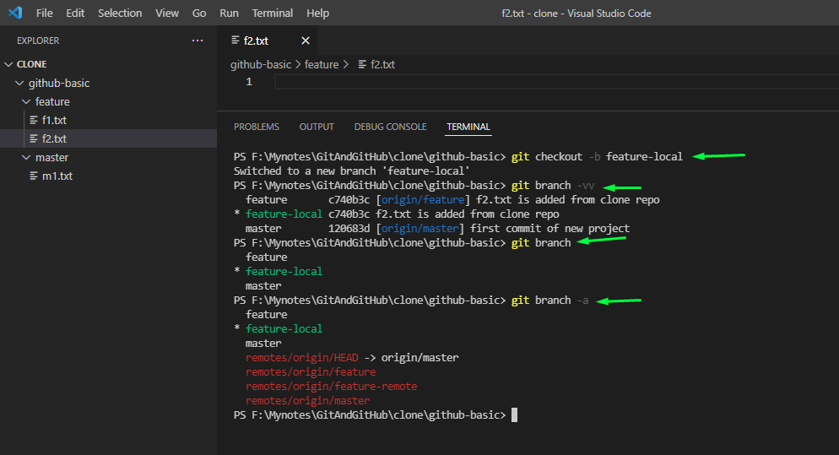

Note that intentionally executed git branch command with different options

1. Now making some changes and pushing this branch to remote cloud repo

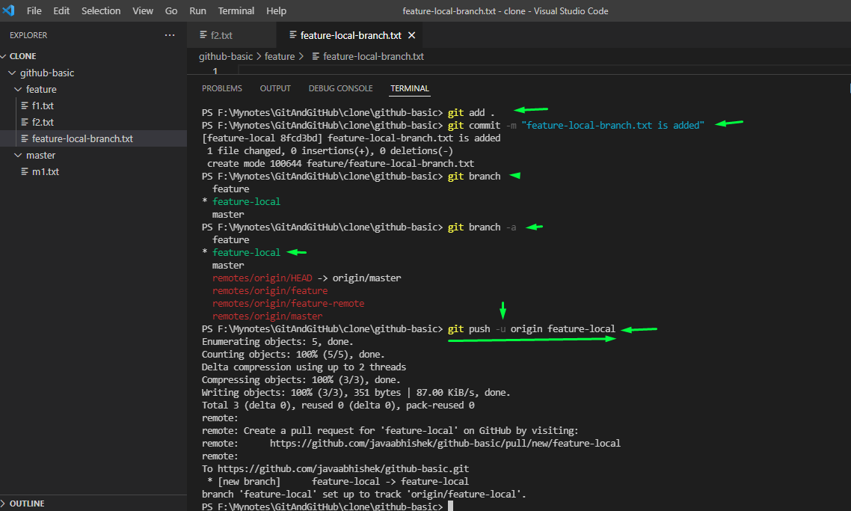

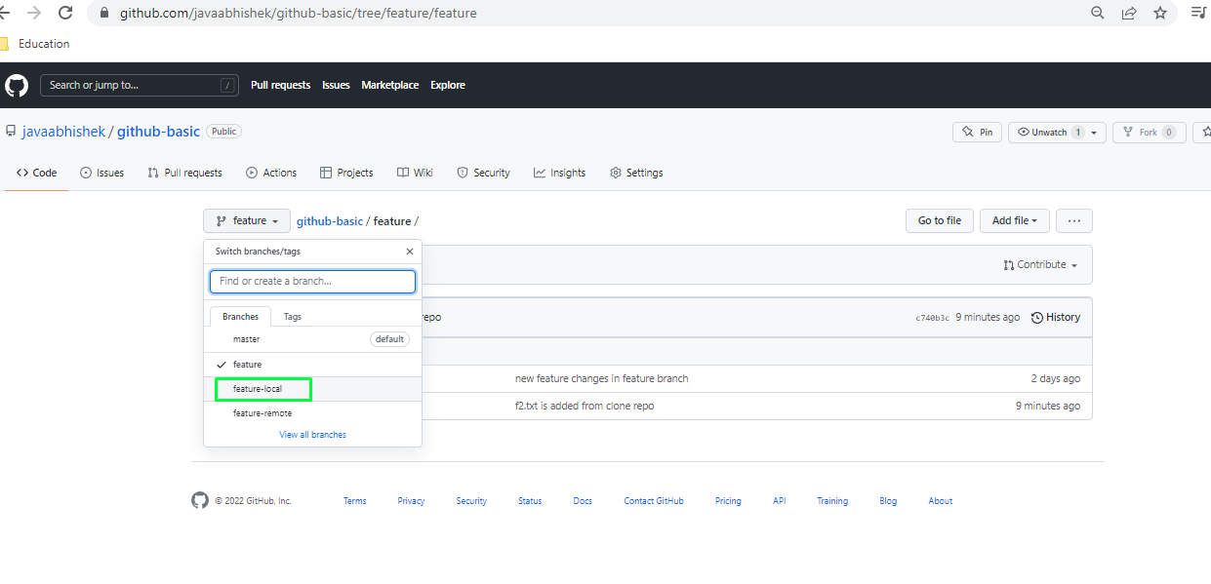

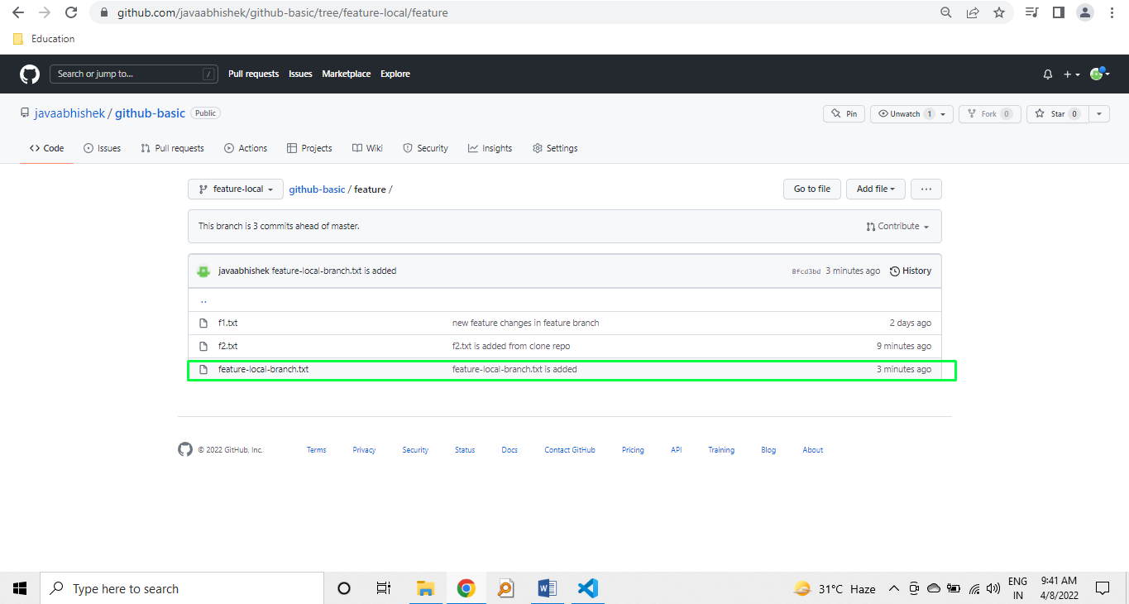

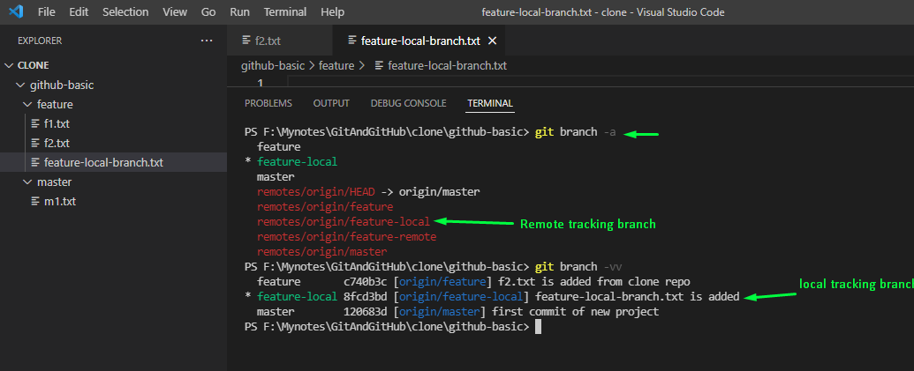

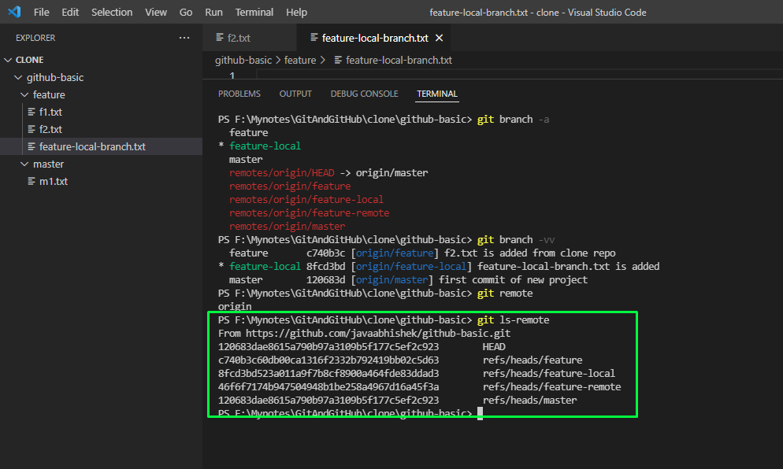

Deleting branch and remote commits

git branch -D {branch_name} : to delete branch

git branch --delete --remote origin/{branch_name}: To delete remote tracking branch if has

git push origin --delete {branch_name}: to delete branch from actual remote cloud

